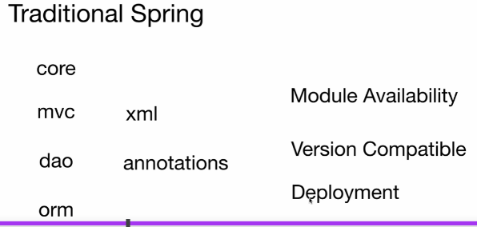

**Problem:**

version compatibility

Need to deploy by its own

**Spring boot features**

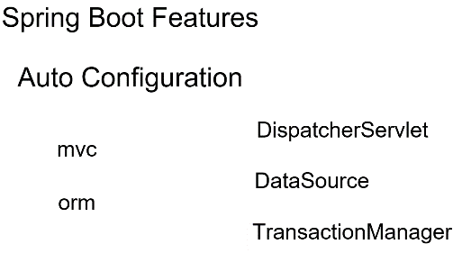

1. **Auto configuration :--- that’s takes xml and annotation based configuration away**

Means no need to configure xml based or annotation based

For orm no need to configure data source

**2-- version compatibility problem will get resolved due to spring boot starter parent**

All types of version will be available in spring-boot-starter-parent

\

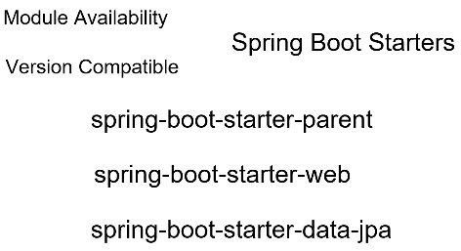

1. **Embedded servlet container:-----**

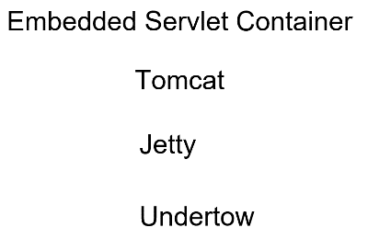

by default tomcat but we can switch to jetty and undertow also

1. **Spring boot actuators:--- give health check**

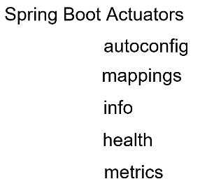

Autoconfig report:----will display everything configured automatically

Mappings :- will give all http request endpoint of application

Info:- will give info about application

Health :- display what is up in application

Metrics:- will show different metrics of application collected at different point and time

Now spring boot will use free for our application

First Project

**Spring boot starters in pom**

**Note:---**

Parent project only having the version info i.e **spring-boot-starter-parent**

Will add all dependency due to **spring-boot-starter** in pom.xml

The libraries are pull what is listed in dependency section but version of those libraries is pulled by parent

**Version incompatibility problem resolved**

**@SpringBootApplication**

Is a top level annotation which contain several other annotation

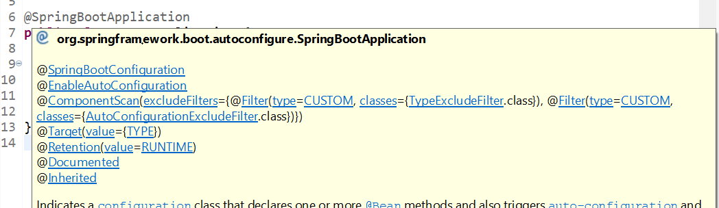

**@SpringBootConfiguration :-**

this class can be have several spring bean which will be available at runtime in application

**@EnableAutoConfiguration**

This annotation tells spring boot to automatically configure the spring application

Based on the dependencies it sees on the class path and do any configuration if it is required

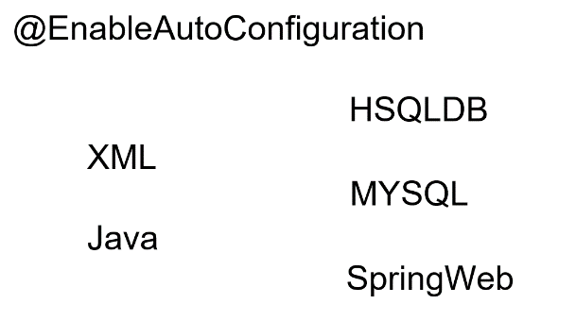

Example :--

it will automatically configure the data source for in memory database

Spring web :--- spring boot automatically create dispatcher servlet

**@ComponentScan**

This annotation tells spring Scan through the classes and see which classes have respective annotation like @Component , @Service, @Repository and create bean of those annotation

By default it scan packages where it lives and also it will scan child or sub packages of that

**@SpringBootTest**

This tell spring boot go and search class that marked with @SpringBootApplication and creates a container which will contain all the beans

Do dependency injection

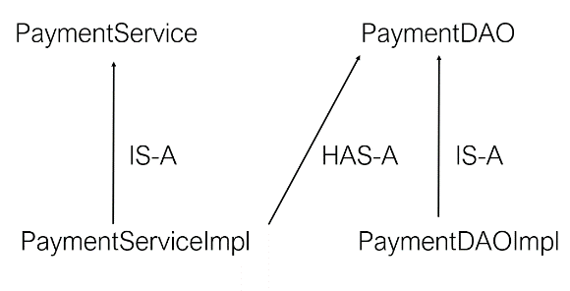

@Repository

public class PaymentDaoImpl implements PaymentDao {

}

**@Repository** :- Object of this class be created and wherever it is required should be injected

**Note:--**

all stereotype annotation tell a bean of this class can be created and injected

**Autowired :-- bean will automatically wired at run time**

Means it will check that class which is marked by @Repository it means bean will created and which will wired in the variable which is marked by autowired

Autowiring feature of spring framework enables you to inject the object dependency implicitly. It internally uses setter or constructor injection. Autowiring can't be used to inject primitive and string values. It works with reference only.

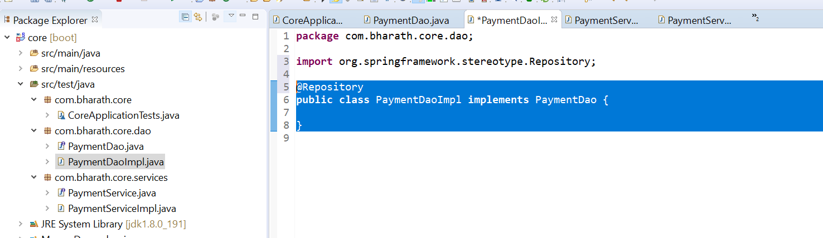

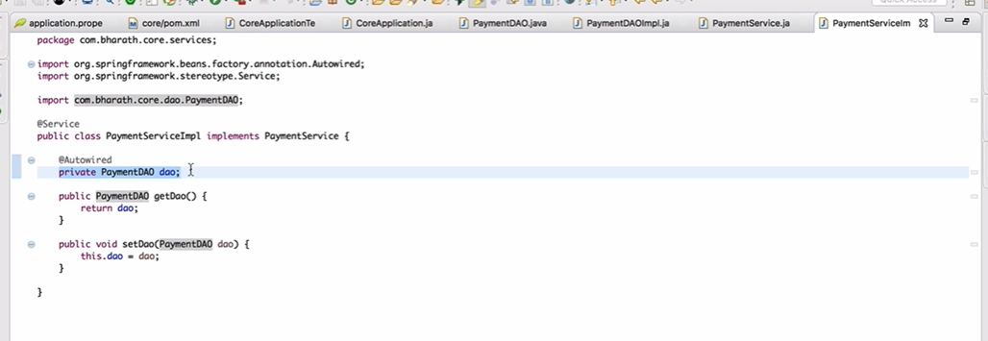

Spring will search PaymentDaoImpl which is marked @Repository , it will create bean and due to autowired it will wired into dao

Testing

If the dependency injection is working

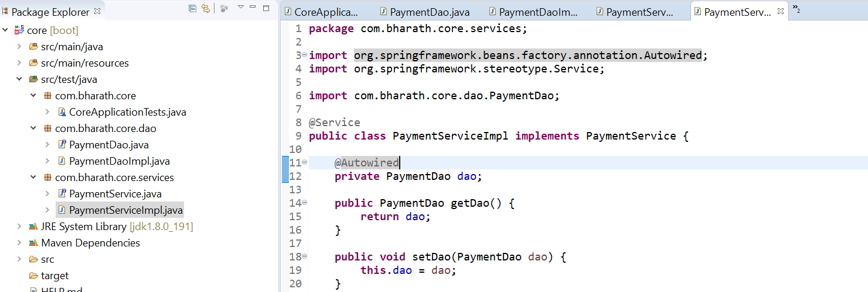

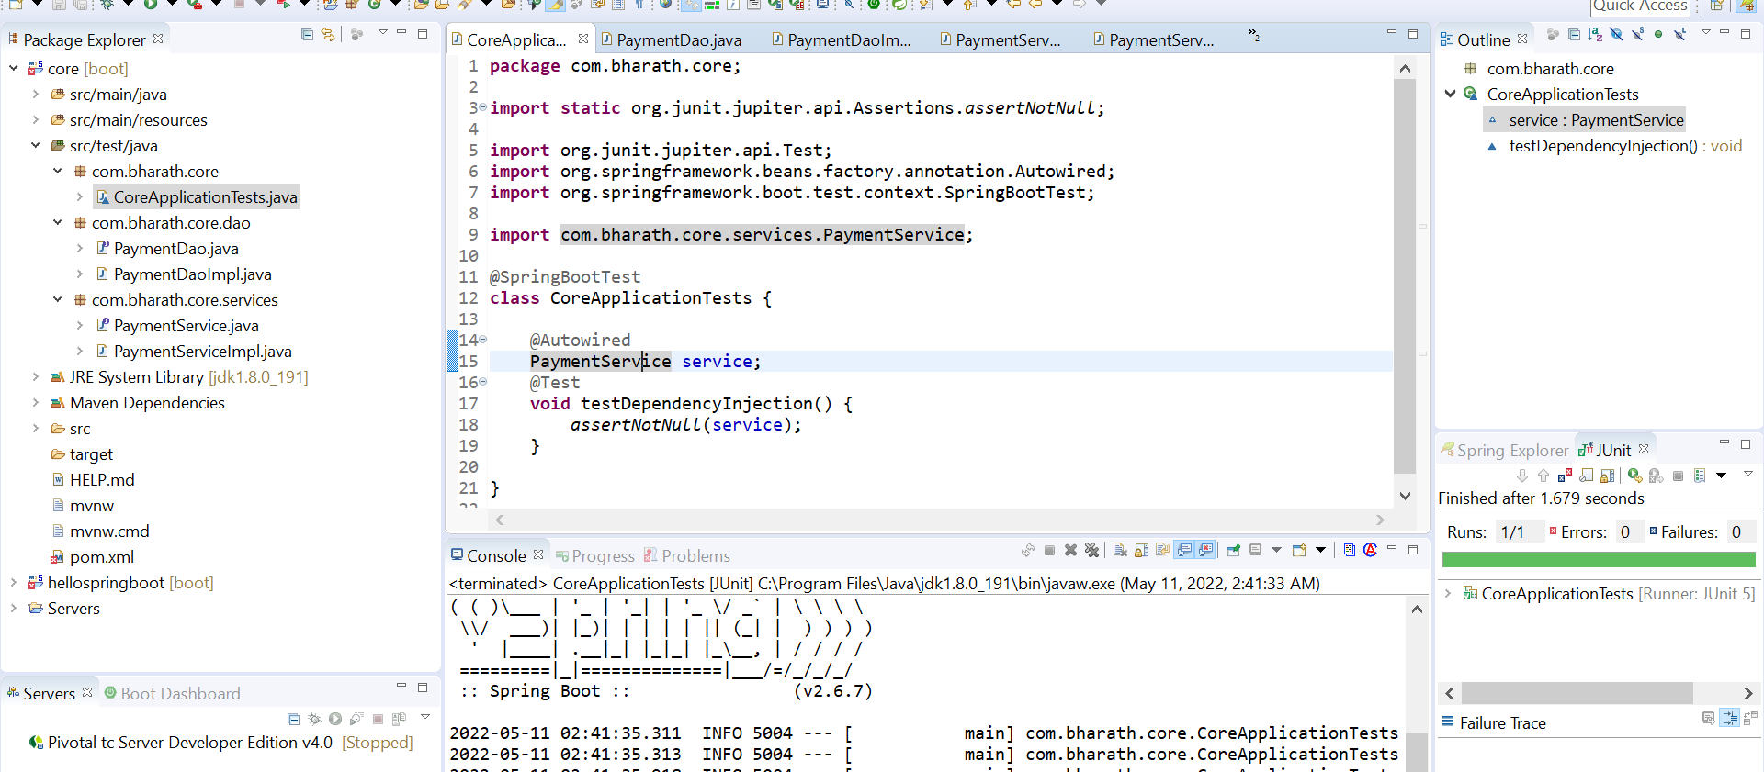

**Tested dao being injected into service**

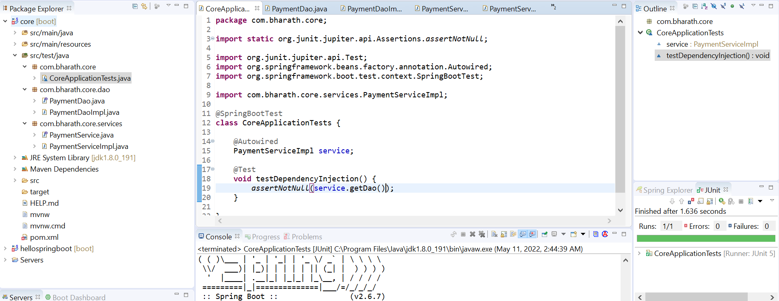

Spring data JPA

Create a repository per entity which will extends jpa repository interface

Using this we can perform crud operation

**NOTE:-**

In pom :- include spring-boot-starter-data-jpa

Will use in memory :- h2 d/b and

spring boot will automatically configure everything and will create table

1. If we want to use mysql then we need to define d/b url,user name and pw

In application.properties

1. By default jpa use hibernate orm

Pom.xml

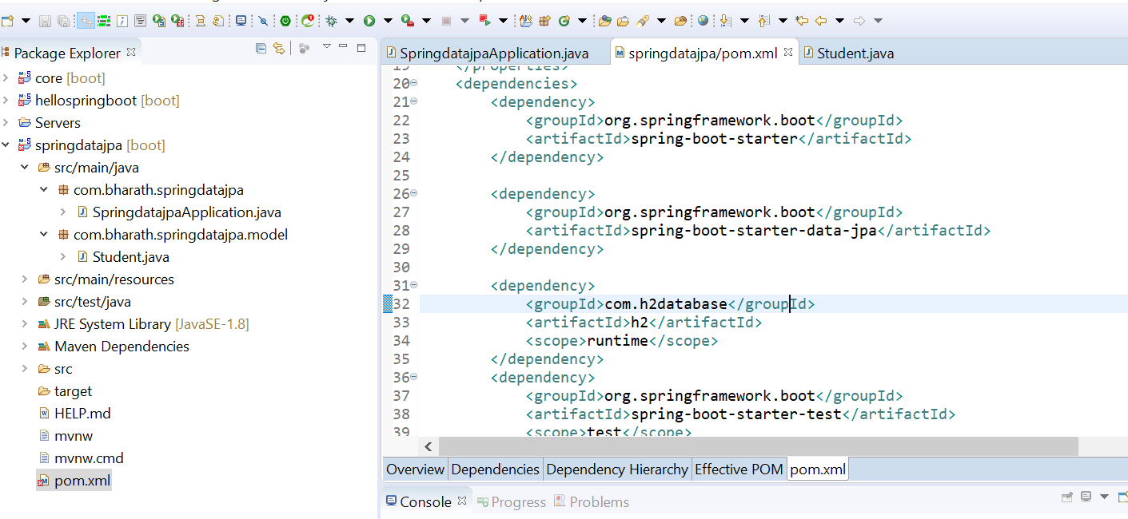

Entity

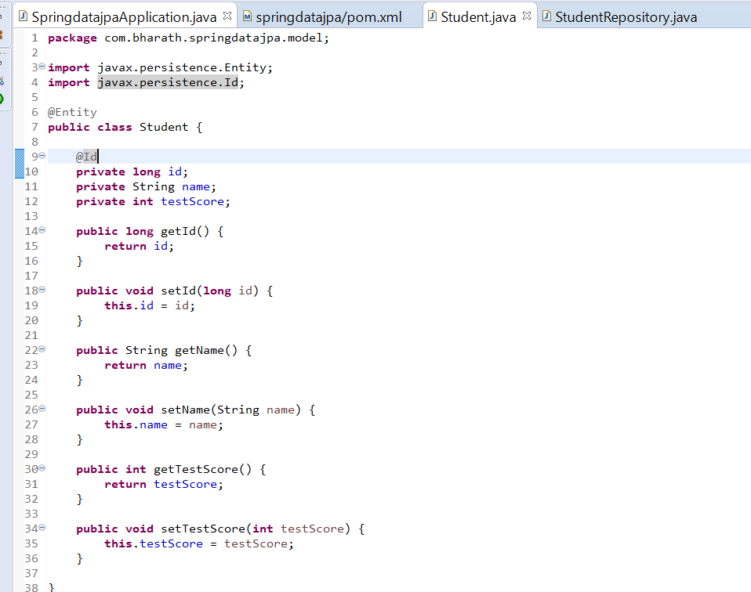

Repos

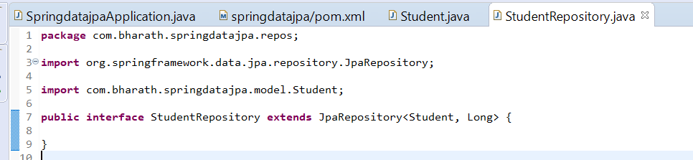

**Test the application**

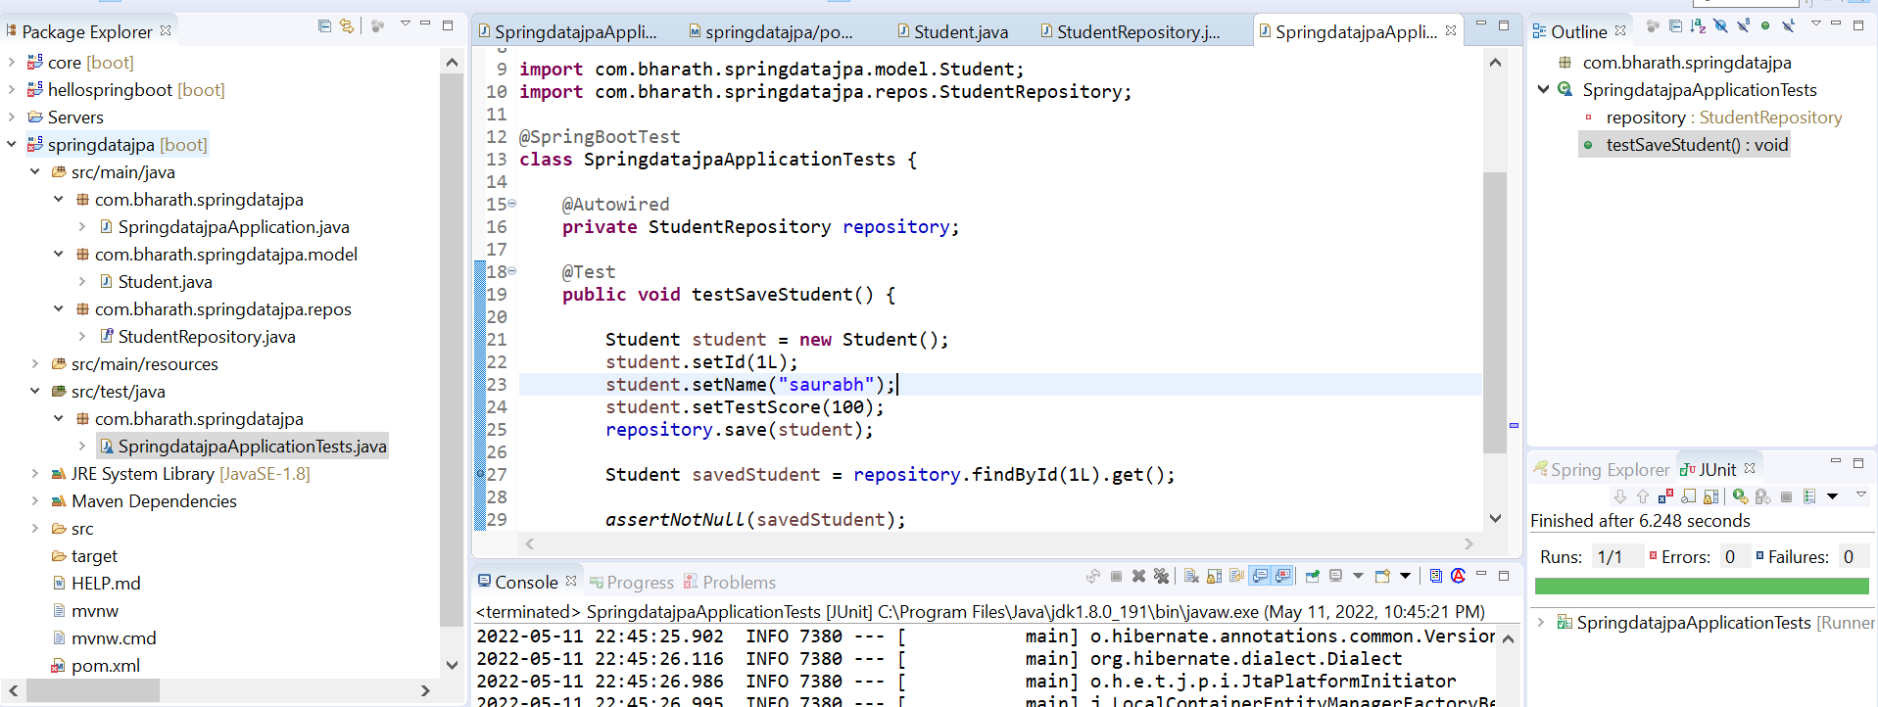

**Requirement :---** to see all sql query created by hibernate behind the scene

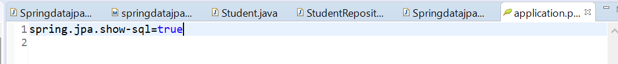

It means orm tools will display sql query created behind the scene

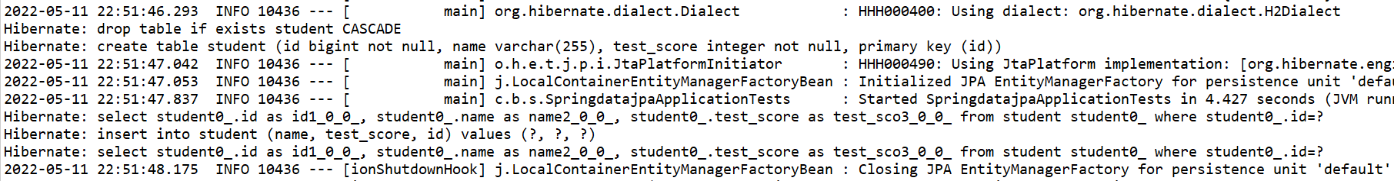

Drop table, create table if record not there then it will insert but if record is there then it will update

Create Rest CRUD api

Rest intro

1. Create product

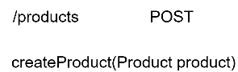

1. Get

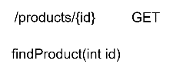

1. Put

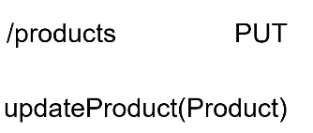

1. Delete

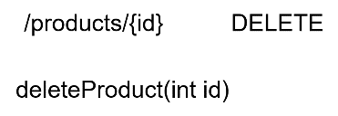

**@GetMapping :--** **@PostMapping :-- @PutMapping :-- @DeleteMapping :--**

bind java method to incoming http method

Pom.xml

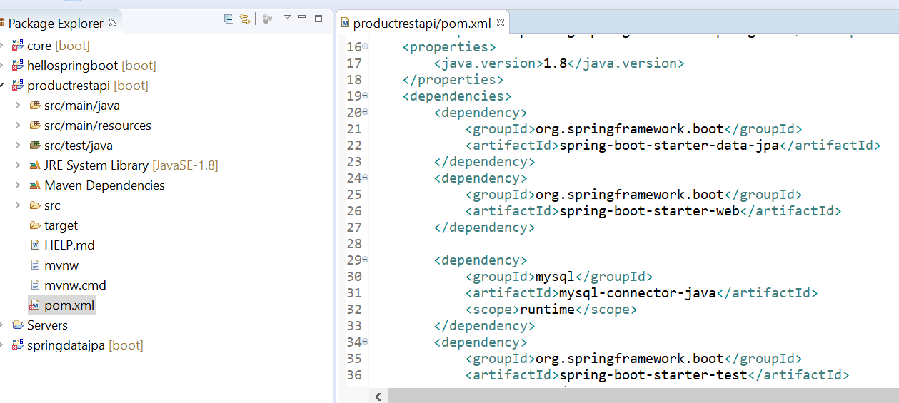

Product.java

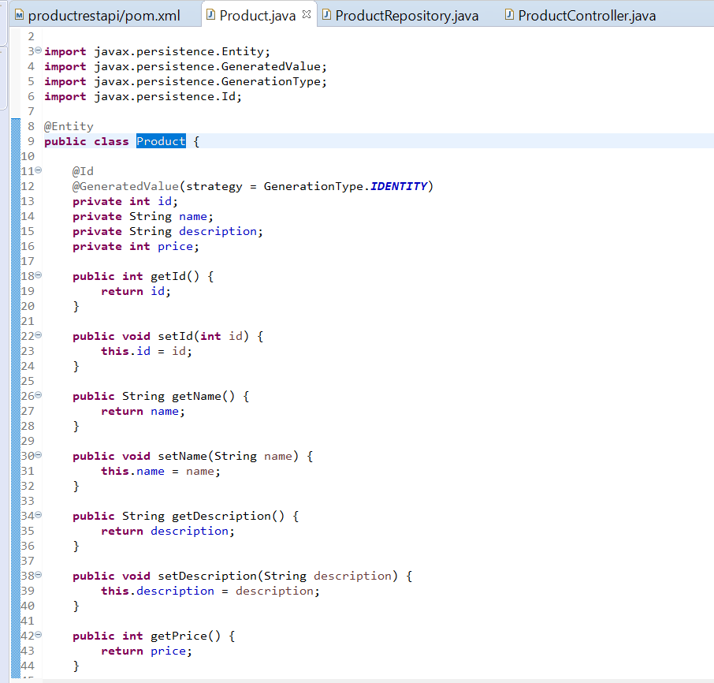

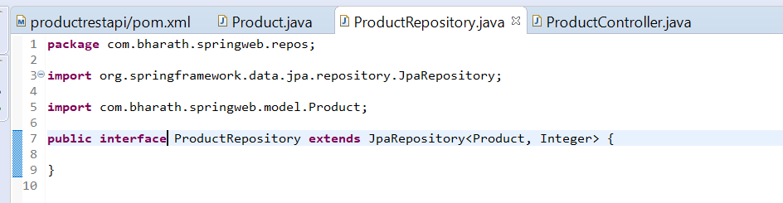

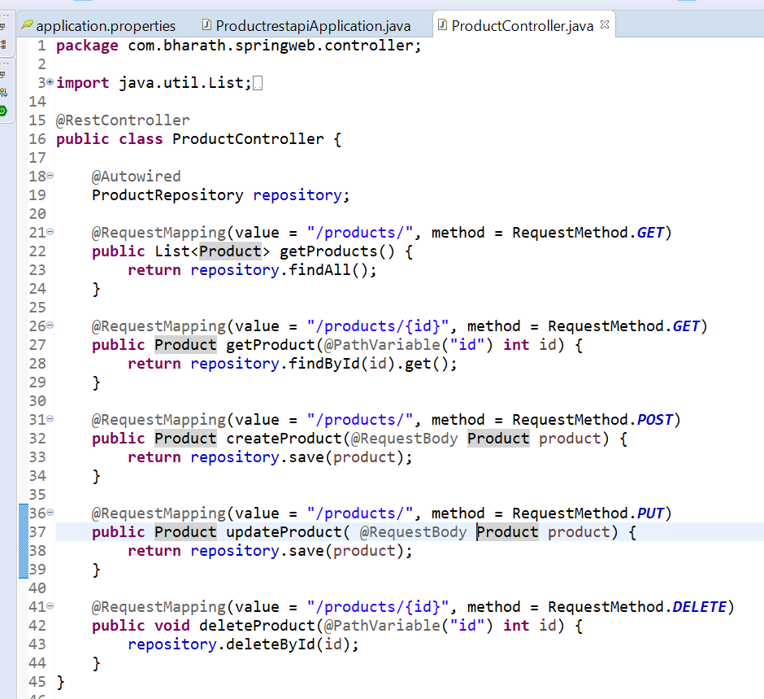

**Configure the data source**

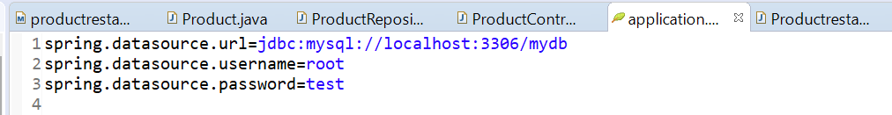

**Spring-boot-auto-configuration**

It will auto configure everything and at run time spring will look into it and enable all configuration

Simply put, the Spring Boot autoconfiguration represents **a way to automatically configure a Spring application based**

**on the dependencies that are present on the classpath**. This can make development faster and easier by

eliminating the need for defining certain beans that are included in the auto-configuration classes

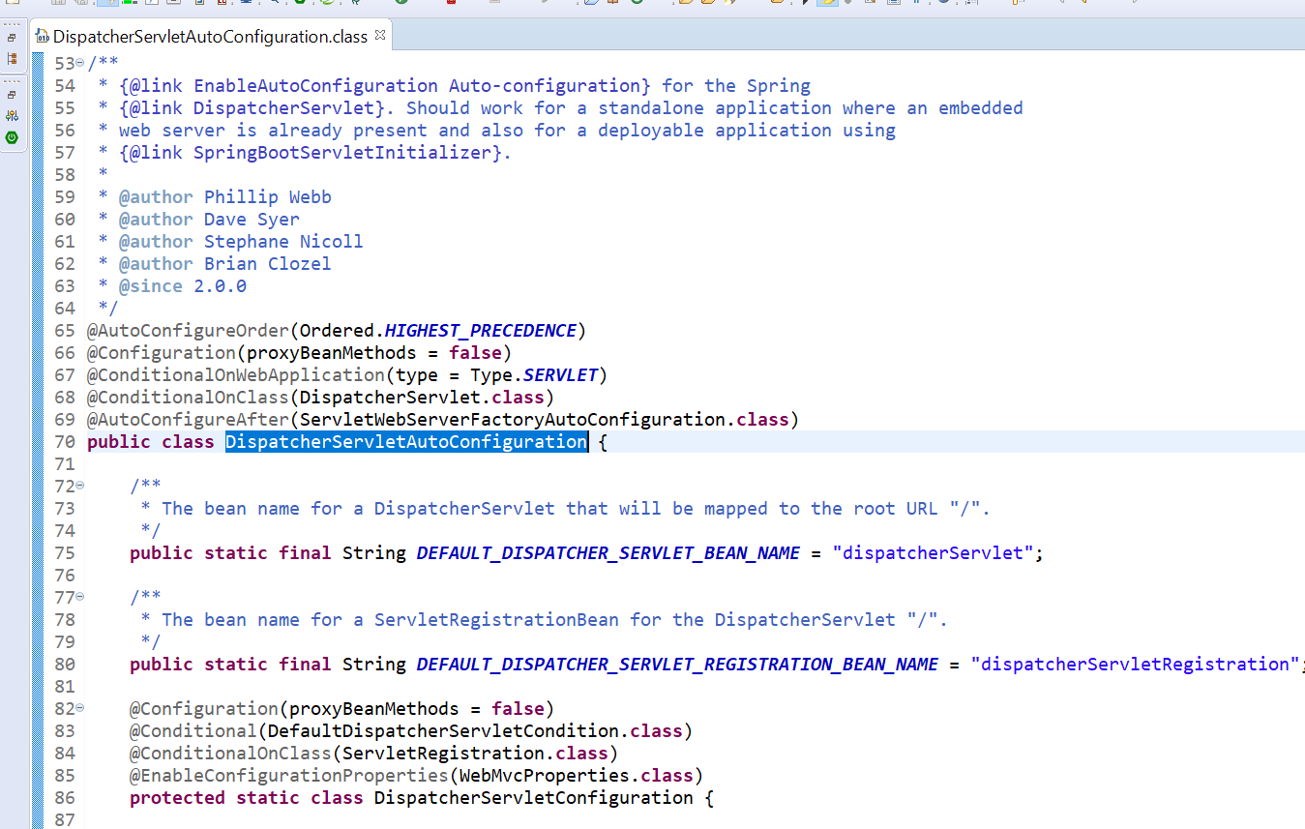

Spring boot will do this for us

**Note**

**Jackson :-** will do serialization and deserialization of json object

**ContextPath**

By default spring boot will not add any contextpath -----localhost:8080/**products/**

**Adding context path:--**

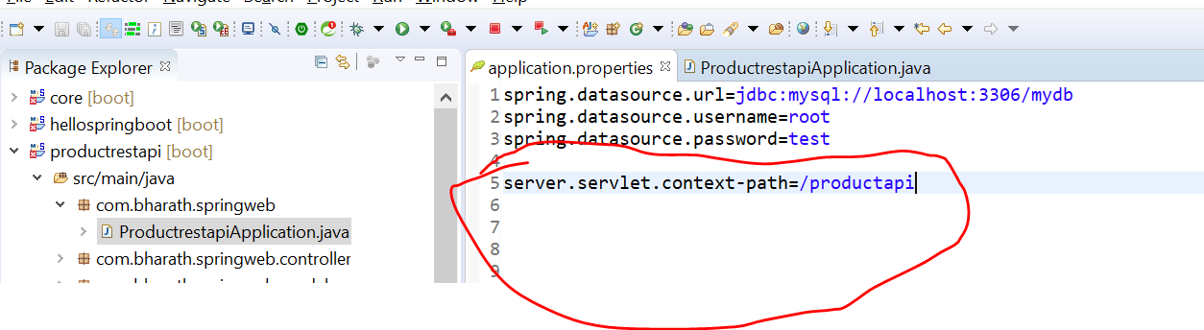

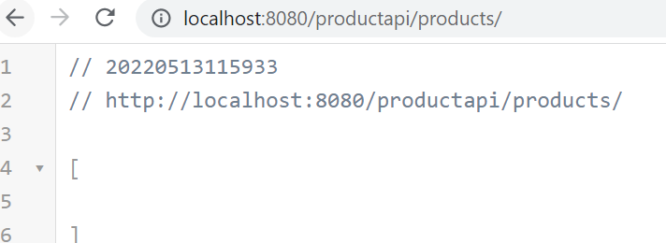

**// output**

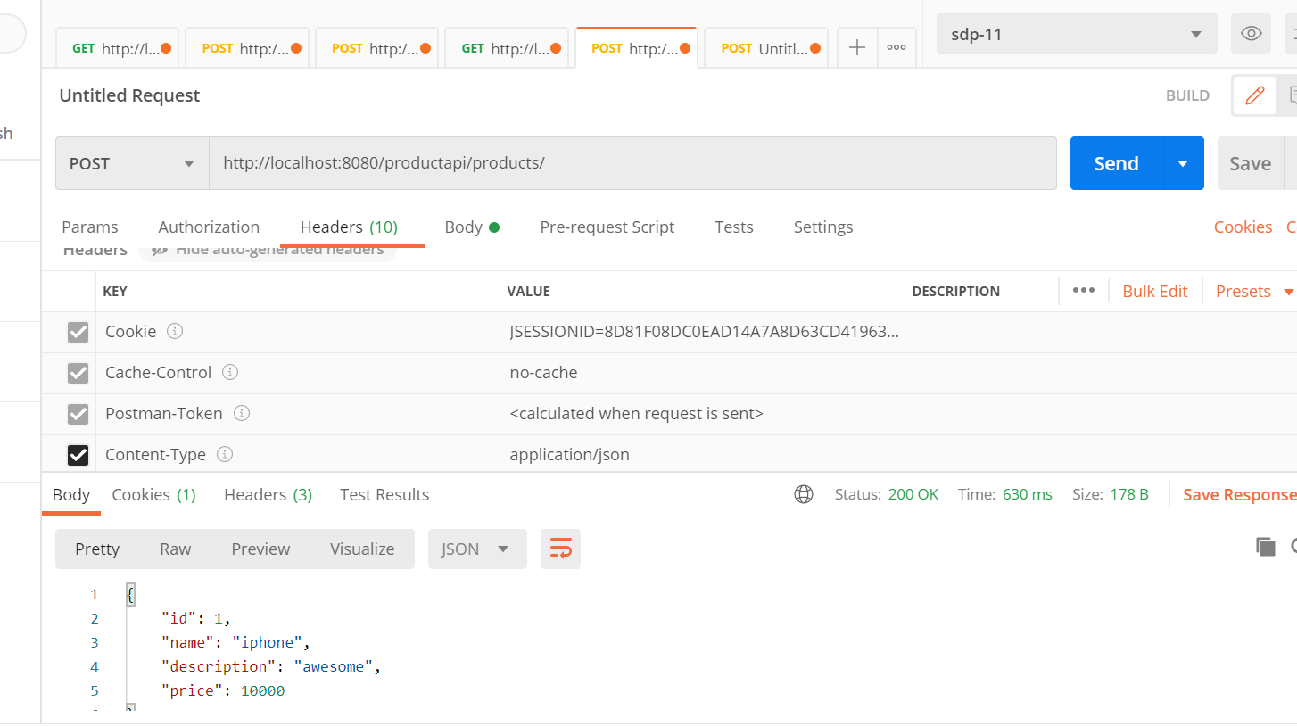

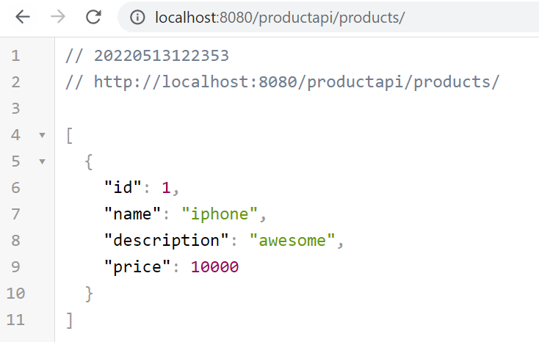

**Retrieve a single product:-**

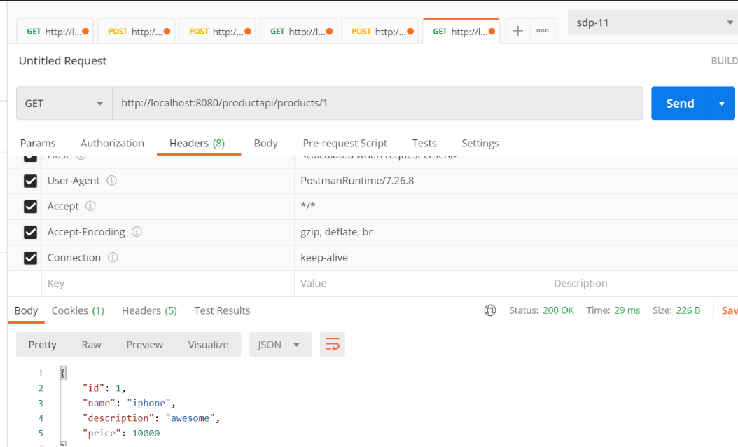

**Update :**  in case of update we need to send a id

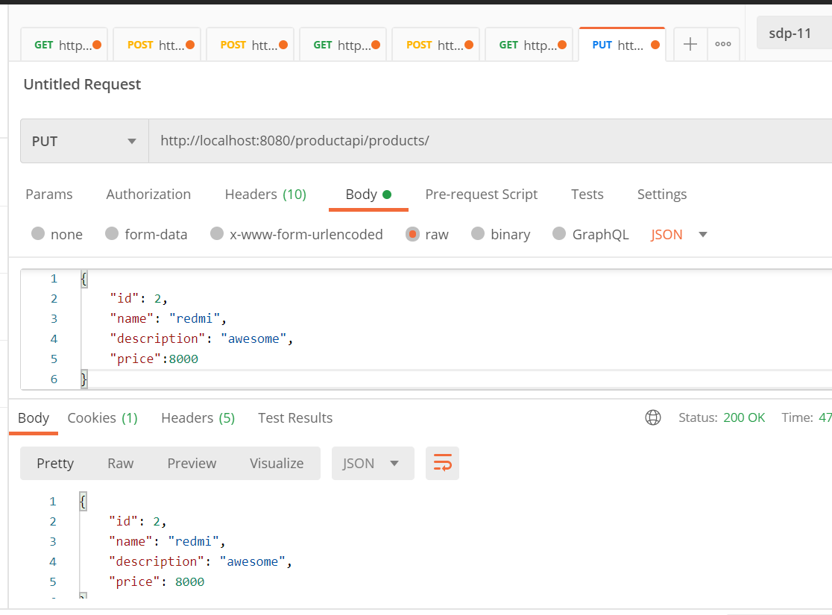

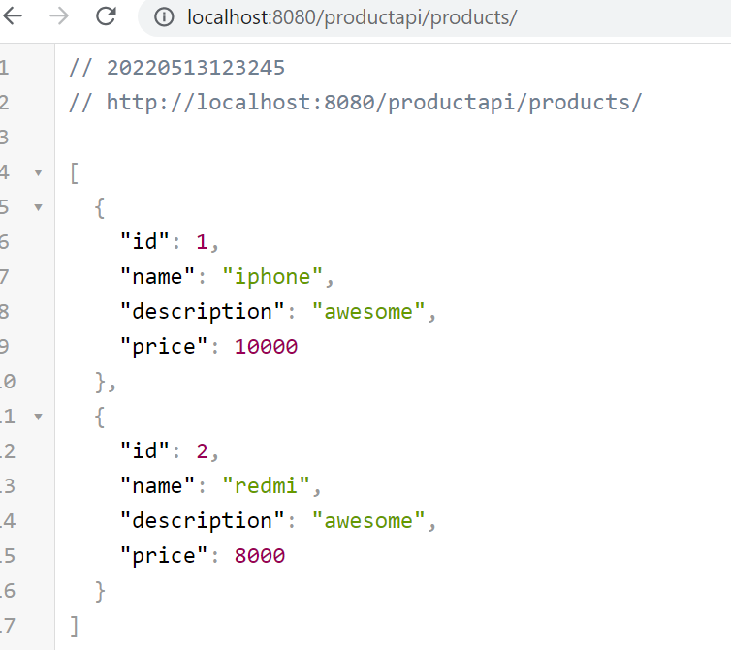

**Changing the embedded server**

**By default spring boot uses embedded server---tomcat**

**First step**

Exclude tomcat dependency from web dependency

**Second step :-**

include other dependency

Consume a rest service using RestTemplate

Get ---getForObject------------

expect a url and type of java object expecting back. It will hit a url and get a json response

And it will convert the response into a java object and hands it to over application

Post --- postForObject

**Create java restful client using RestTemplate**

Rest Template is used **to create applications that consume RESTful Web Services**. You can use the exchange() method to consume the web services for all HTTP methods

**Requirement :-** Retrieve a single product using RestTemplate

**Note :--**

when json come back , response will automatically converted or deserialized into product object

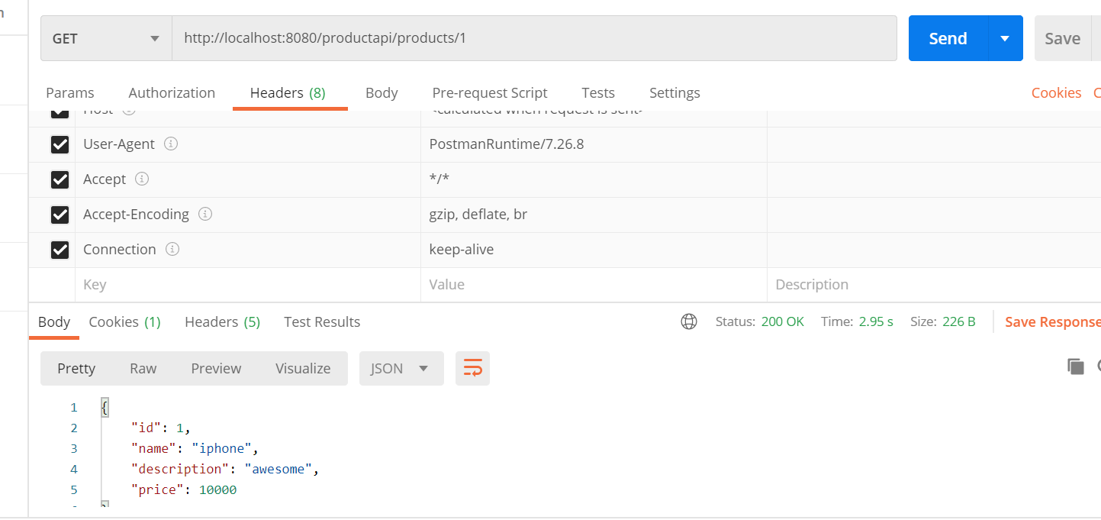

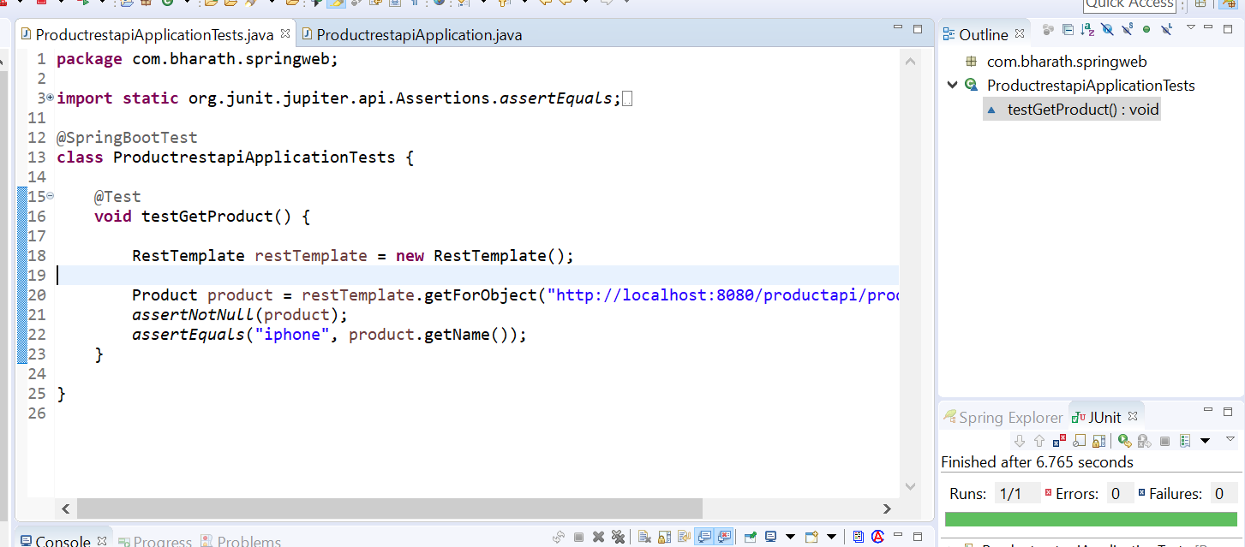

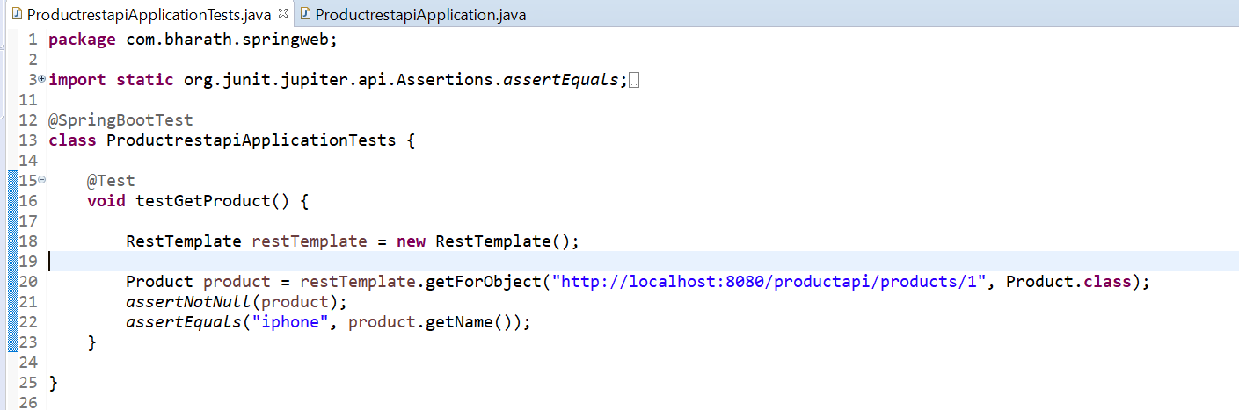

**Http post using RestTemplate**

**Requirement :---** how to create a product using RestTemplate

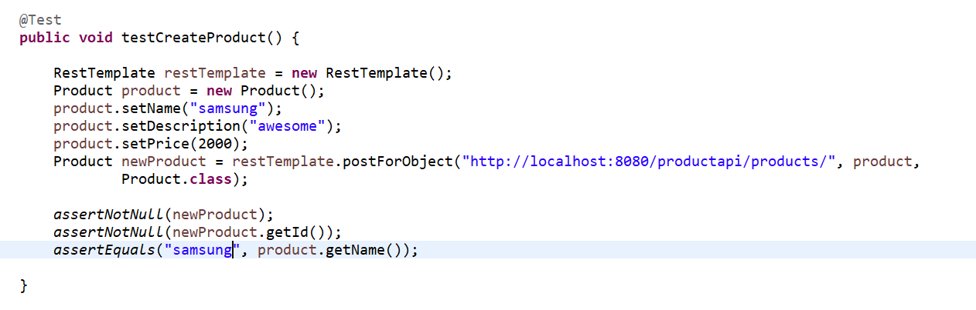

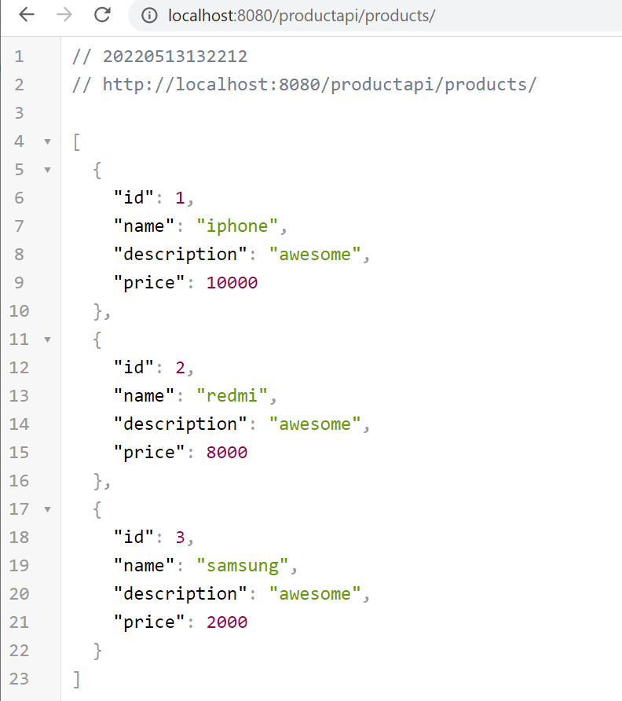

**Http put using RestTemplate**

**Requirement :-** update a product

Initially

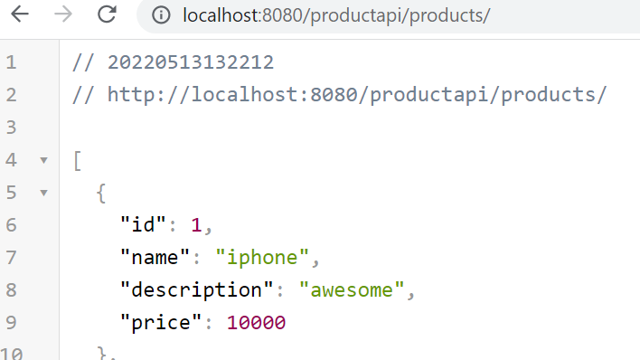

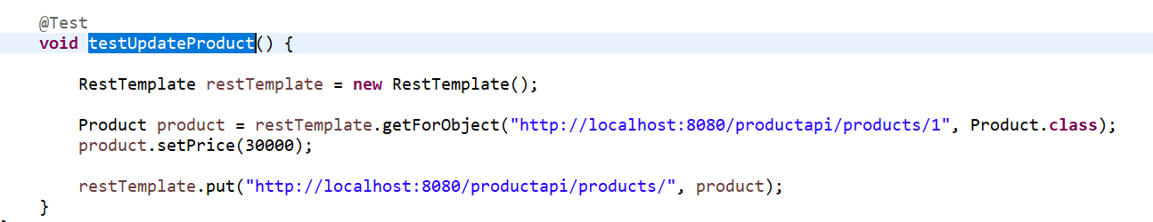

Output

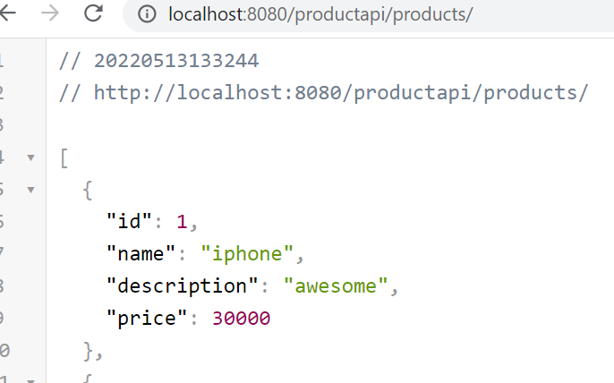

Profiles

Spring boot profiles like configuration(db,rest url, queues and topics) could be different across dev,QA,staging

And production that is where profiles comes into pictures allow us to use different configuration across different

Environment

**Note**

We need to activate the profile when we run the application

**Extracted out url from restTemplate**

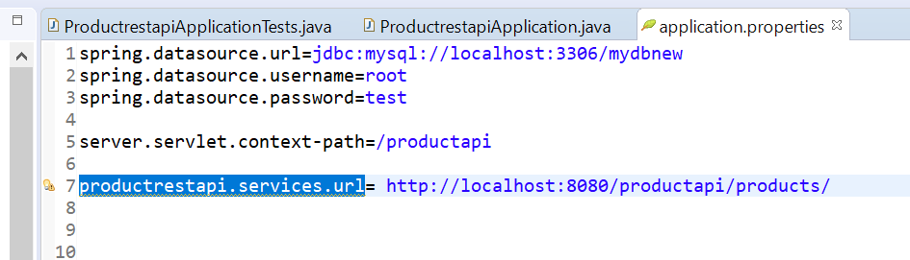

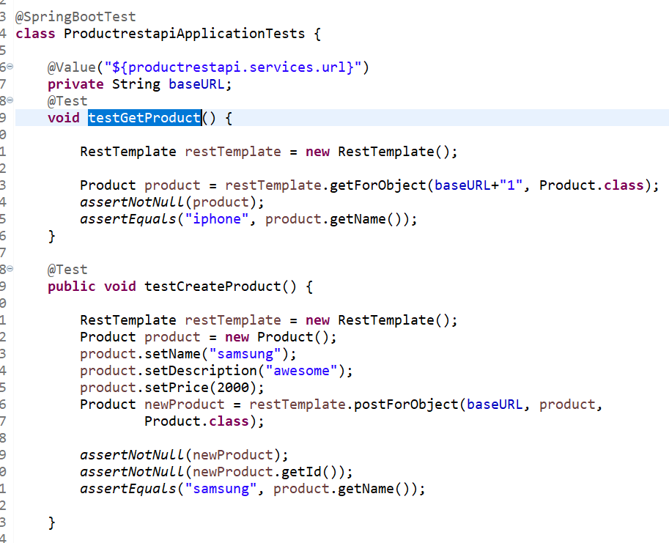

**Create and activate a profile**

**Note :-**

above url configure in application.properties will be different across dev, test and staging env

**Step 1 :-** To use spring boot profile we need to create multiple configuration file

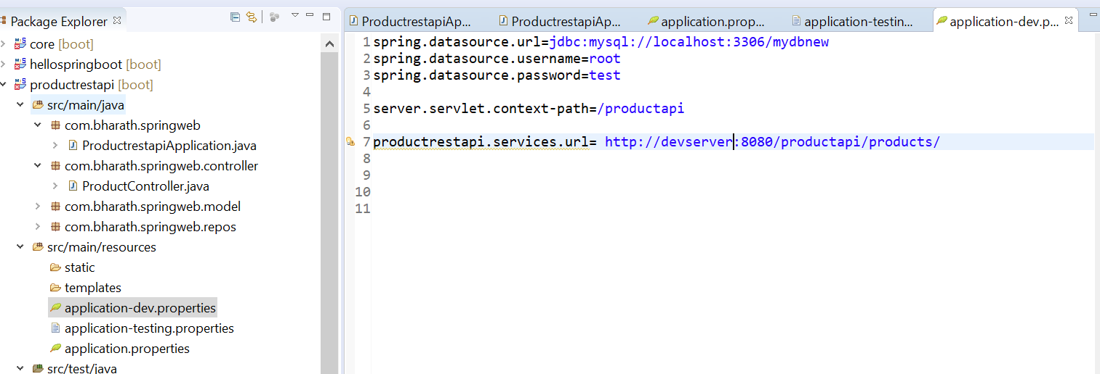

**Step 2:-** to activate a particular profile

If I want to use dev profile

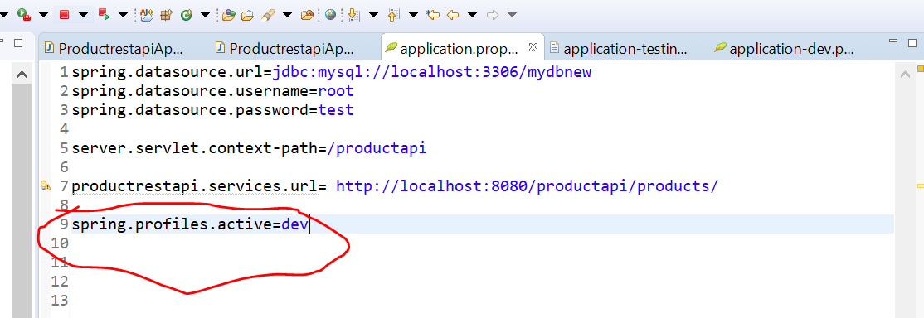

Test will get failed because dev server not exists

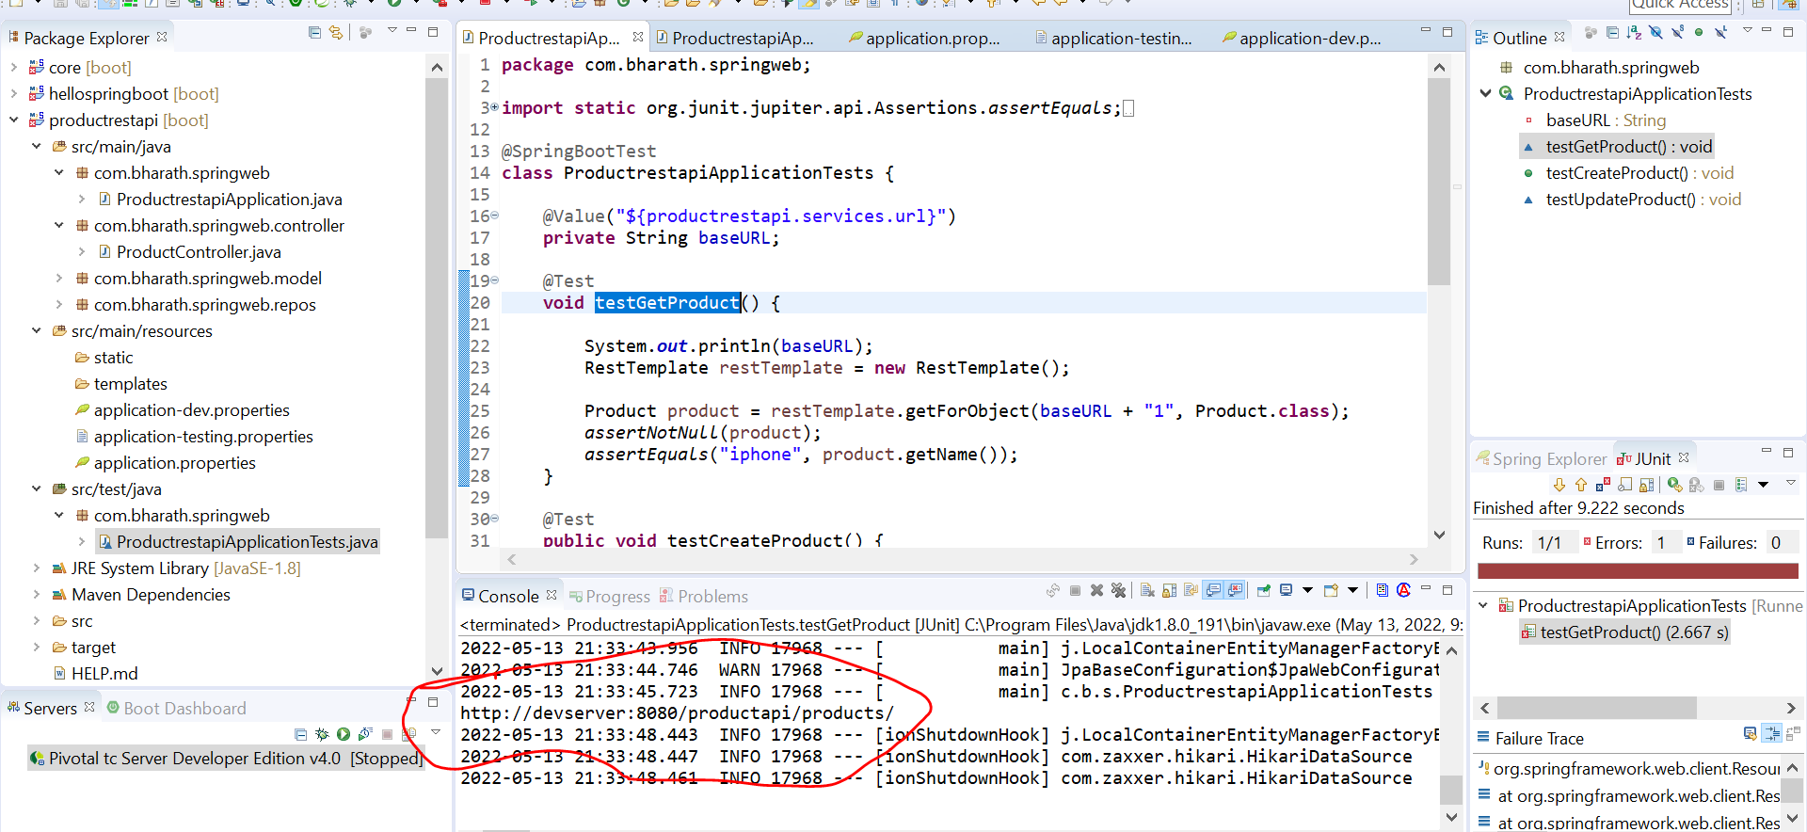

Note :-

this is not a good way of changing profile manually since if testing team doing test they will not go to code

And change it and there is a way to change it dynamically

Logging

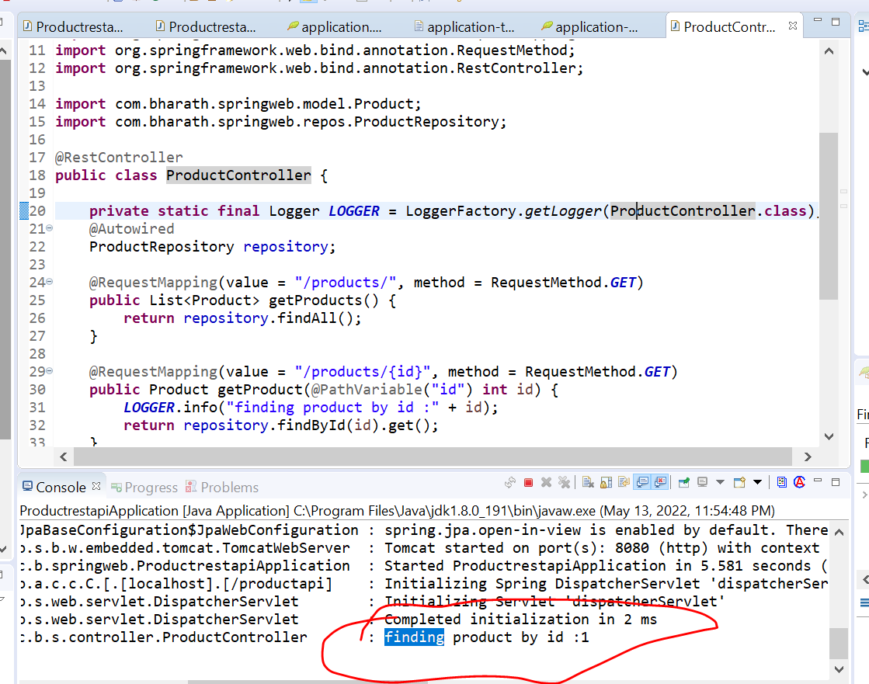

Log to file

Note :--

By default all logs go to console.

by using this will get all console log in file

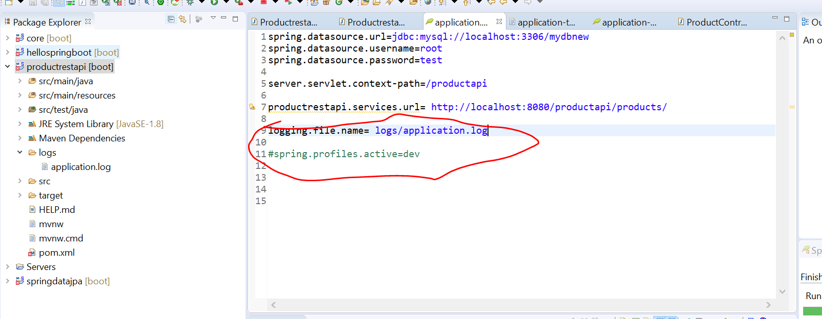

Change log level

Logging.level.root=error

We can do logging at application level also

Logging.level.com.bharath.springweb.controller.ProductController = error

Health Check and metrics

**Health check :**--- whether our application is up or down. If down then why it is down

**Application configuration** :---- we should have complete access of configuration that application is using

At runtime

**Application metrics :--** the exact health of application what kind of memory is using

**Key application events :---** application receiving or sending a message to a queue or it saving it in a d/b

Note:--

Spring boot provides all these metrics free to us

For this we need to enable spring boot actuators for our project

Once we configure it spring boot exposes several rest points

**By default health and info information exposed out**

**Enabling health checks**

**Need to add :-** spring-boot-starter-actuator to our project

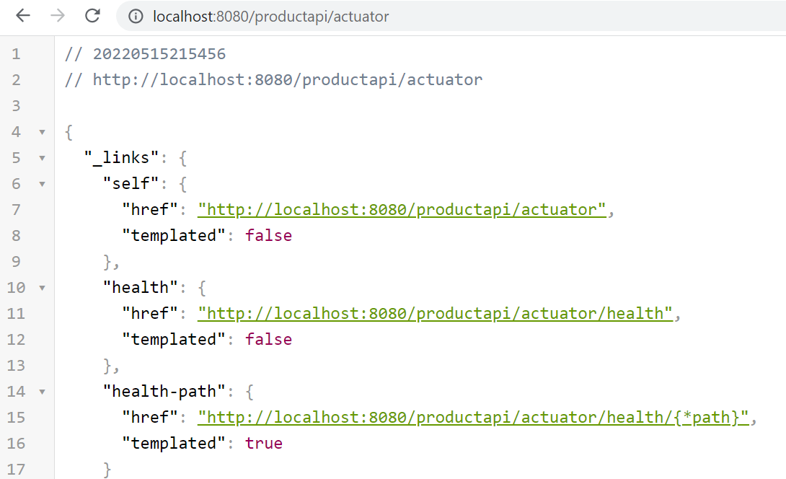

**Expose Health details**

**Note:-**

Spring boot provides various properties for each of the end points that exposes out under actuator

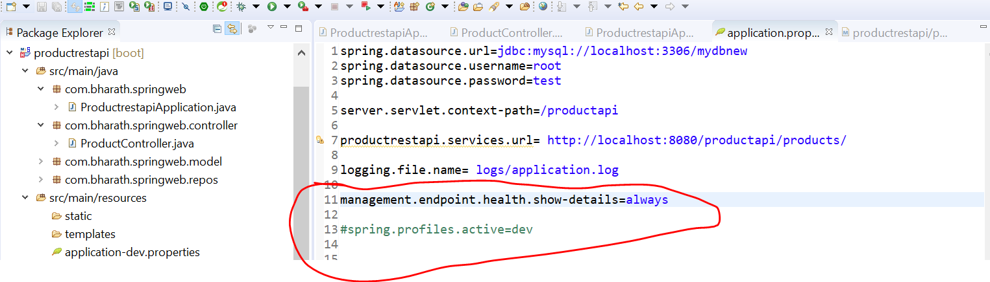

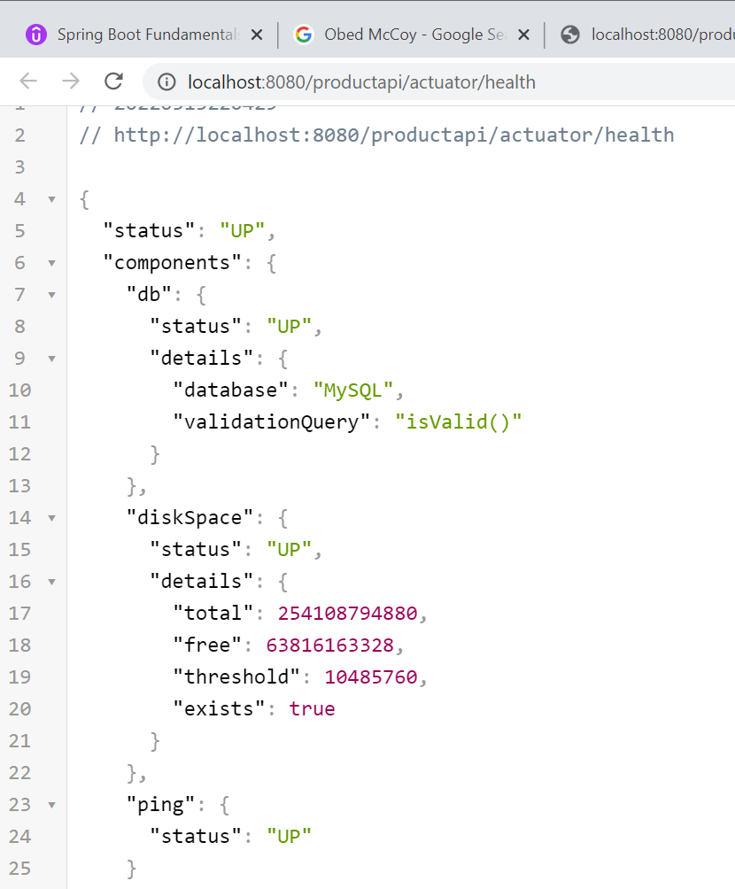

**Add Build info**

Want to add build info information to the project like version etc

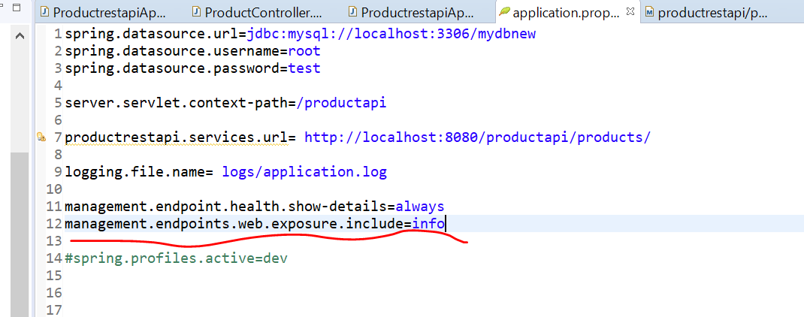

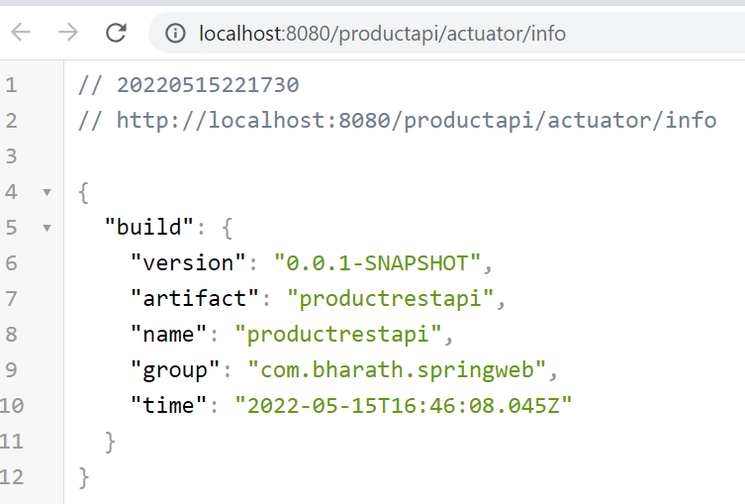

**Expose Other endpoints**

**To expose all other endpoints we need to include in application.properties**

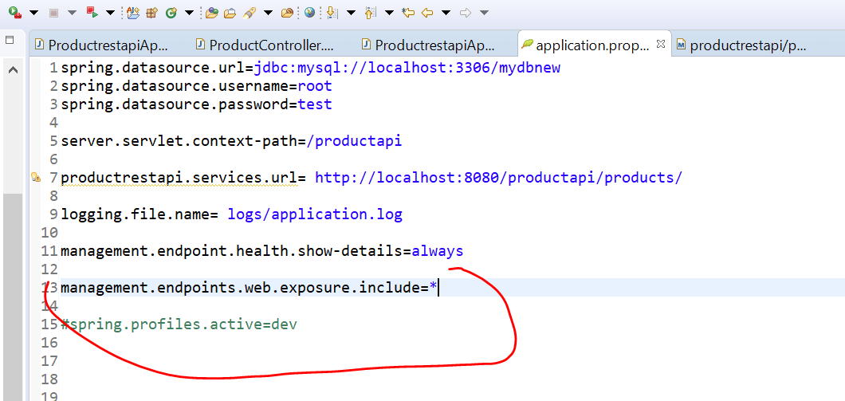

Star represent include all the endpoints

**This time we are able to see many other metrics**

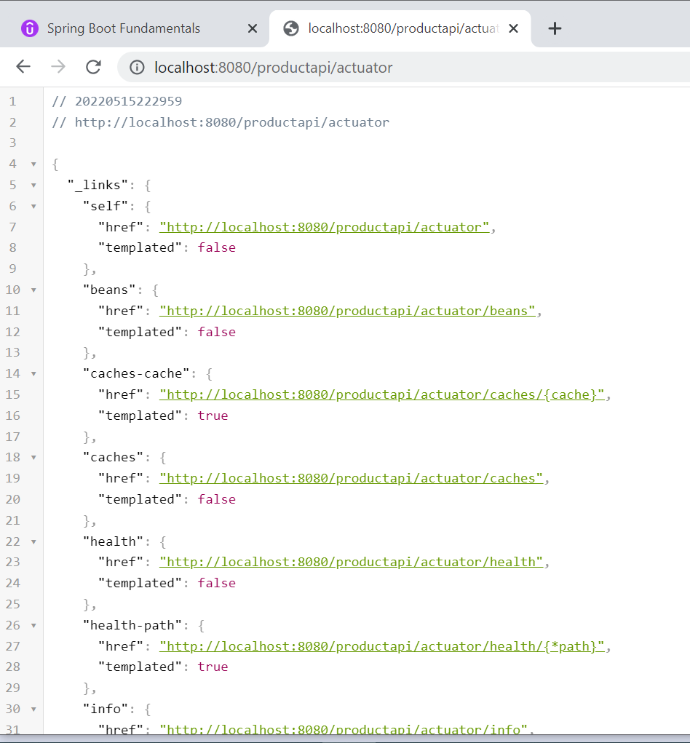

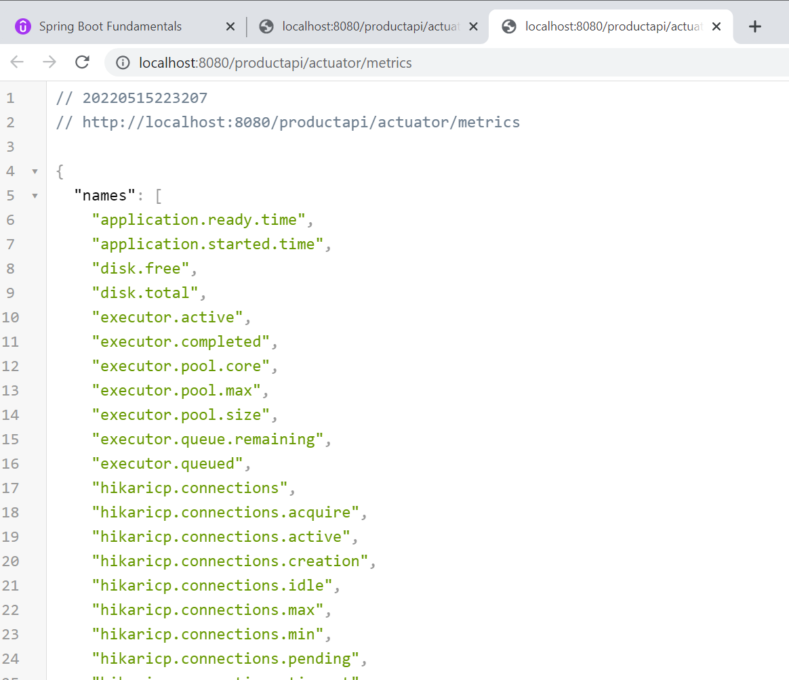

Note:--- all the name but no value. We can copy the name and paste in url and hot we will get value

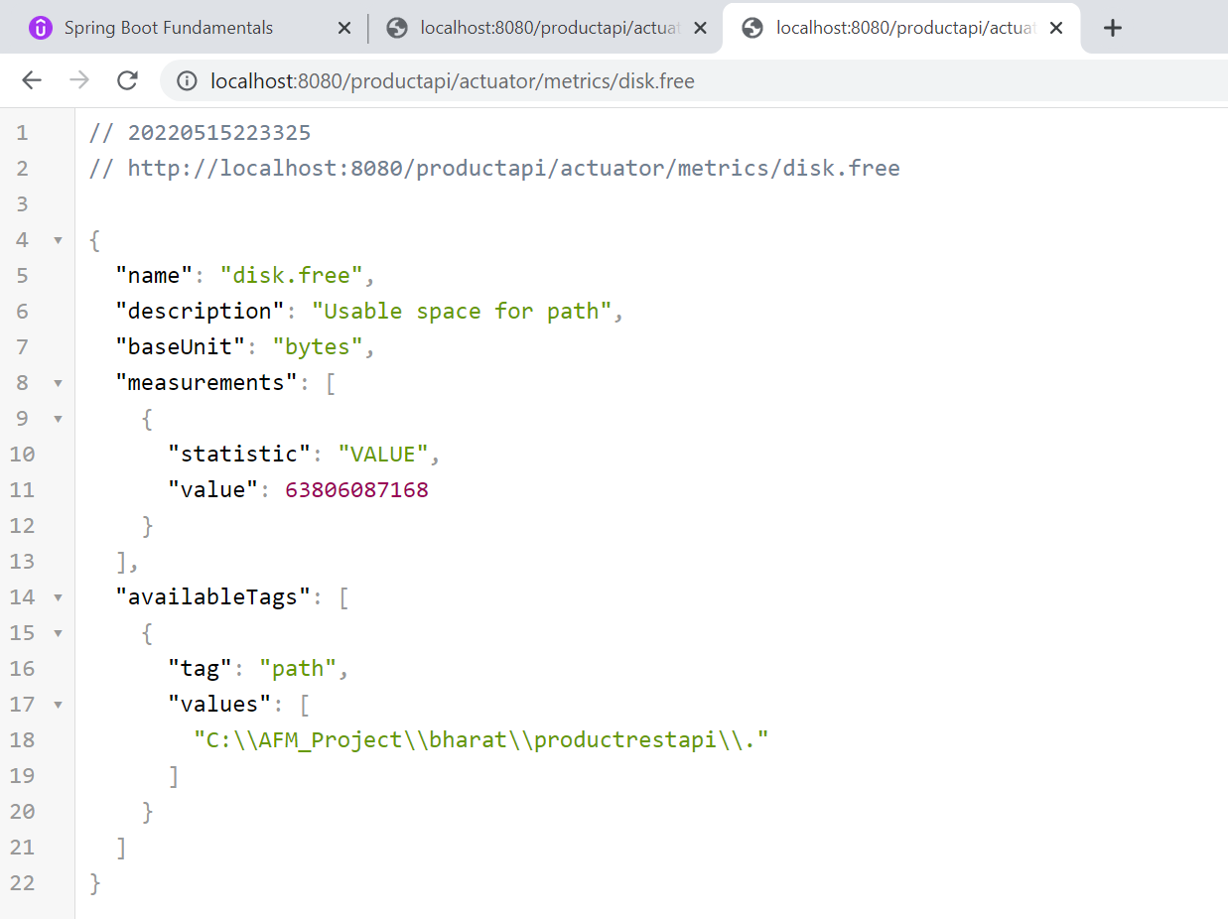

**Note:**

Metrics are very useful when we are doing performance tuning information

**Expose other endpoints**

**Note**

All health information is coming from spring but if we want to customize it

We need to implement certain interface for this :---custom health indicator

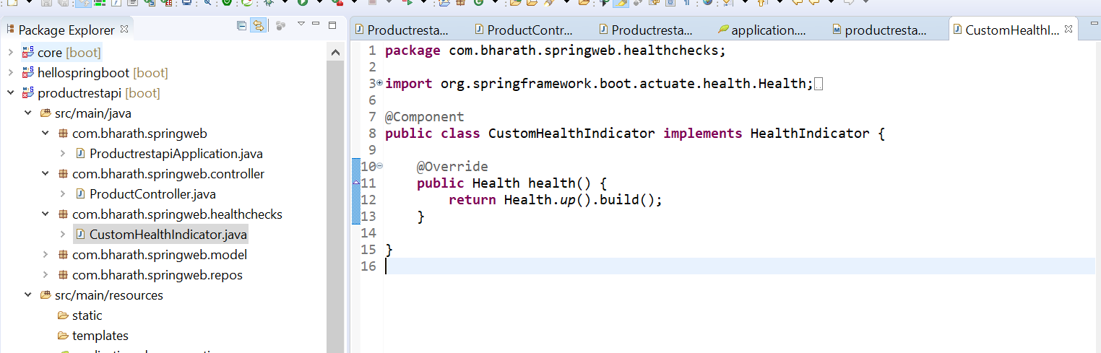

**Custom info added**

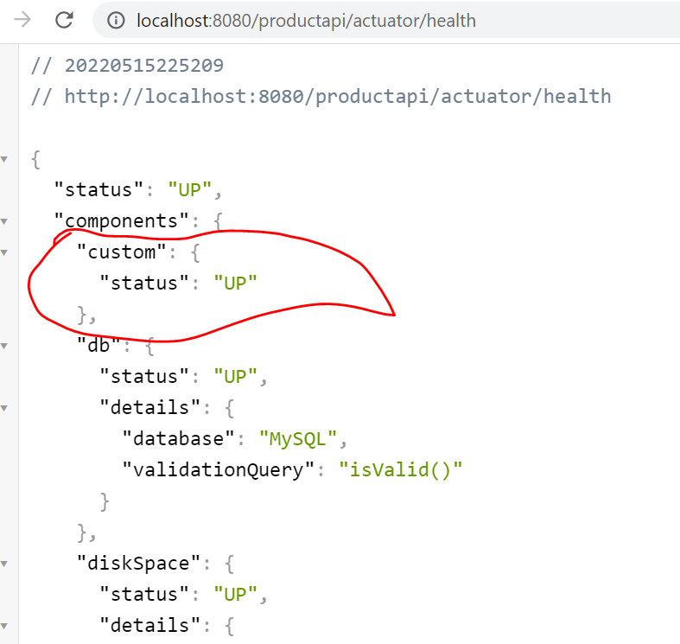

**Spring Security**

**Enabled:----** need to add

**Spring-boot-starter-security**

**Note**

Automatically basic authentication will be enabled

By default :--- username --user

Password :--- will be there in console

**Thymeleaf**

Instead of using jsp will use template

Thymeleaf will create .html pages which will have both static and dynamic code

**Thymeleaf in action**

Create the project

Create the controller

Create the template

**Thymeleaf** is a modern server-side Java template engine for both web and standalone environments.

*From <*[*https://www.thymeleaf.org/*](https://www.thymeleaf.org/)*>*

Thymeleaf is **a Java library**. It is an XML/XHTML/HTML5 template engine that is able to apply a set of transformations to template files in order to display data and/or text produced by your applications

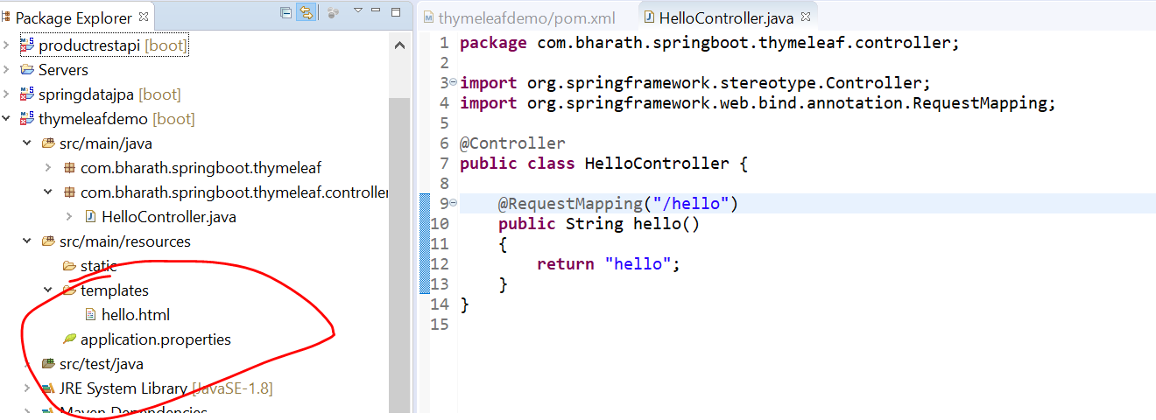

**Note:**

This controller forward the request to templates

Template method return hello and template engine look under template by name hello.html

And it will send the html to the web browser

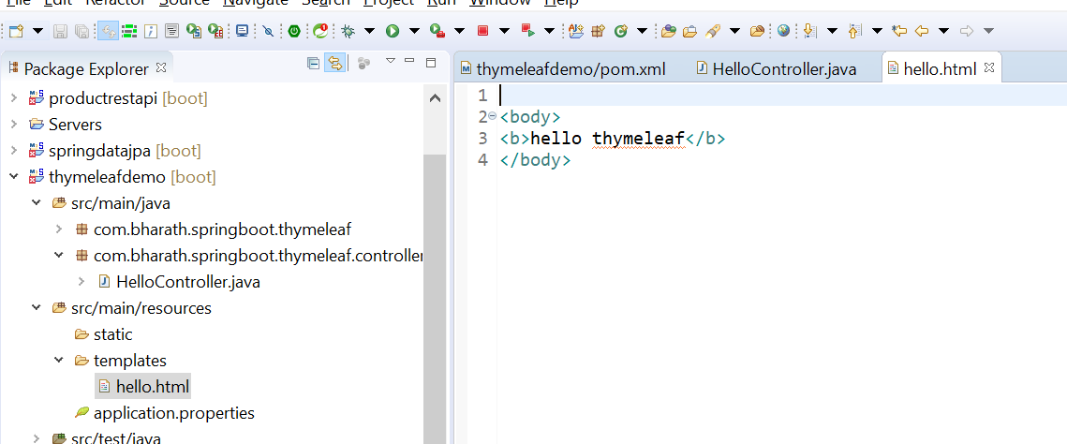

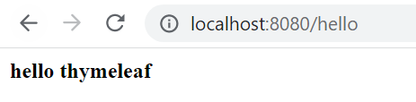

**sending data to template**

Dynamic data passing

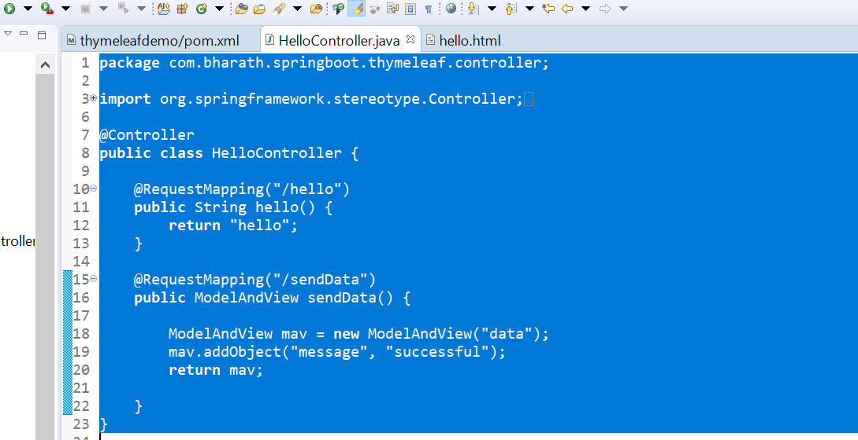

Note:--

In this template we are passing modelAndView object

We can render the message inside data.html

**Create a template**

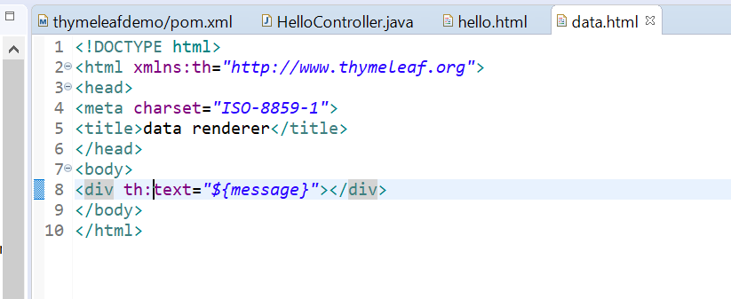

**Note:**

To use thymeleaf syntax we need to include name space of thymeleaf

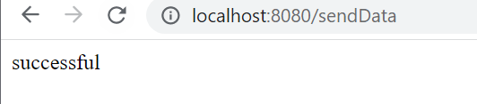

**Disable cache**

**Note:**

When thymeleaf render html entire file come into cache

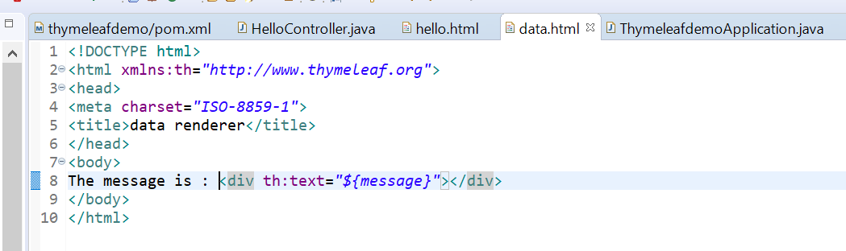

We change the message but still it will not reflect in browser although it is static message

To reflect this we need to turn off thymeleaf caching

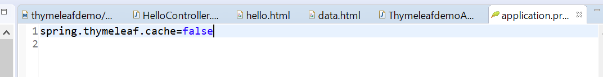

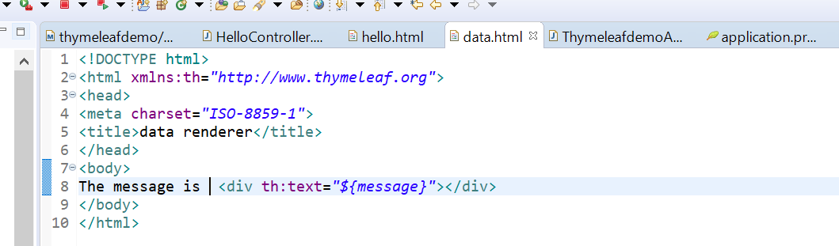

**Sending Object Data**

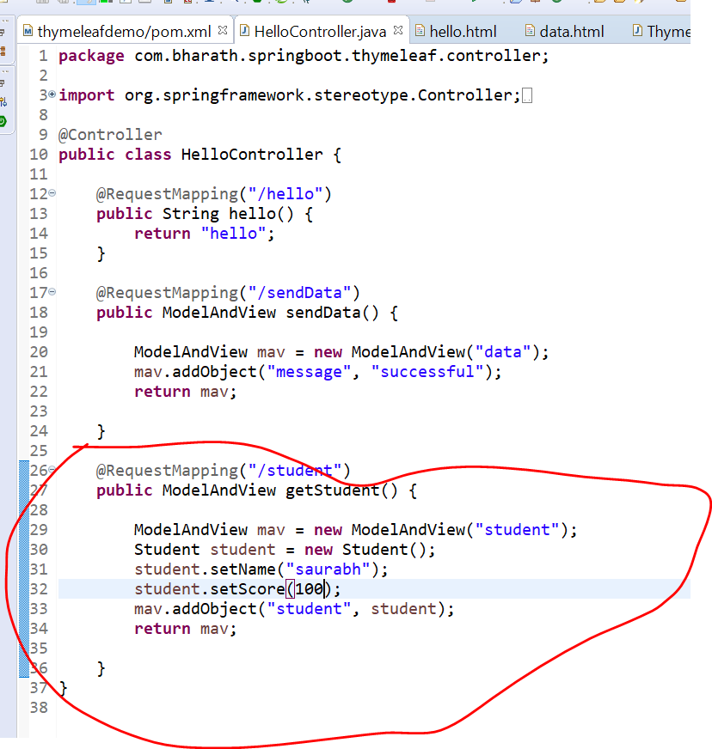

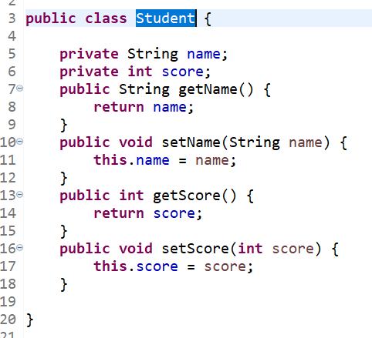

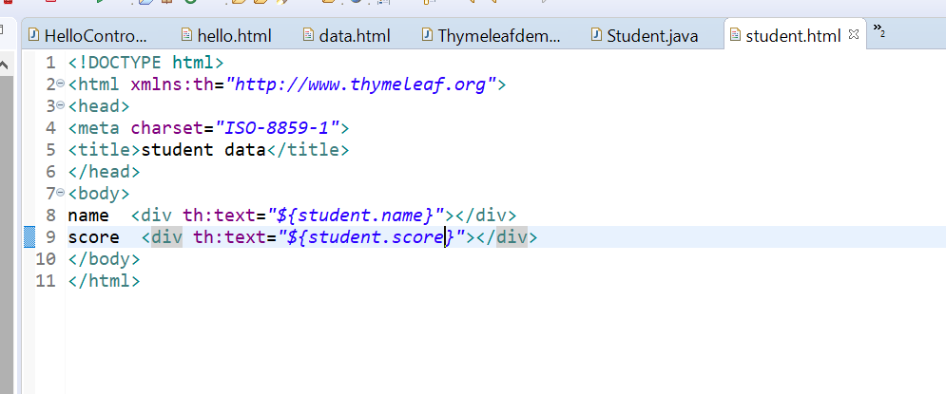

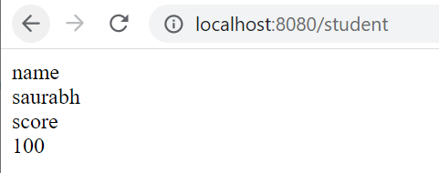

**Rendering Multiple Records**

**Loop list of object using thymeleaf**

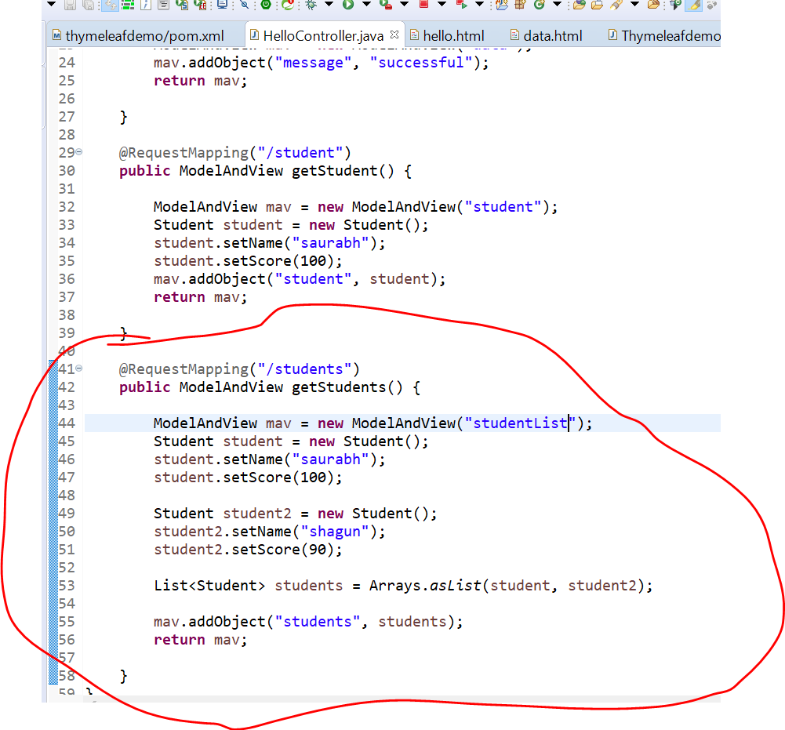

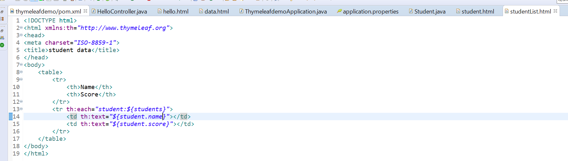

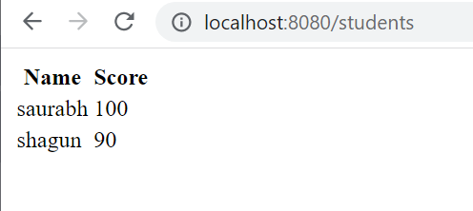

**Create a html form**

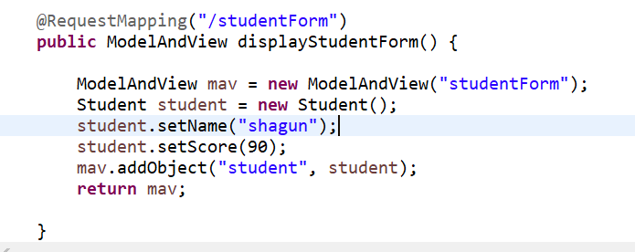

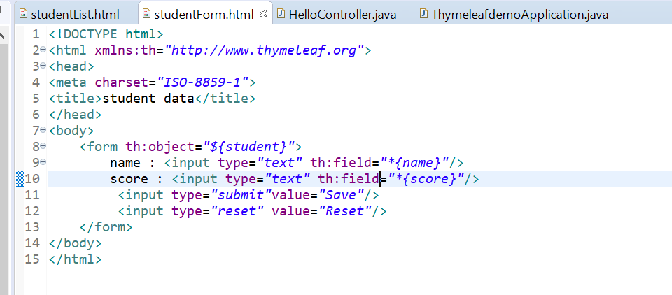

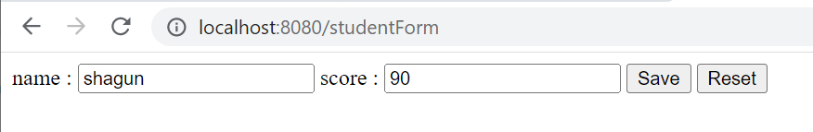

**Process form data**

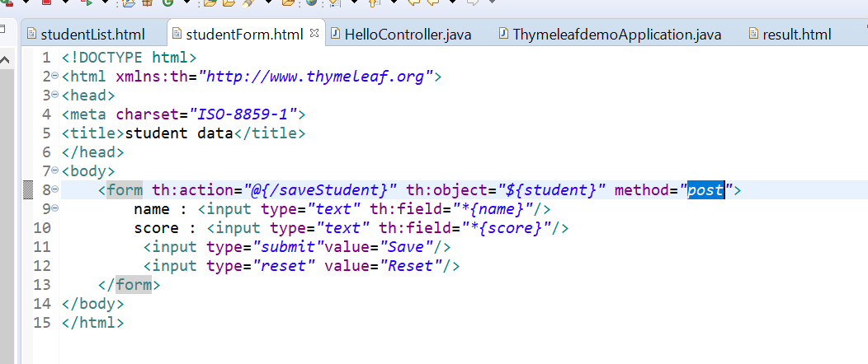

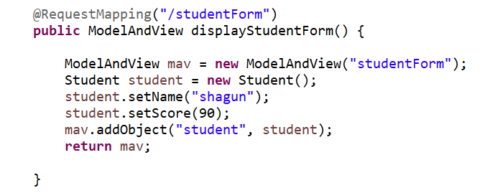

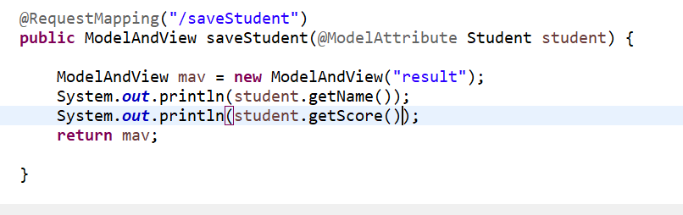

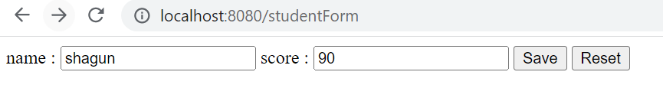

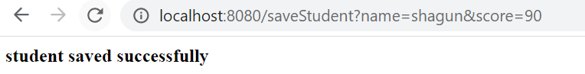

**Database Caching**

**Storing the data of an object in temporary location**

**Note:-**

Cache will be refresh every time object is updated

When client read the same exact data the orm tools need not need to go D/b.

It will read it from caching

It improves the performance of our application

**Steps to enable caching**

Spring uses hazlecast, eh cache. Here will use hazlecast

Hazlecast will stored object and maintain it

**Steps:**

**Add dependencies**  spring boot and hazlecast

**Create cache configuration** config

**Enable and use caching** @EnableCaching

**Evict cache** when should be the cache will get clean because overtime the cache size will get increased and application

Can get crashed

For evict cache hazlecast uses some policy like

**LRU--** least recently used means which object use less will get removed

From cache after some time

**LFU,NONE,Random**

**Add Maven dependencies**

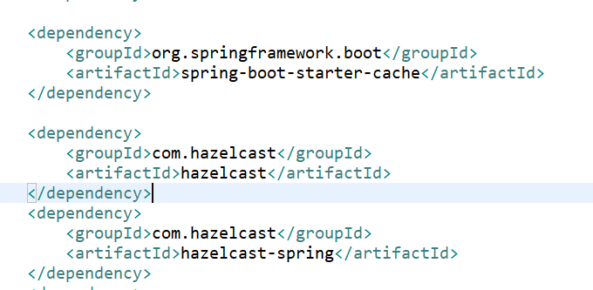

**These three dependency are required**

First one :---to enable cache

Second:-- to support hazelcast jar

Third:---it will support into spring also

**Configuring caching**

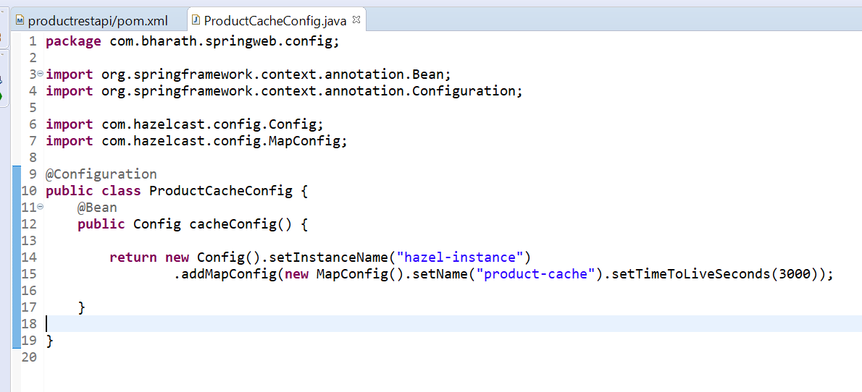

**Note:-**

We are returning a bean of type hazelcast config

**Enable and use caching**

**Step 1-**

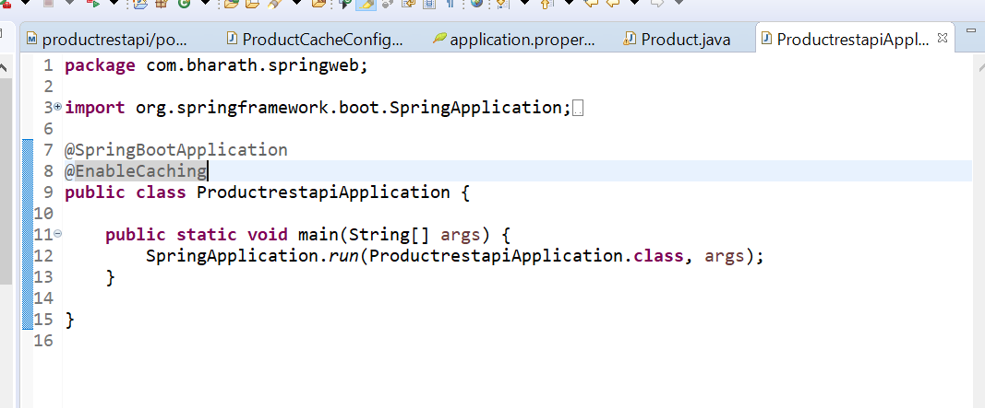

**Note:--**

**We need to implement Serializable for caching to work**

**Step -2**

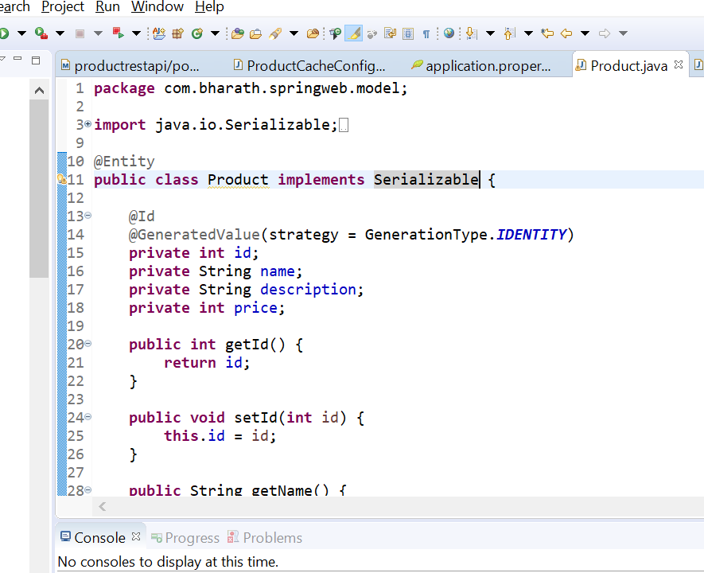

**Note:--** internally hazlecast serialize our models

**Step 3-**

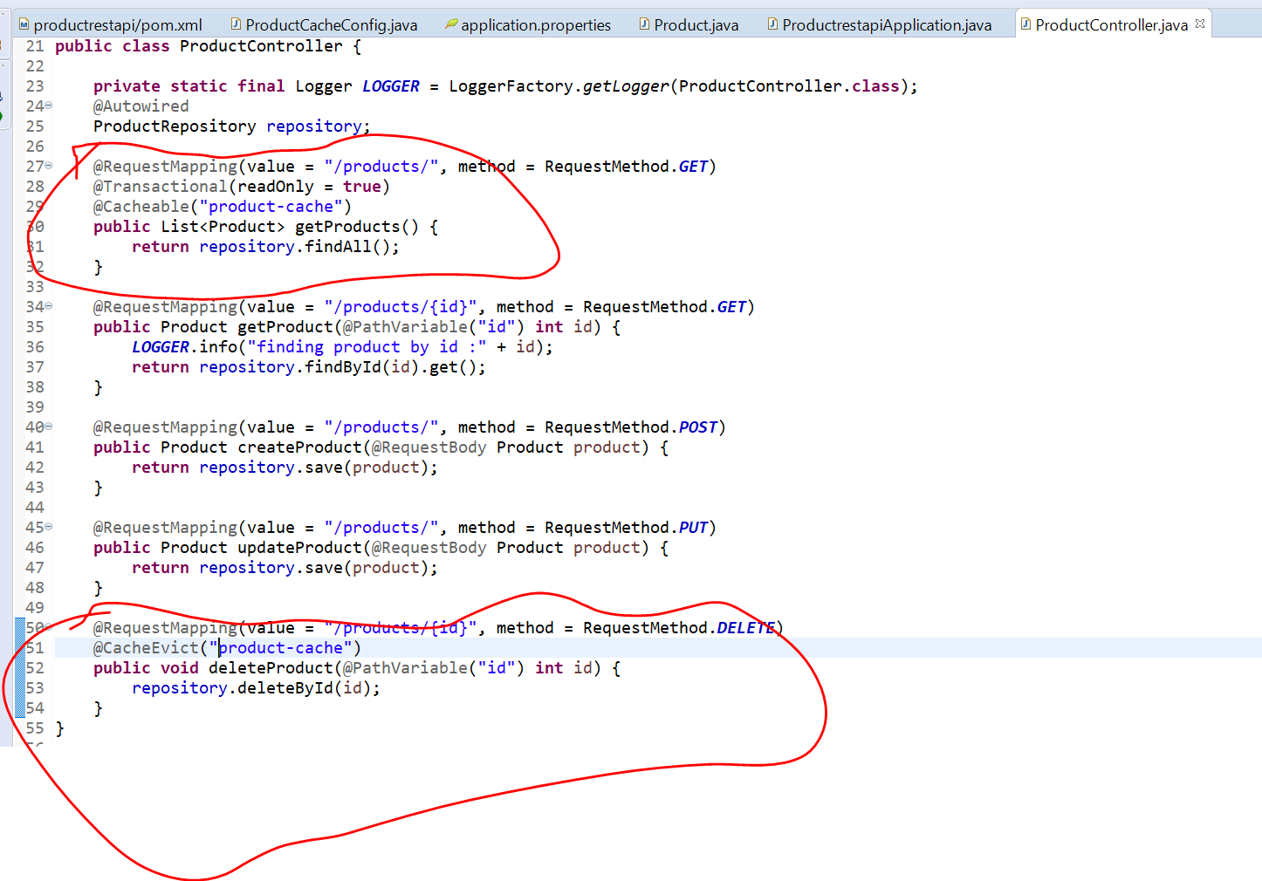

**@Cacheable(provide cache name)**

Now test the application caching is enabled

Spring Batch

Note:

Job we create and each job comprised of multiple task

Task 1- copying data

Task 2 - transferring files

Task 3- generate reports

These job can be scheduled at a certain time

Step

ItemReader -----------read from d/b or message queue

ItemProcessor-----------apply some business login

ItemWriter----------------write to d/b or message queue

Job all these details are stored in d/b using jobRepository

**Job launcher:**--- is responsible for taking the job and executing it

Job:---multiple step:---multiple task---each step responsible for IR,IP,IW

**Batching API**

**A job** is made of one or more step

And to create a step we need to create IR,IP,IW

Job listener :---before job and after job

Batch config will have all job and step

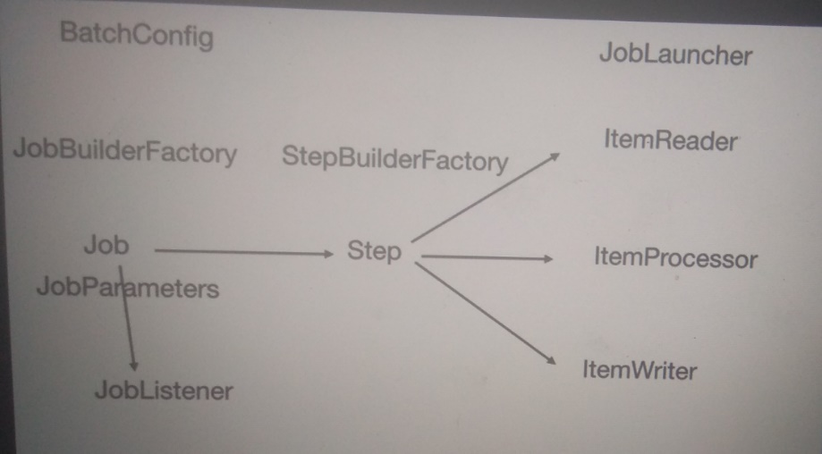

Once we have IR,IP,IW will use stepBuilderFactory to create a step to which we pass R,P,W once we step in place

Will use a JobBuilderFactry and pass a step to get a job and will configure all these in java based configuration file

And to launch this will use jobLauncher

**Create Project**

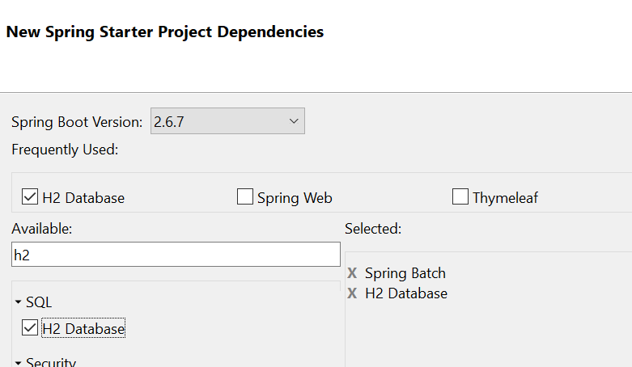

**Create Reader**

Responsible for reading data and return some data

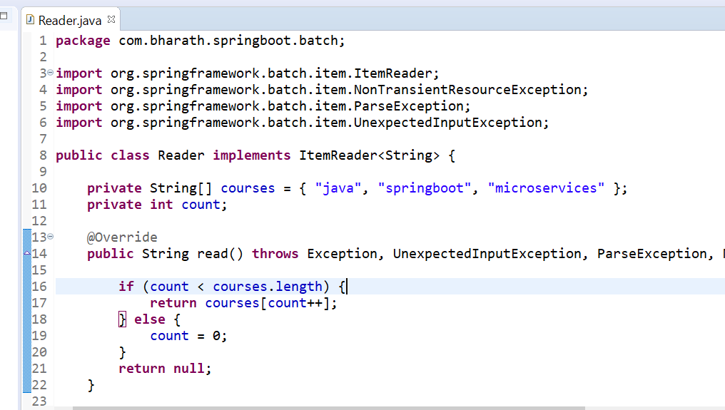

**Implement Processor Writer and listener**

**Processor**

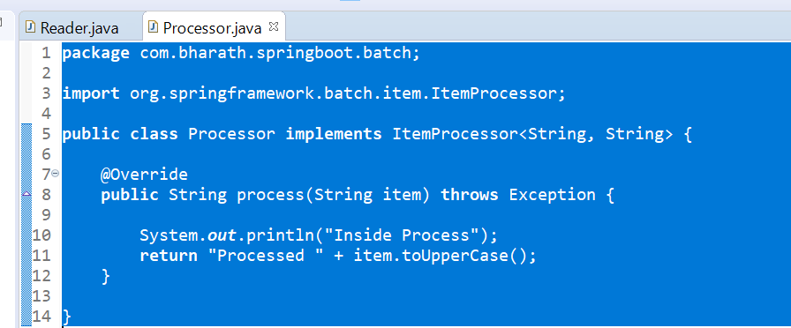

**Writer**

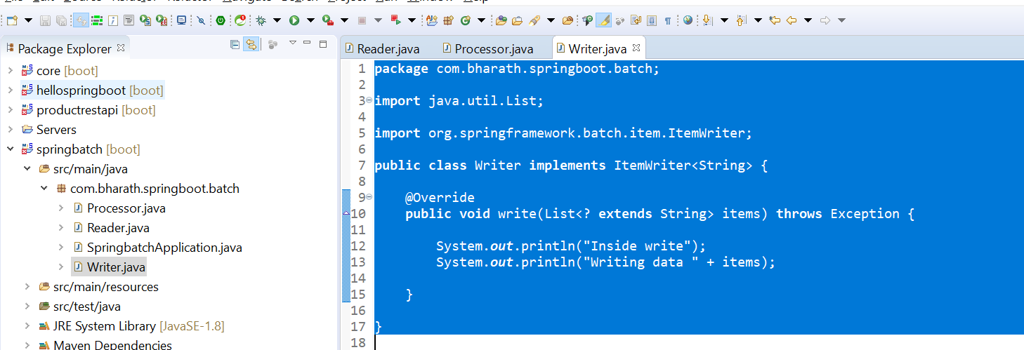

**Listener**

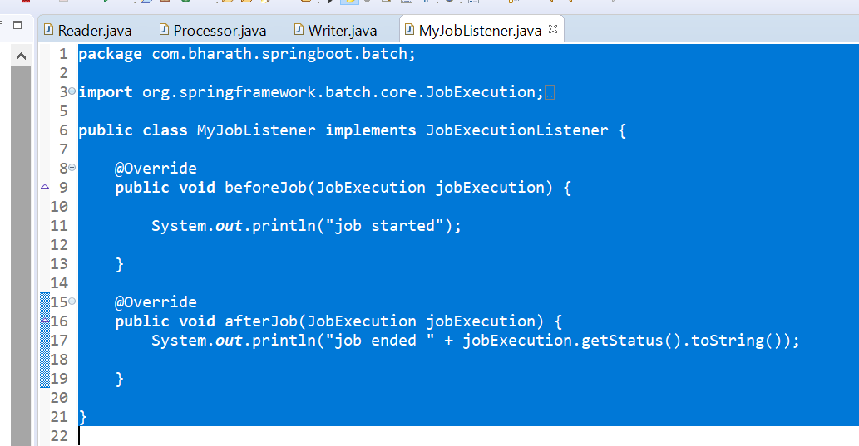

**Configure the beans**

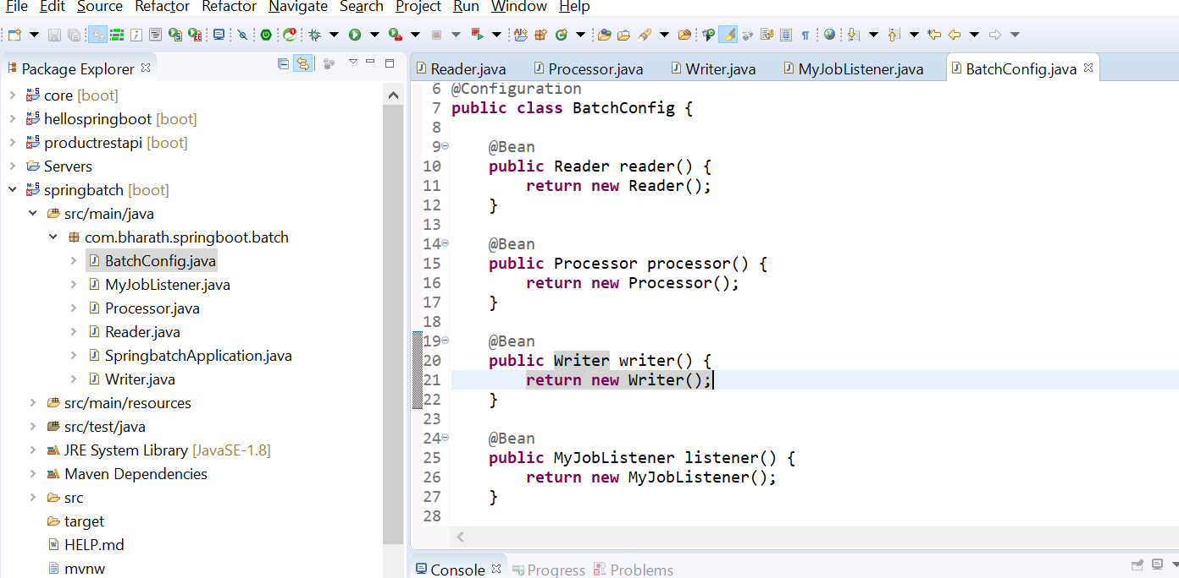

**configure the step**

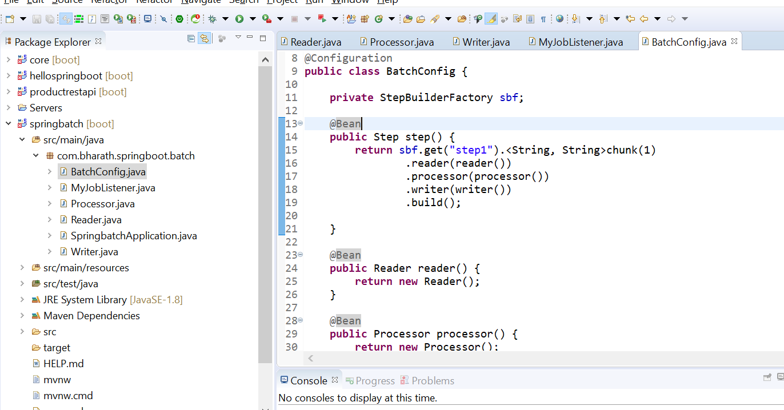

**Configure the jobs**

**Note:**

**Incrementor** will provide new id for each job

**RunidIncrementor ;** that will automatically increment job id

Start will take step as argument

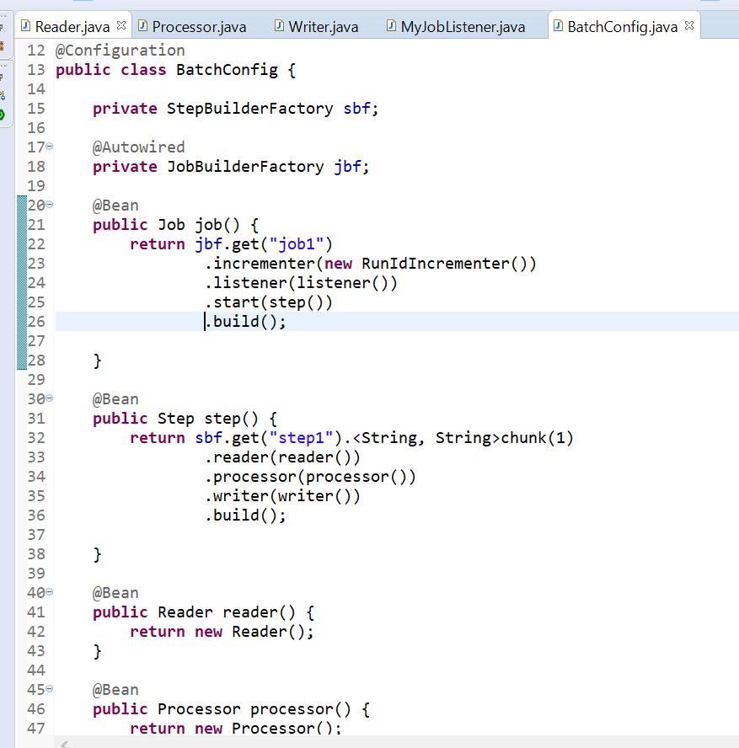

.build :--- responsible for creating a job using all these information

**Write a test**

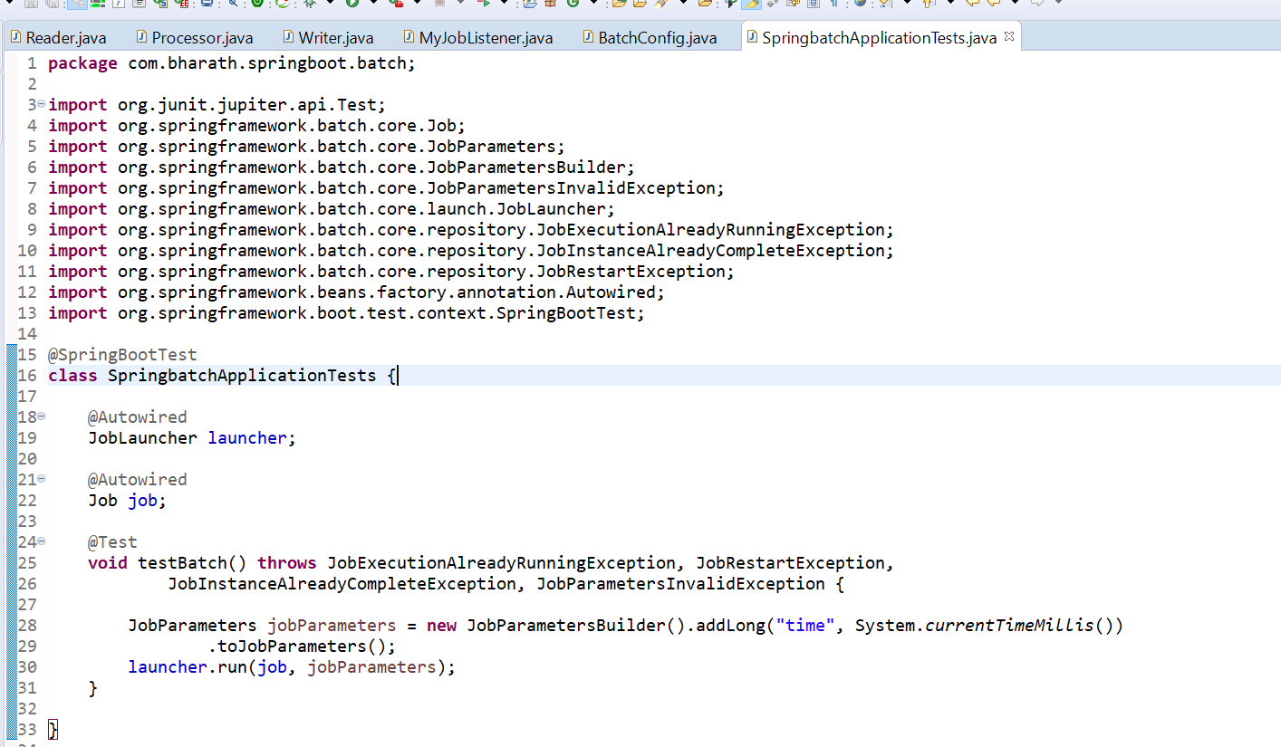

**Batching in action**

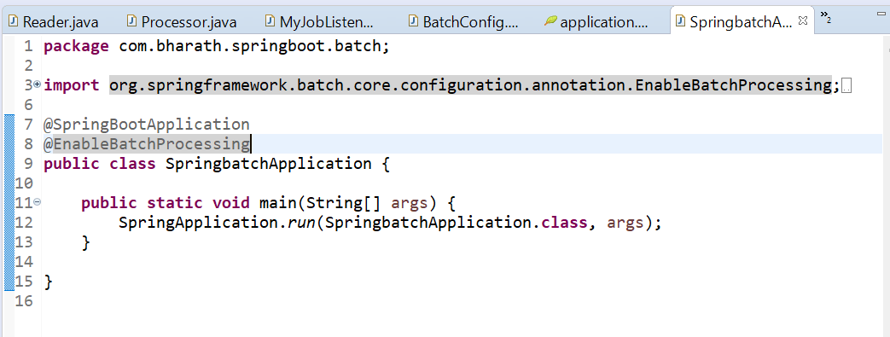

This tells we want spring batch support

**Need to put this ( not required)**

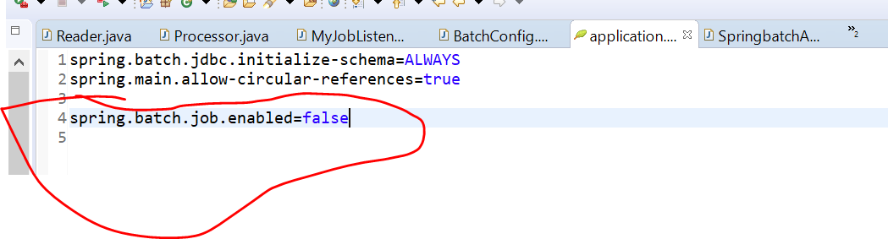

Output

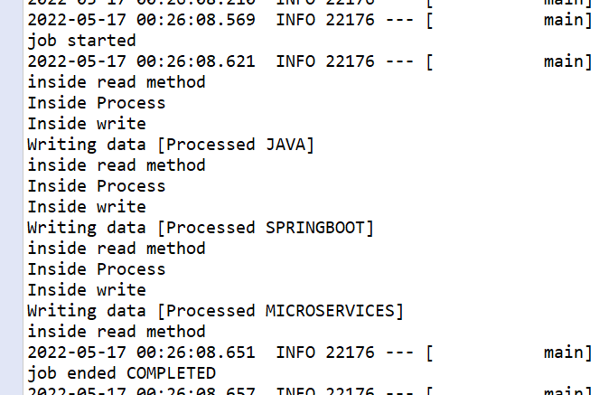

**Configuring Chunk size**

**Change chunk size as 2**

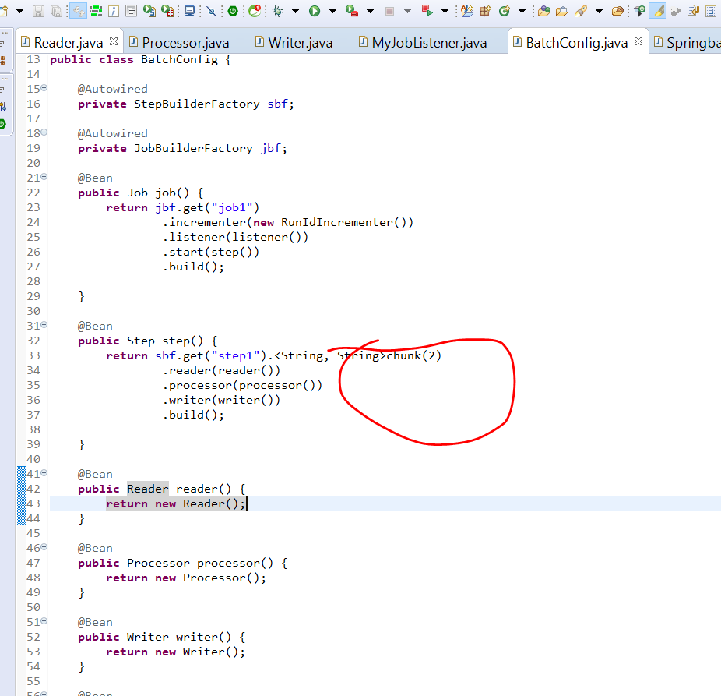

**//output**

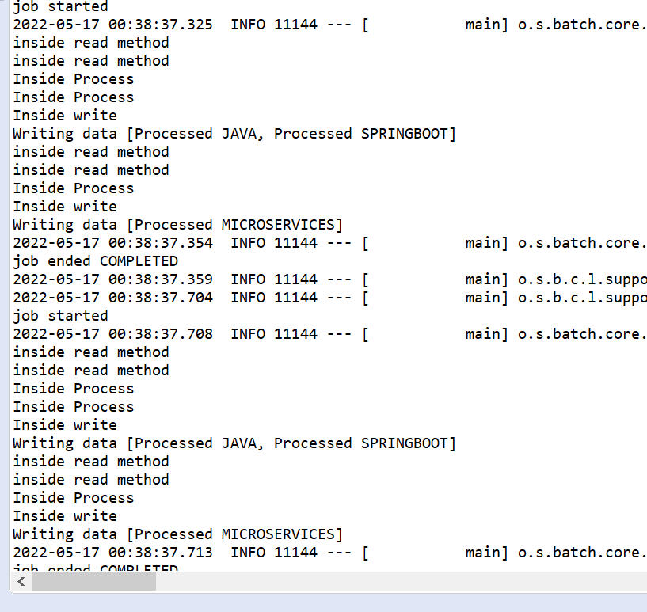

**Chunk size 3**

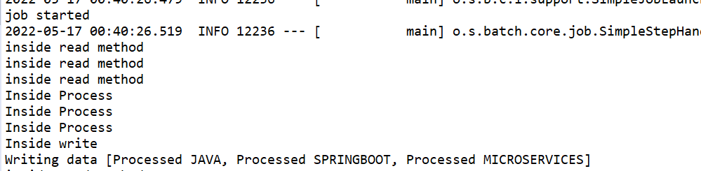

**CSV to Database**

**Requirement :-** how to copy data from csv file to d/b using spring batch application

**LineMapper** :--- knows to read one line at a time

**LineTokenizer** :---convert into comma seperated

**FieldSetMapper** :--- convert into model object

**JDBCBatchItemReader** :--- responsible for taking the object and writing into d/b

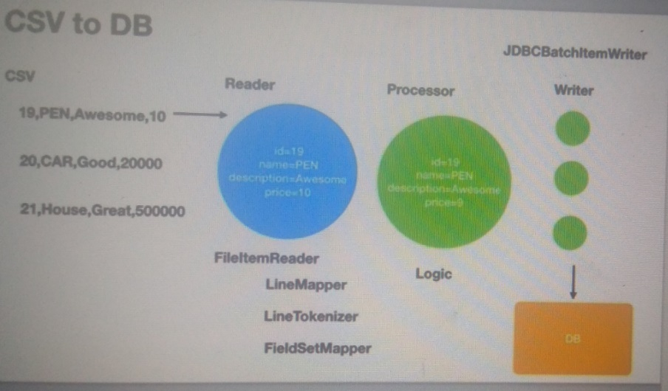

**step 1-Create the project and model**

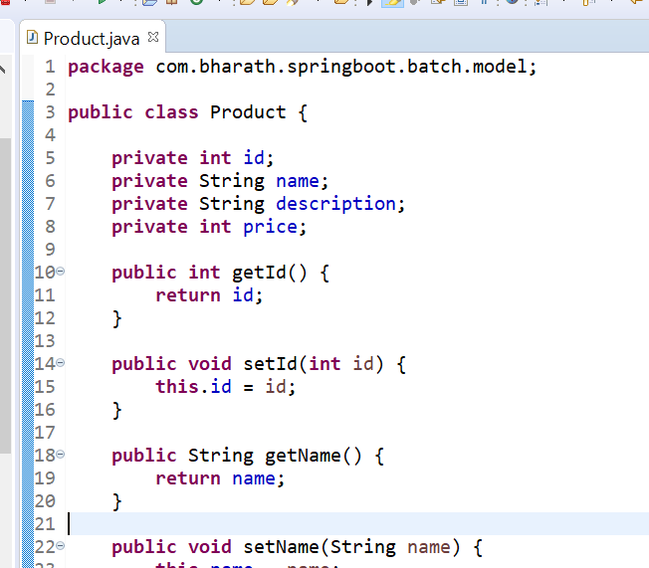

**Step 2 - create the csv**

**Three records in csv file**

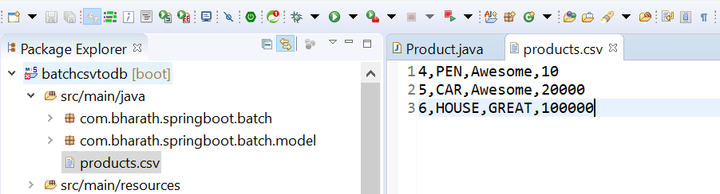

**Note :--** each of the lines here will become a d/b row

**Implement Reader**

FlatFileItemReader : that is responsible for reading the flat file and convert into model object called Product

LineMapper :--- that is responsible for mapping each line into product object

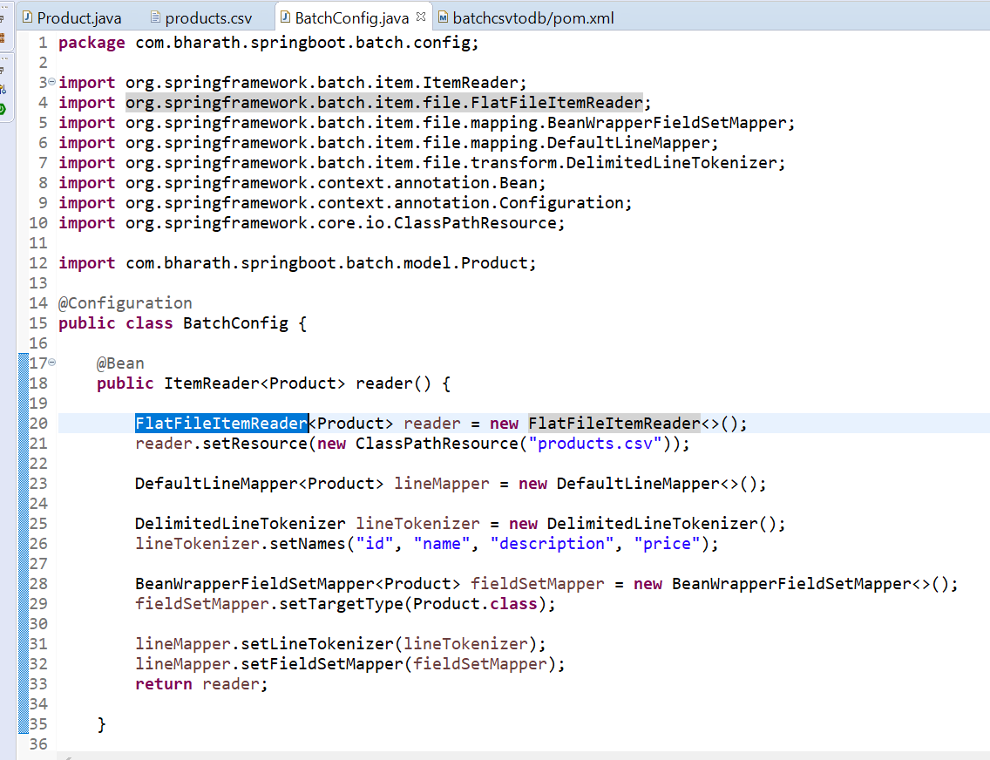

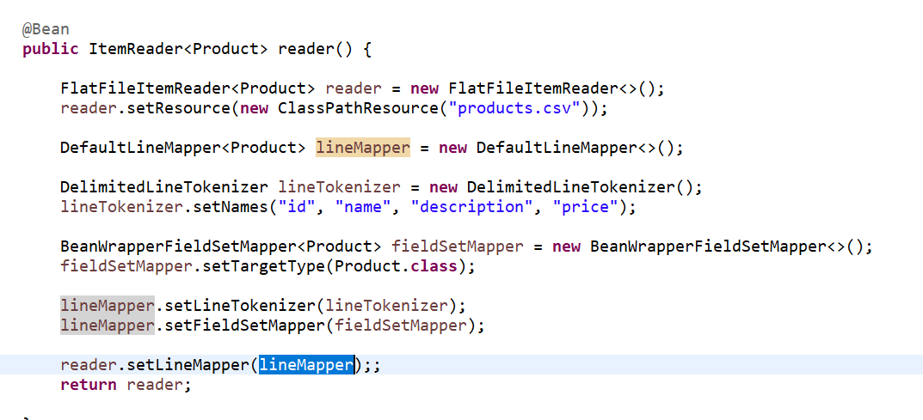

**Implement Processor**

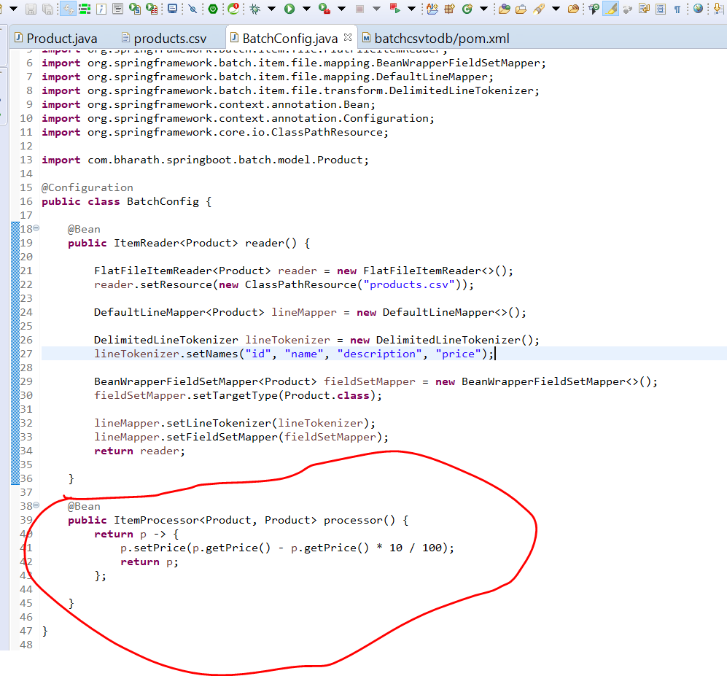

**Implement Writer**

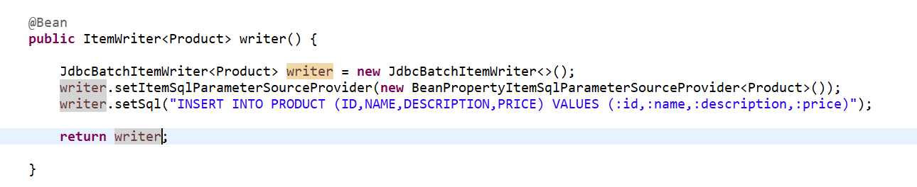

**Configure the data source**

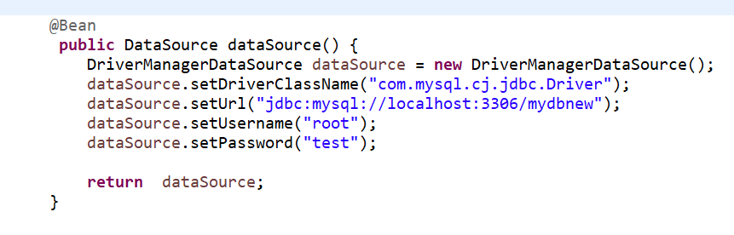

**Configure step and job**

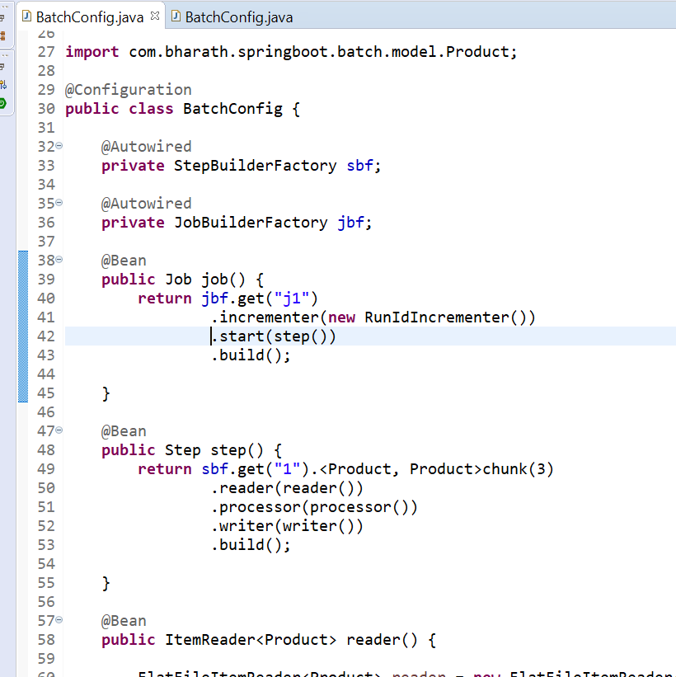

**Write a test**

**Enabling batch Processing**

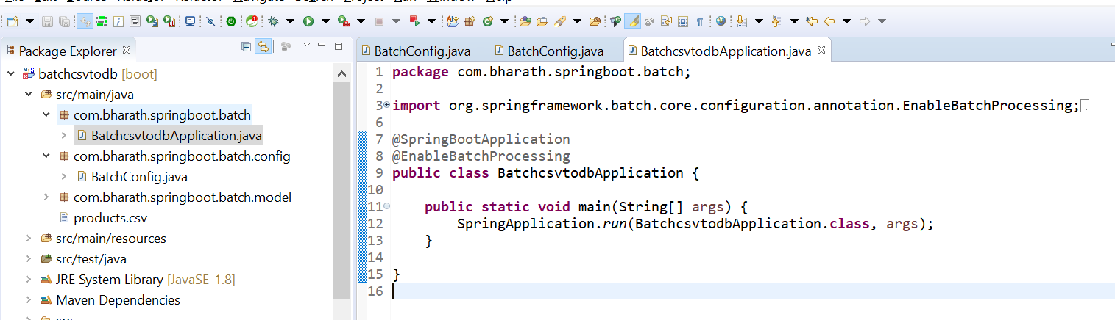

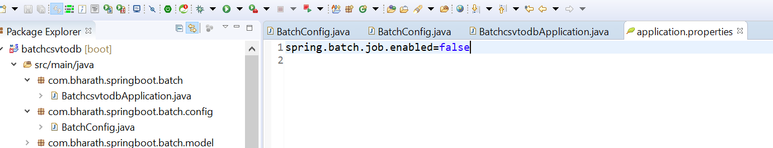

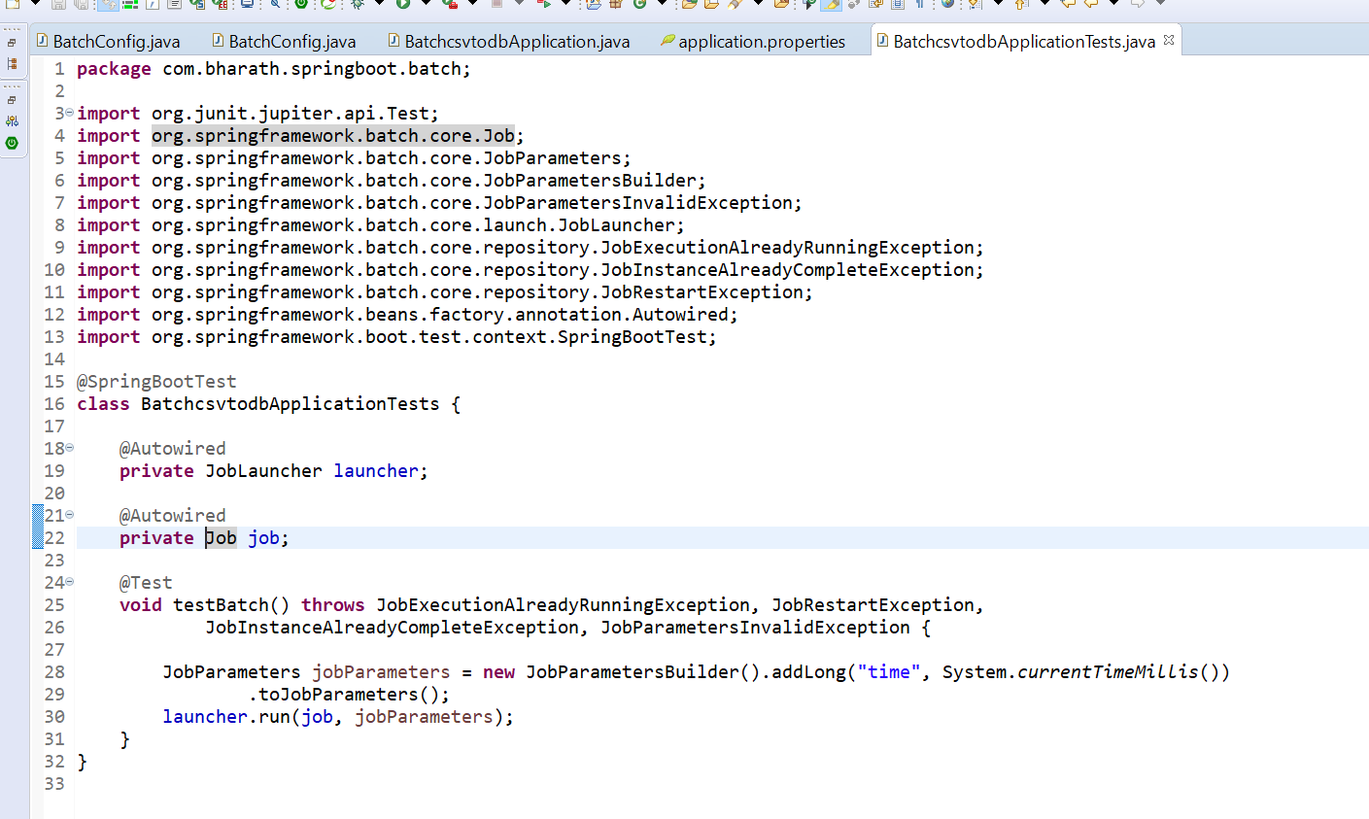

**CSV TO DB in action**

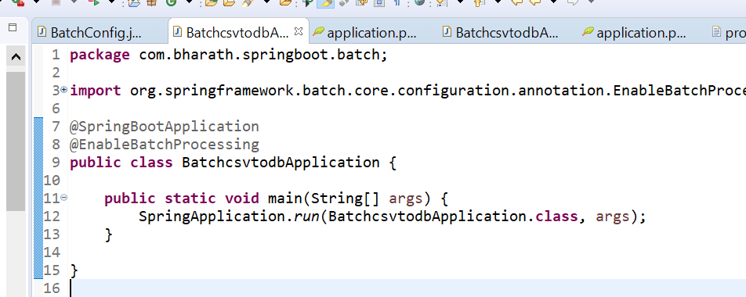

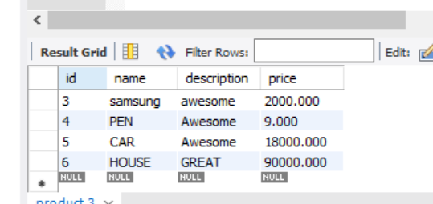

**Unit Testing using MockMvc**

**Unit test :**

need to test a single component like controller the call should not go into repository

**Requirement :**-- need to test controller by mocking service or repository

**@WebMvcTest :**---

without running the server it will be able to test the class

@WebMvcTest annotation is **used for Spring MVC tests**. It disables full auto-configuration and instead apply only configuration relevant to MVC tests. The WebMvcTest annotation auto-configure MockMvc instance as well.

It only focus on controller not services and repository

**@MockBean :**--- it will create a mock object of that bean and inject into it

**Create the test**

**Integration testing**

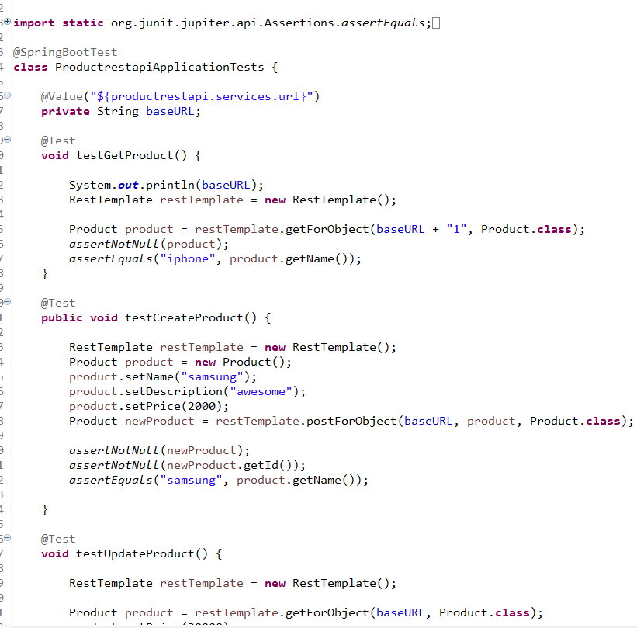

**Using MockMvc :**--- will make a restfull call

**Mock the Product Repository**

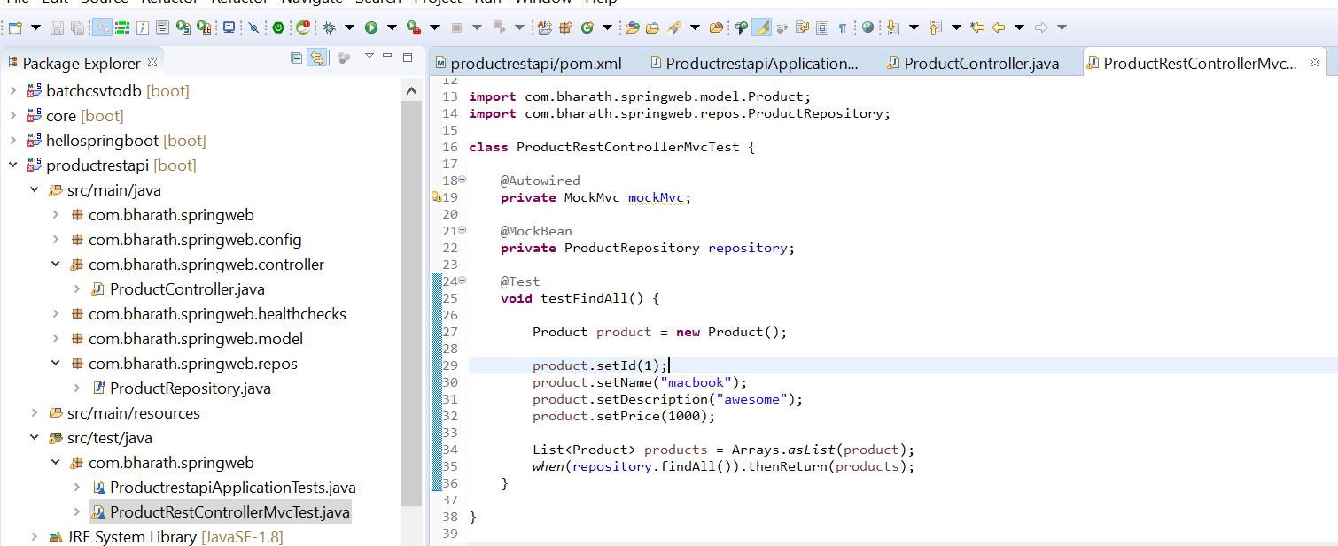

This is mock repository , it will not go against a d/b

**Use MockMvc**

**Objective :-** restfull call using mockmvc

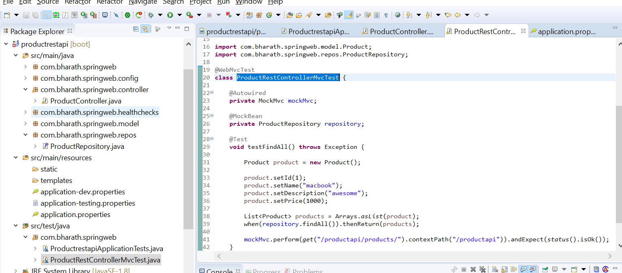

**mockMvc** will call a restful call except running tomcat everything will happen

**Expect Results**

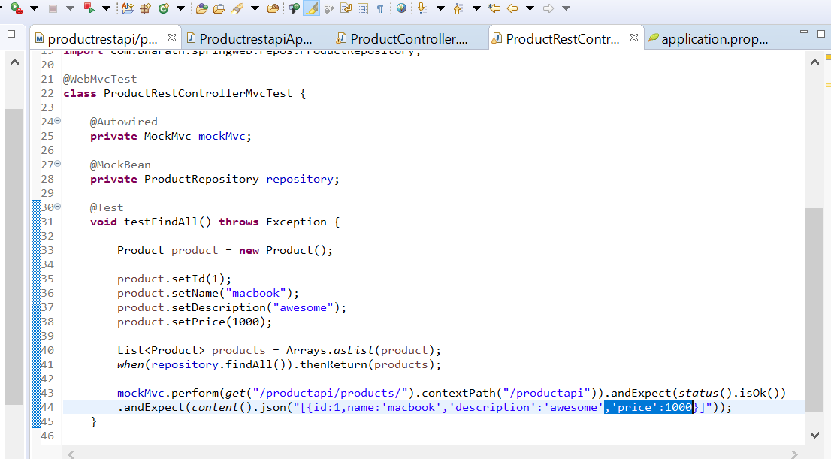

**Refactoring**

**ObjectWriter :--** will convert list object into json array

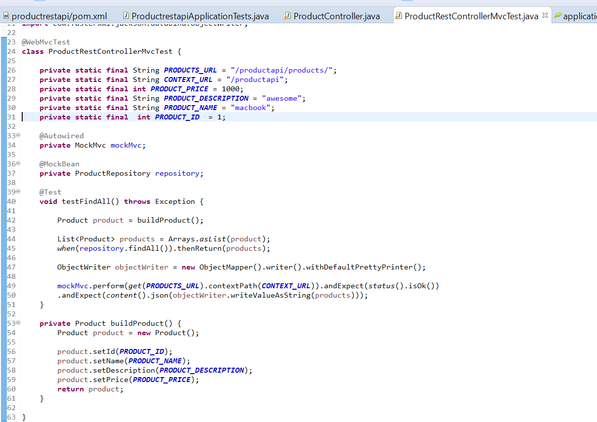

**Test Case**

**Objective :-** need to test this

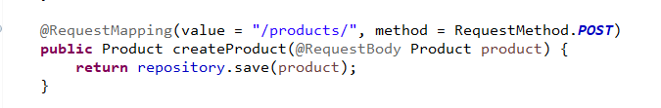

Since it is unit test repository.save should be mock

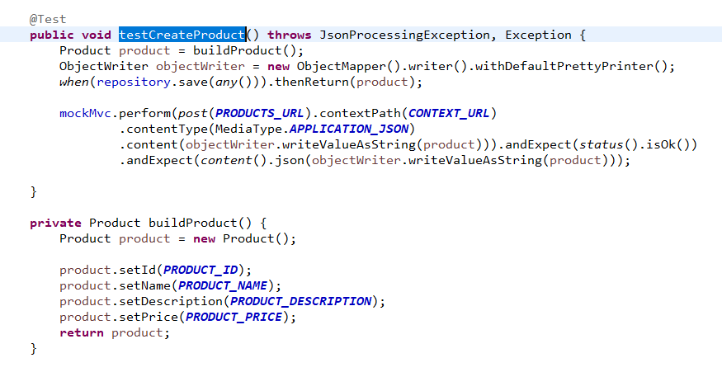

**Test Update and Delete**

**Objective**

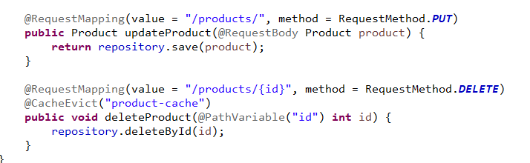

**Update test case**

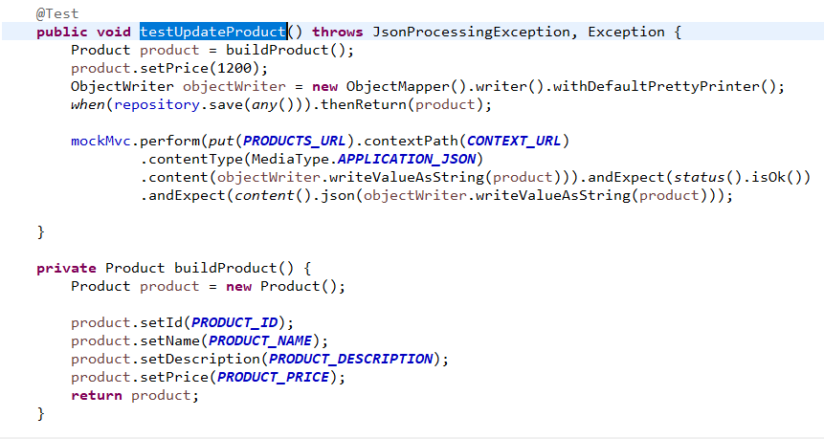

**Delete test case**

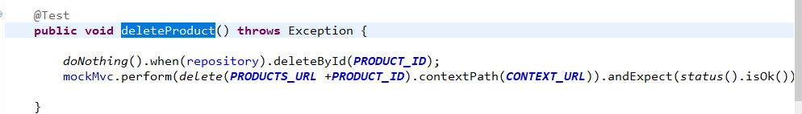

**Messaging**

Sender ------message -----------Messaging Server(MOM) like ActiveMQ----------------Receiver

**Why Messaging ---**loose coupling

**JMS**:---- support two types of messaging model

**Point to point :---**

producer--------- jms provider ---------receiver

The message is consumed by only one receiver then it is responsibility of jms provider to delete the message

In point-to-point messaging, **JMS producers and consumers exchange messages by using a destination which is called a queue**. Point-to-point messaging is available for JMS applications only. JMS producers send messages to the queue, and JMS consumers receive messages from that queue.

Example :-- greeting card

**Publish/subscriber**

Produces ----message---topic------ multiple Subscriber (multiple consumer will consume the same message)

Producer will send message to topic and jms provider will ensure message will reach to all subscriber

Even subscriber didn’t poll to jms provider

**Example :--- news paper subscription**

**JMS:----** specification and api

**Spring JMS**

**Note :--** spring provides support of JMS

**Spring provides a JMS integration framework that simplifies the use of the JMS API** much like Spring's integration does for the JDBC API.

**JmsTemplate** ---

**send and receiv**e which is straight away we can use to send and receive message from queue or topic

Everything else like creating connectionfactory and session will be take care by JmsTemplate

**convertAndSend**

String to text message

Object to Object message

**Note :---** JmsTemplate internally uses JMS api

**Steps**

Create the project

Create a sender :- send a message to queue using JMSTemplate

Create a receiver/Listener

**Install apache active MQ**

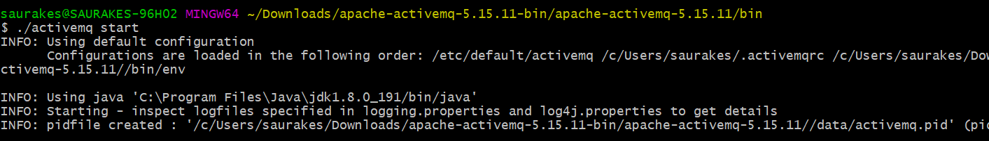

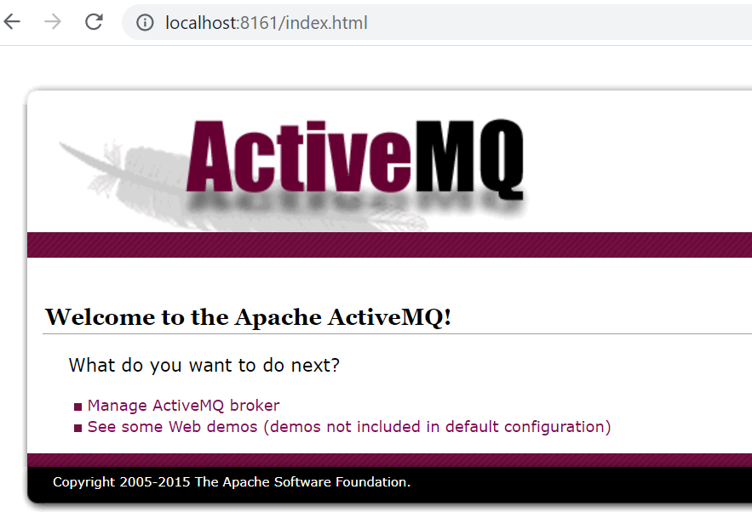

./activemq stop

**Create the project and message sendery**

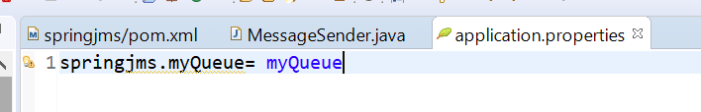

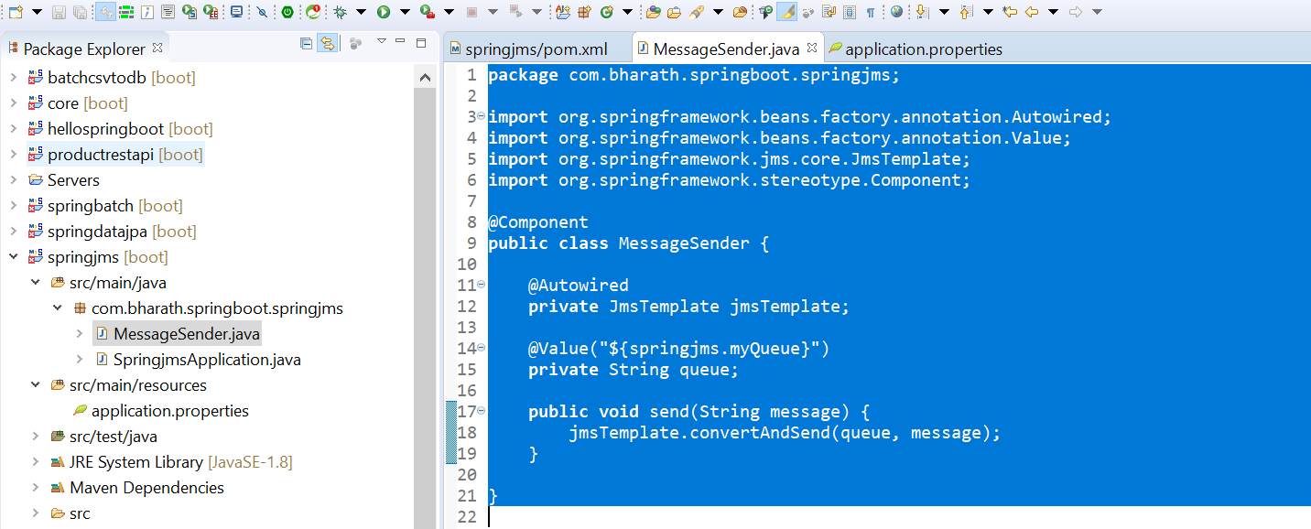

**Create Message Listener**

It will read message for us from queue or topic

**JmsListener** :---it will read message from queue and inject into parameter

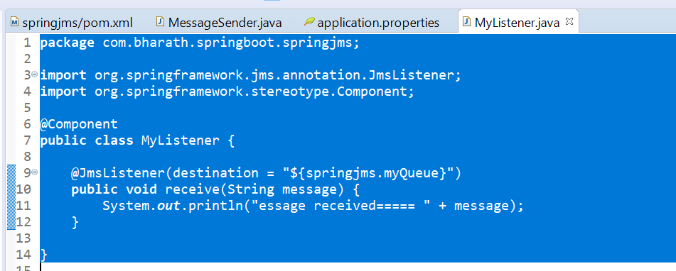

**Test**

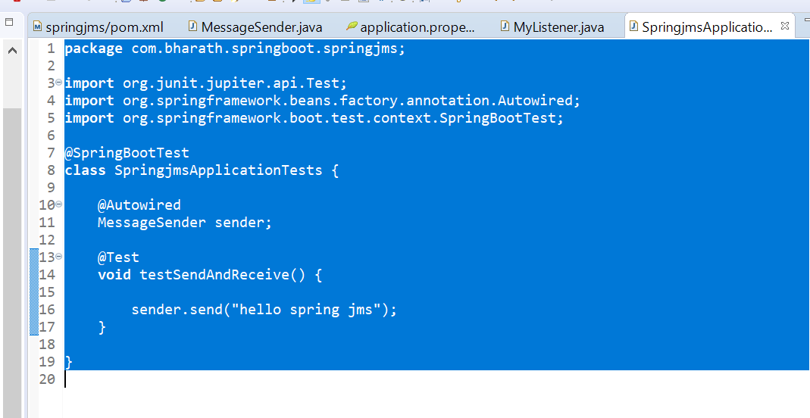

**Note :--- we need to enable jms**

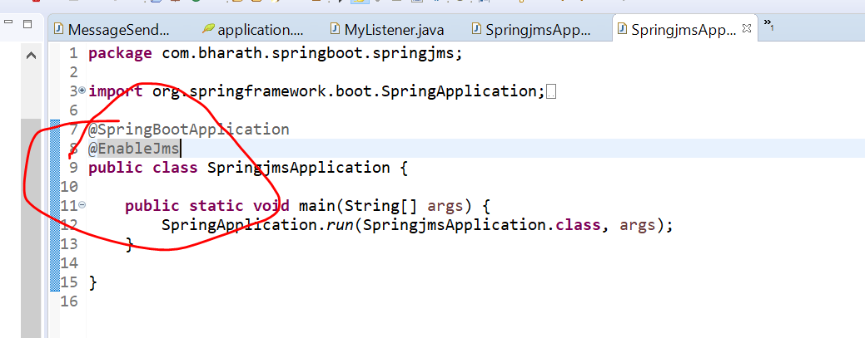

**Note :---**

we need to add certain properties to tell spring boot that active mq is running on machine

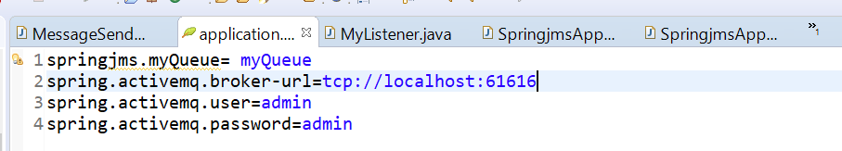

**Output after running test case**

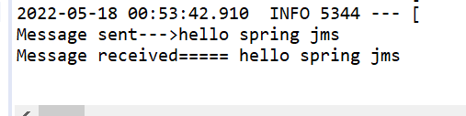

**Note :--** when application start springboot registered the listener

**More about spring jms**

**imp**

**Spring.jms.pub-sub-domain=true -------it means now queue will considered as topic**

**Swagger Rest Documentation**

All the restful service we expose in document in json or yaml

Swagger will generate this document for us

**Swagger ui :----** we can test restful webservice

**Spring boot and swagger**

**Steps**

**Springdoc-openapi-ui**

**Swagger** /productsapi/v3/api-docs

**Swagger-ui** /productapi/swagger-ui.html

**Swagger-in-action**

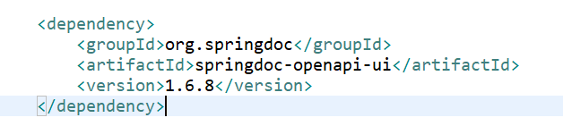

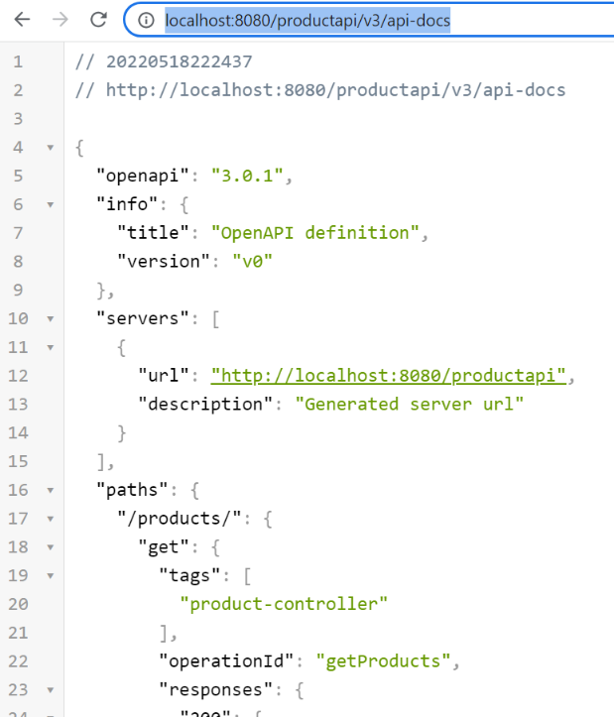

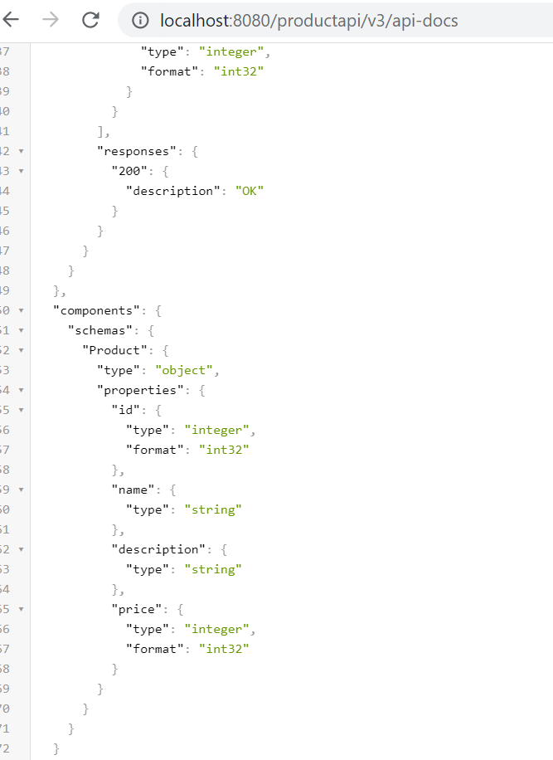

Schema is the entity

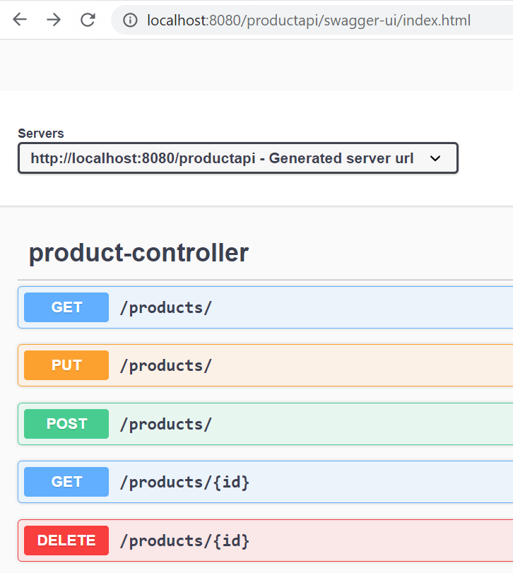

**Change URI**

<https://springdoc.org/>

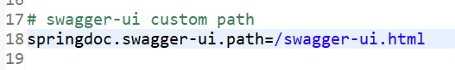

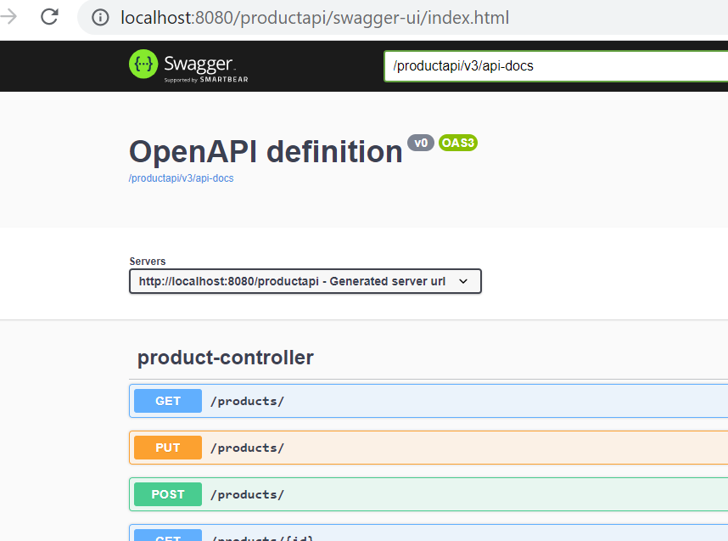

**Swagger Annotation**

<https://springdoc.org/#migrating-from-springfox>

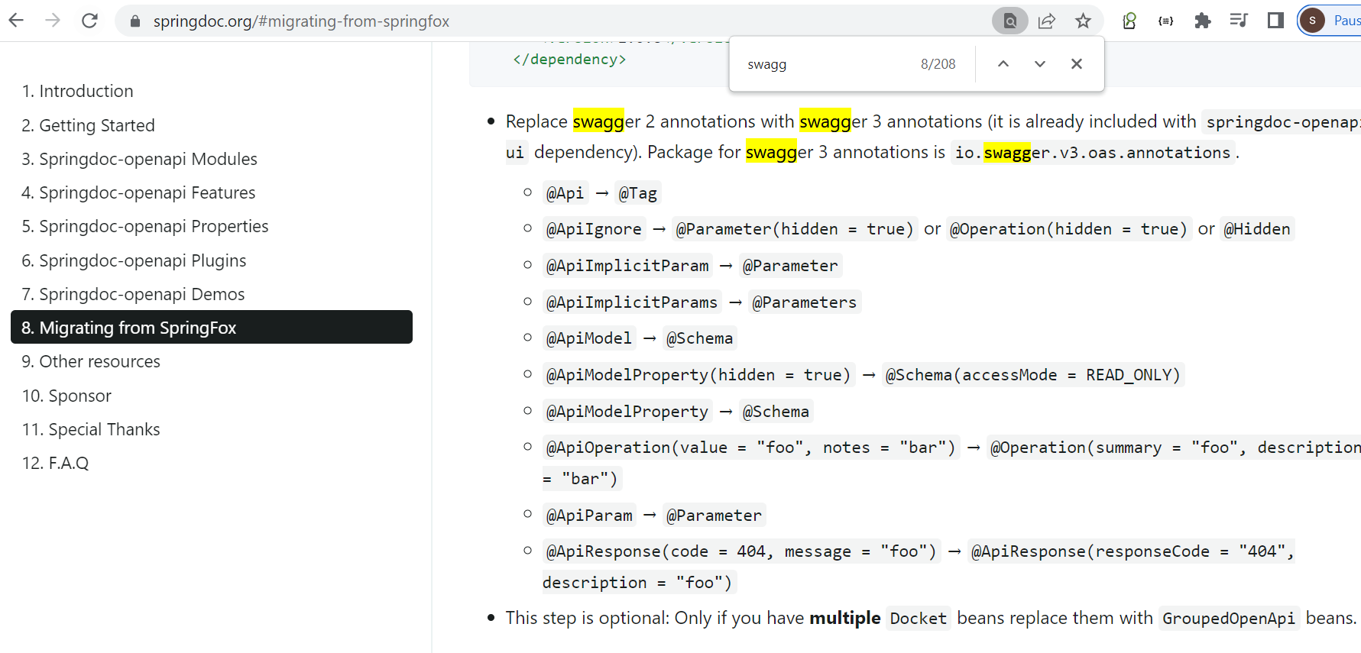

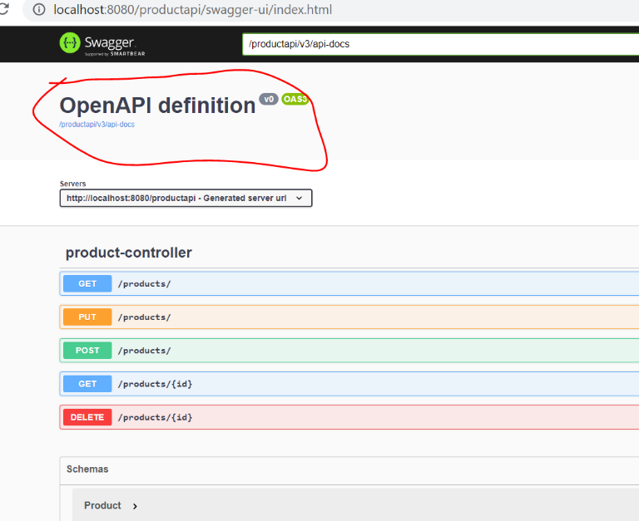

We can change this using swagger api

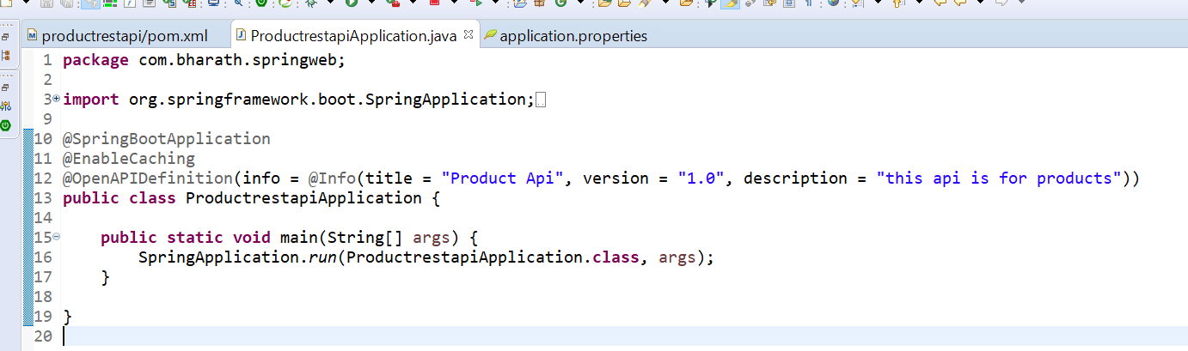

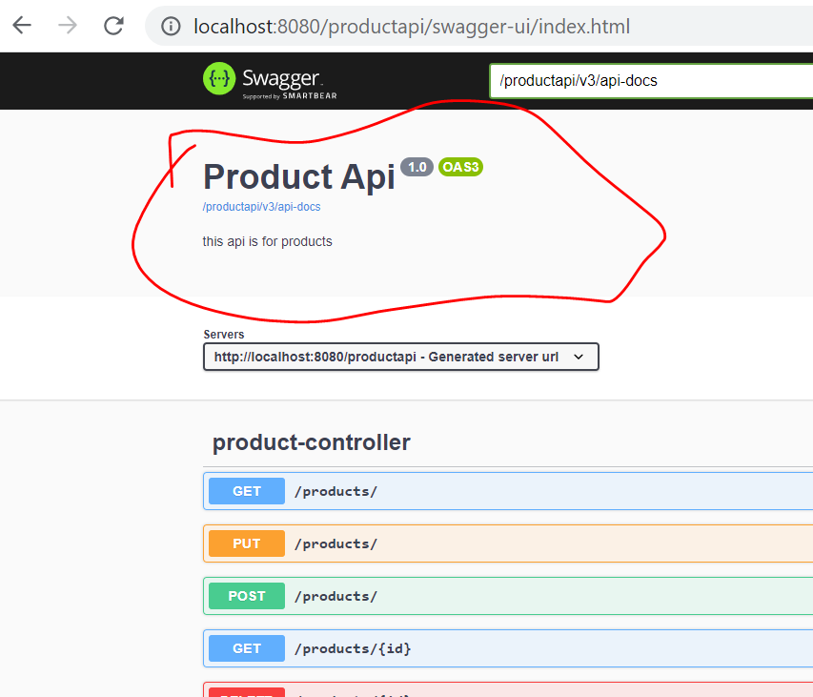

**Swagger use in restful endpoints**

**@Tag(name="") :---**we can use at class level

**@Operation :-** we can use at method level

**Note :-**-

we can also use at parameter level--------@Parameter

Return type ------@ApiResponse

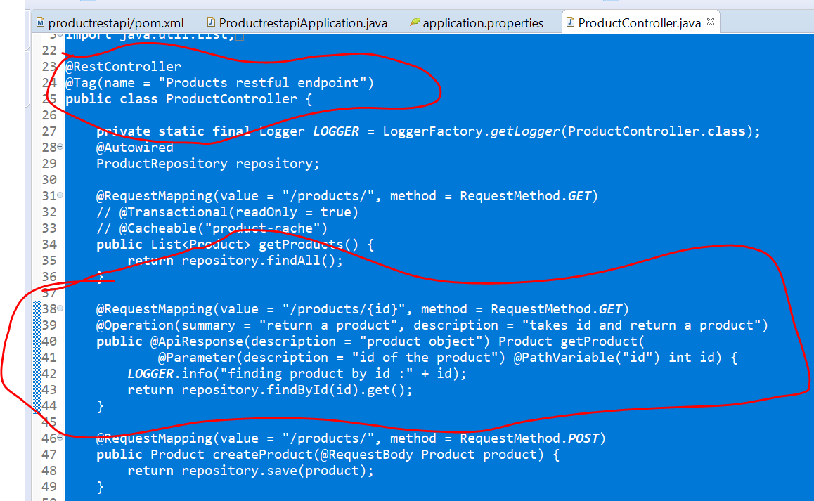

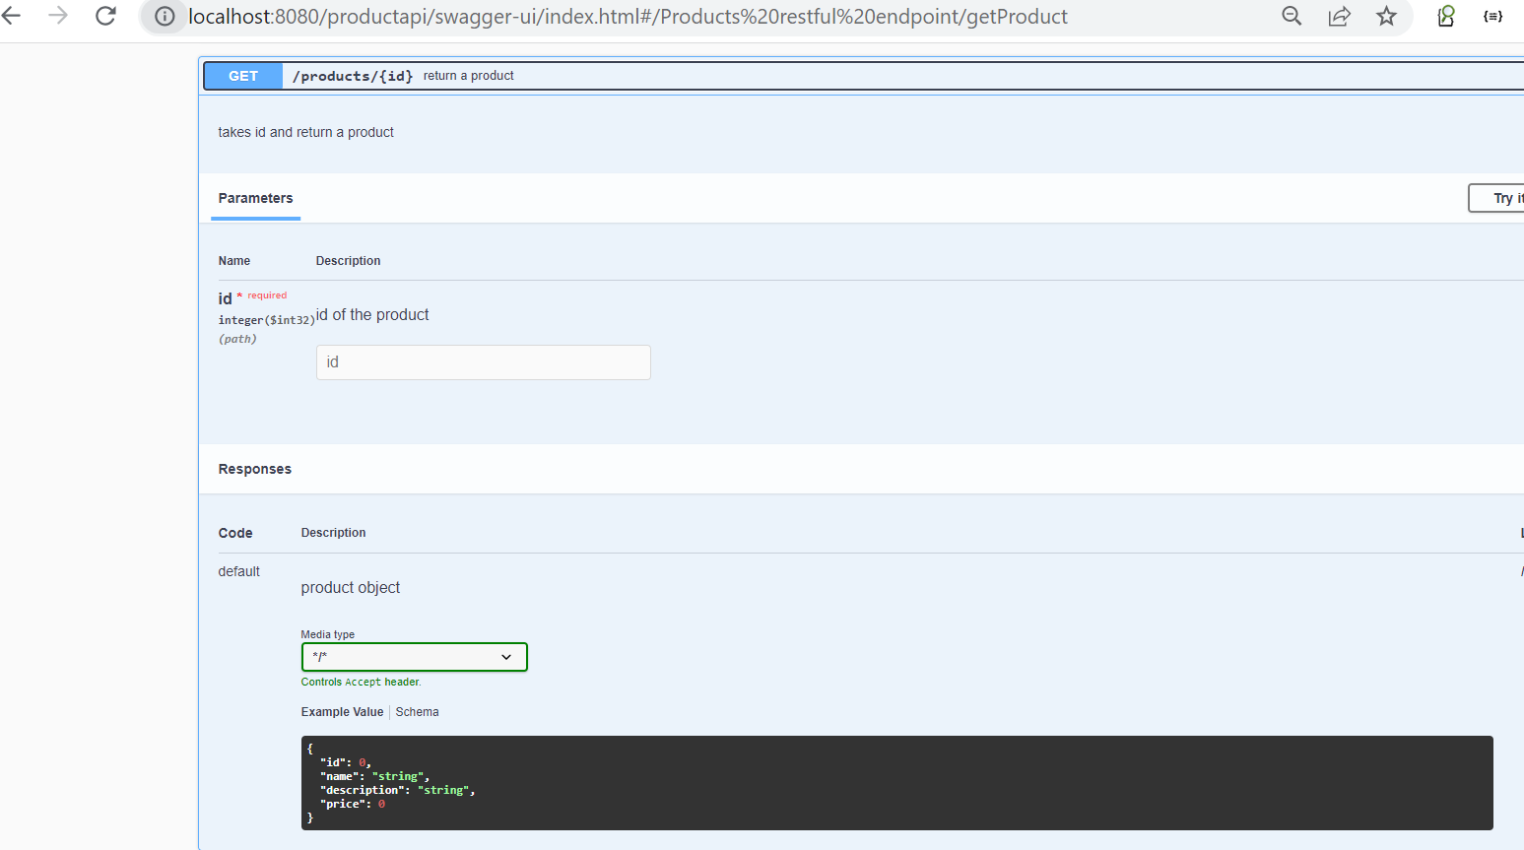

Note :

If we don’t to display method at swagger ui , we can use annotation at method level

**@Hidden**

Validations

Introduction

Any restful api should validate the data when it come to request before it starts using it.

To make sure client is providing all data in correct way

Validation api ------------bunch of annotation

Hibernate-validator --- implementation of validation api is provided by hibernate-validator

**Pom.xml**

Spring-boot-starter-validation -------- it will automatically pull validation api and hibernate-validator

@AssertFalse on Boolean filed if we marked this then value of field coming should be false

@AssertTrue

@Past this s for data , the date should be in past

@Future

@Max

@Min

@Size

@NotNull

@Pattern can be use against a regex

**Step 1**

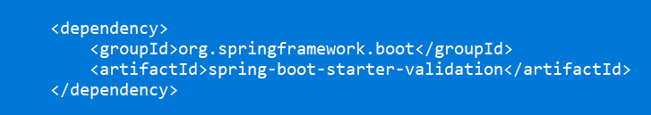

**Step 2**

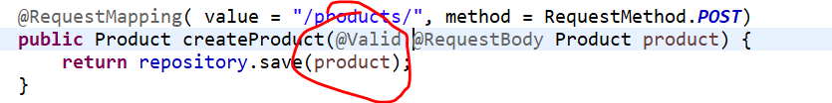

Once we marked with this **@valid** the incoming request should be validated with right data

Before the request is being processed

Step 3

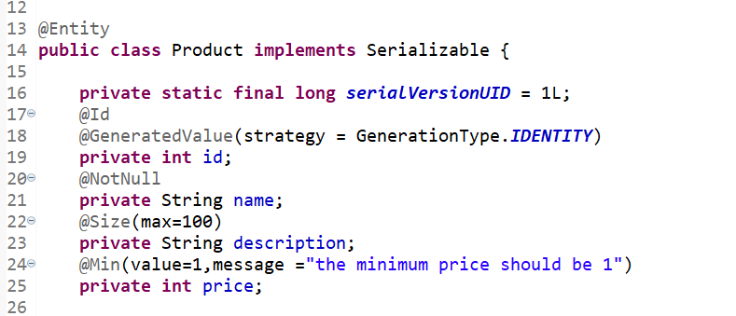

**Rest File upload and download**

**Step-1**

**create project**

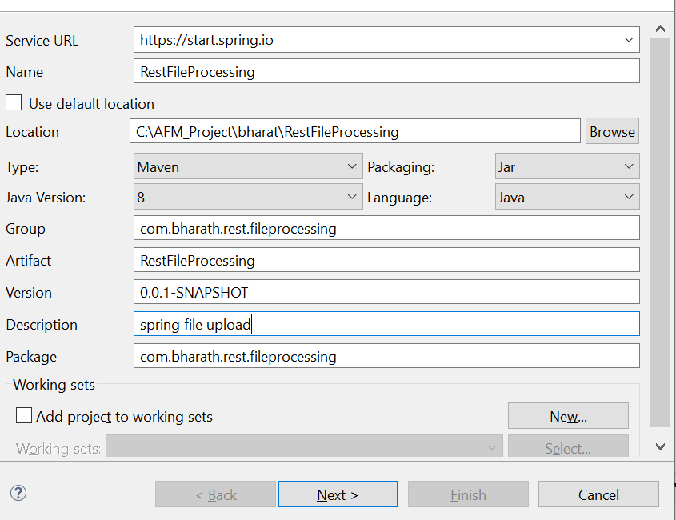

Add spring-web

**Step 2:--implement file upload**

**Step 3: test**

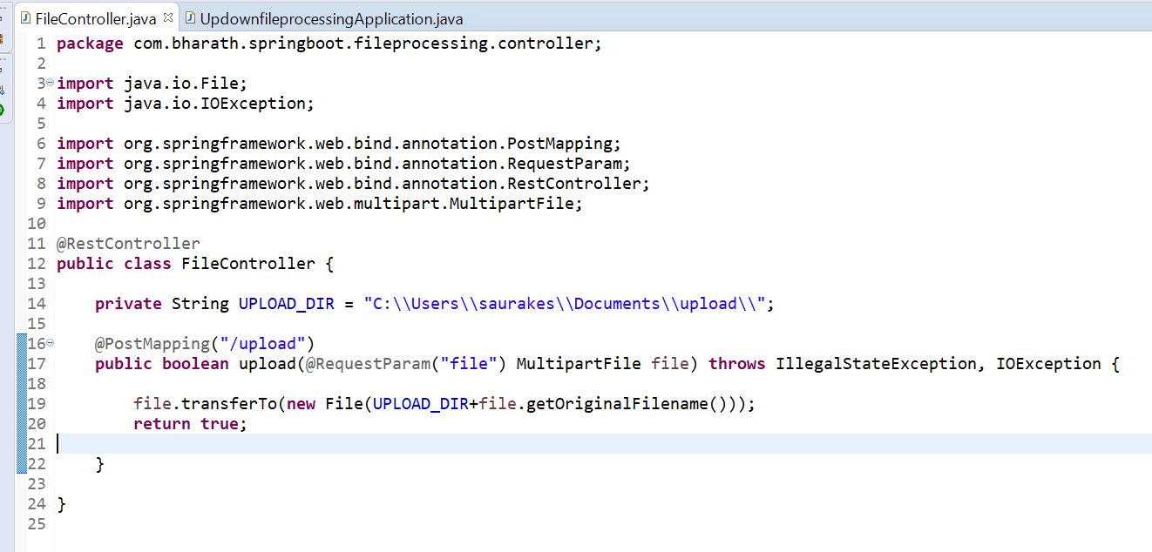

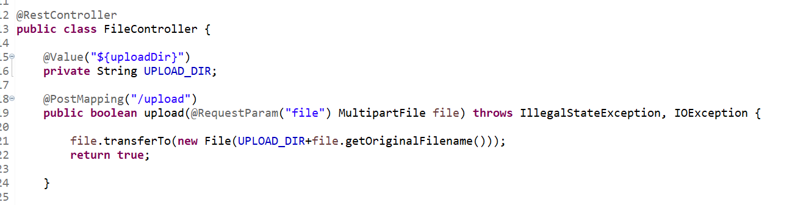

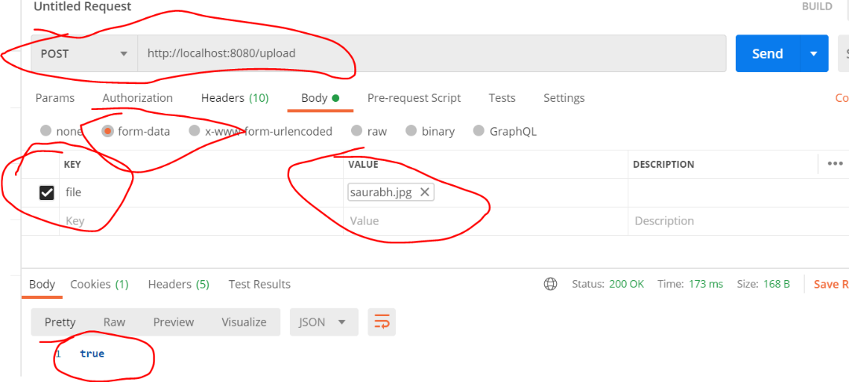

**Implement and test file Download**

Will read binary data and send back as byte array

Headers will tell what type of data is coming back

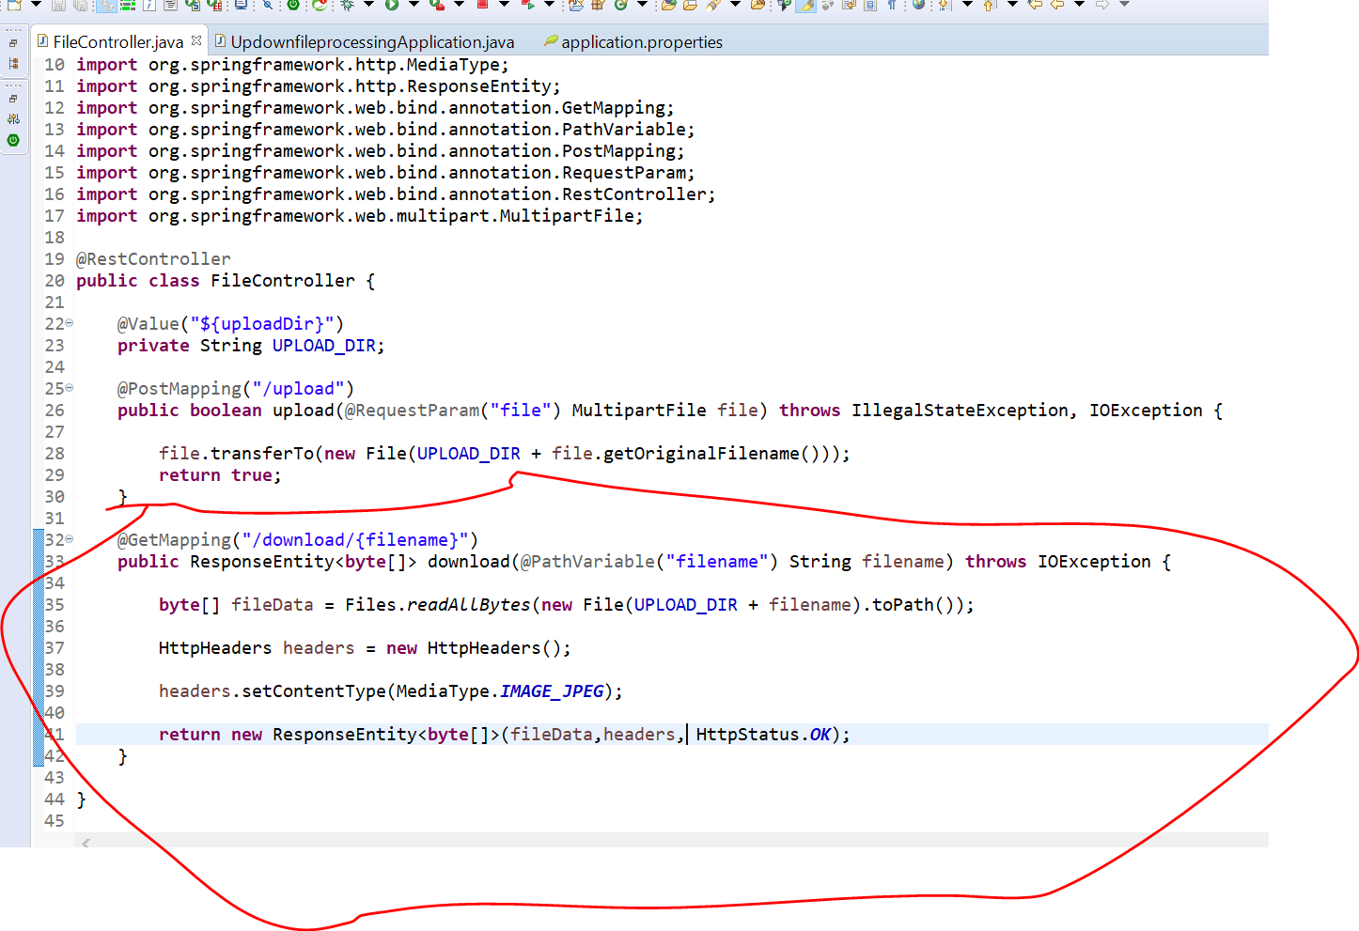

**//output**

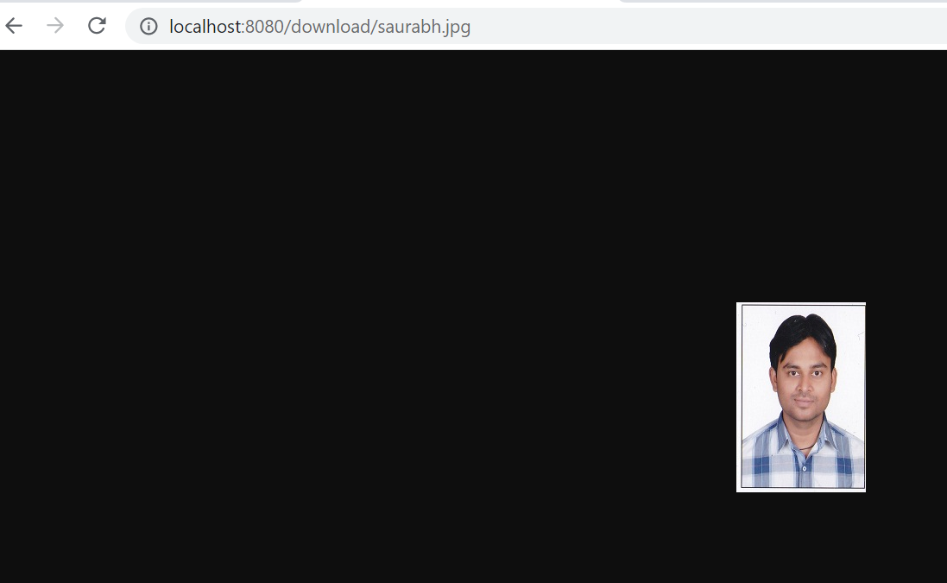

**RestTemplate APIs**

**Agenda :---**

whatever we are doing from postman for upload file same thing we need to do from coding using resttemplate

**Upload client**

Going to test upload functionality by writing a test for it

**Understand using this for upload**

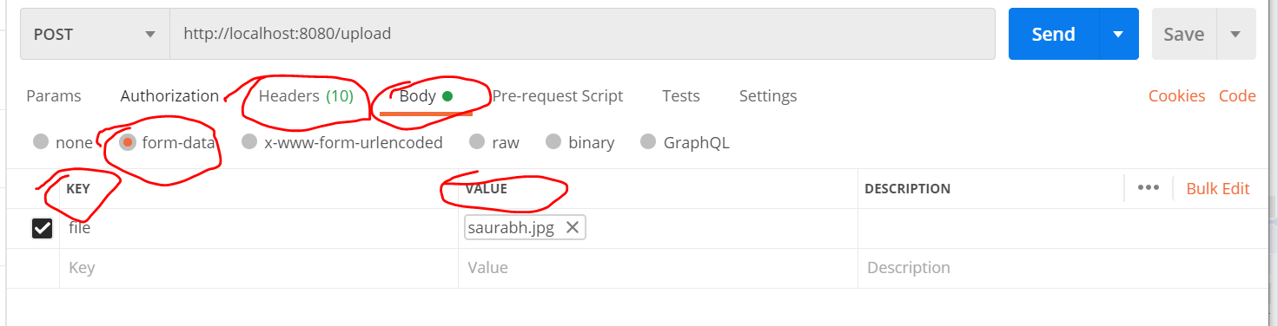

**Step 1:-- create header**

**Step 2:- create body**

**Step 3:-- create httpEntity that we can pass in post method**

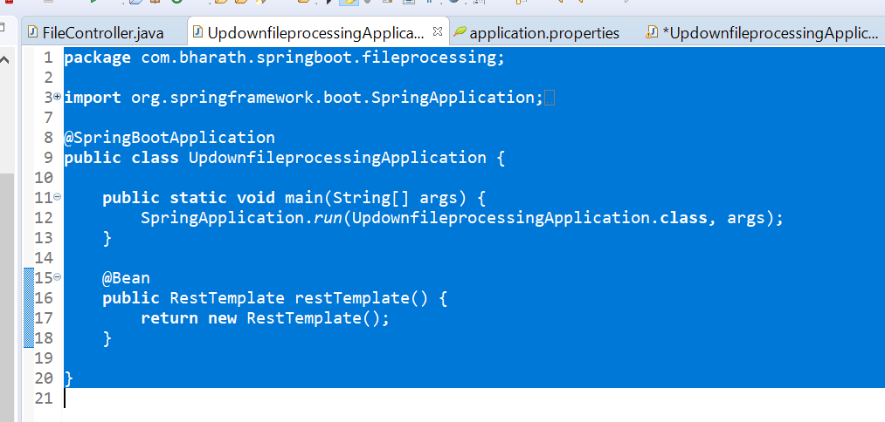

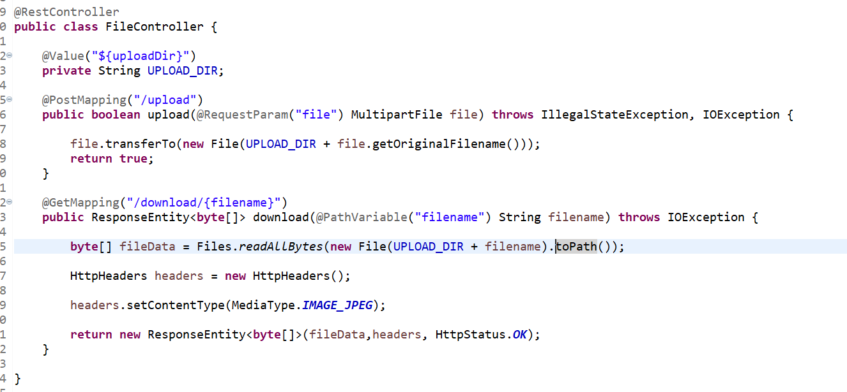

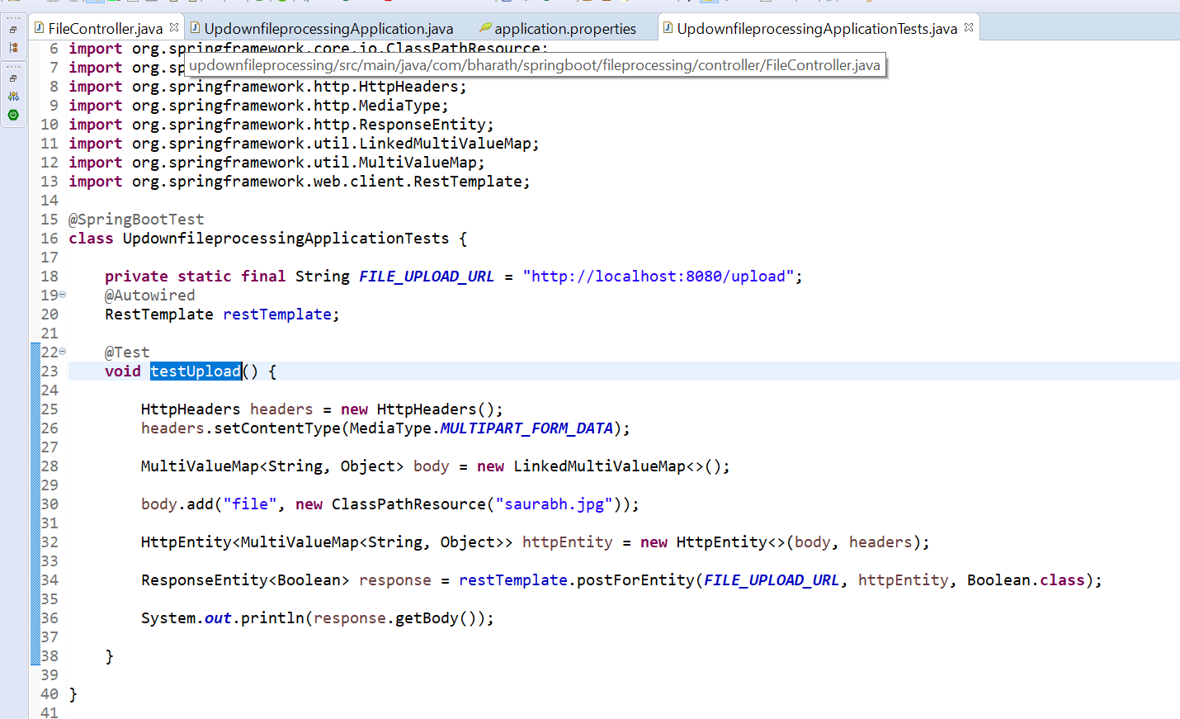

**Note :--** image will be under resource folder

**Download Client**

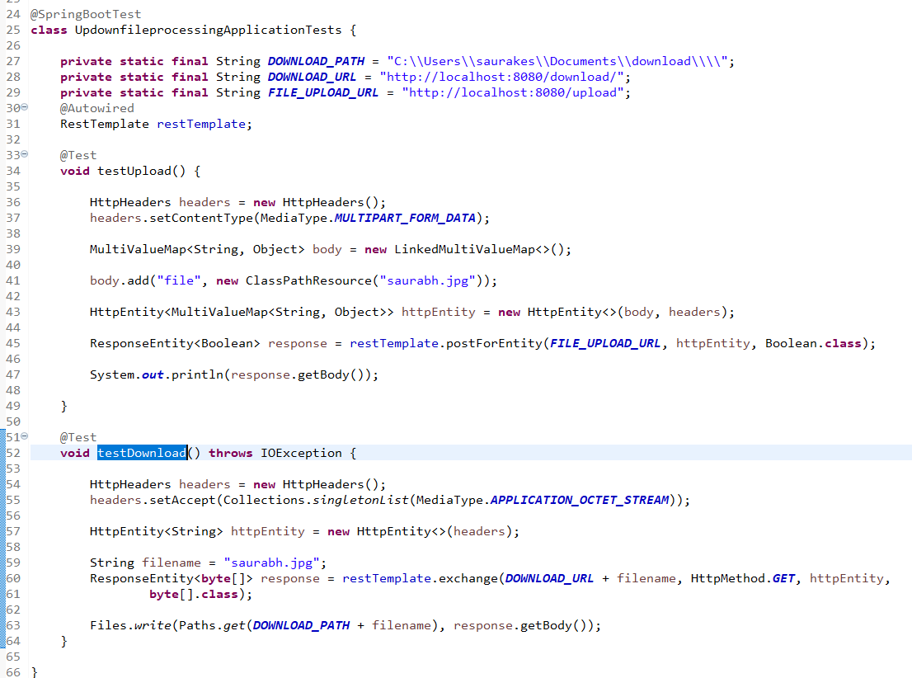

**Spring Reactive Programming**

Aysnchronous

Non blocking communication

**Back pressure :**

The subscriber application which consumes the data will have the ability to specify how much data

It will consume at a given point of time so it has control how the data will flow. It will give application

Not to take load or crash

**Spring reactor**

Subsciber----------------------data stream --------------------publisher

**Back pressure**

**Note :**

Back pressure will automatically handled by spring framework through spring reactor

Back pressure will be handled on subscriber side

**Spring reactor api provides two imp classes**

**Flux-**---------------- 0 to n ------------ publishes any number of element

**Mono**--------------- 0 to 1------------ produce 0 to 1 element

**Spring webflux** :--internally uses spring reactor by default but we can also use other library like RxJava

**Create reactive project**

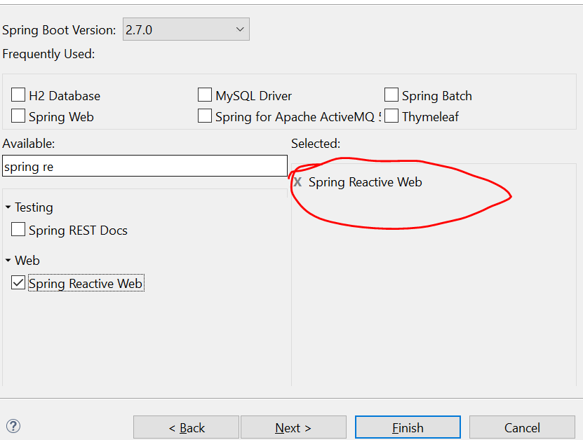

**Note :--**

Along with webflux reactor- test will come

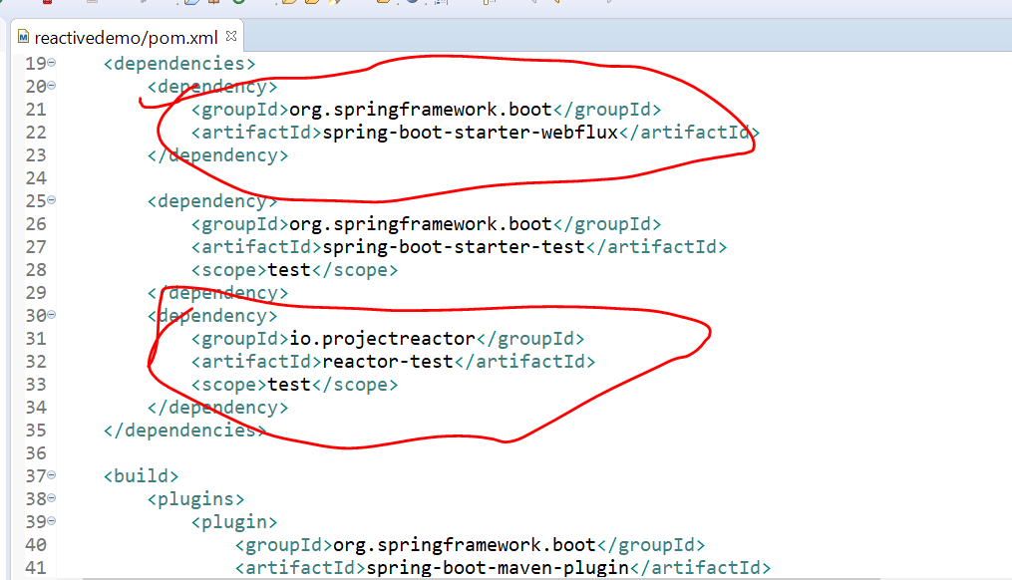

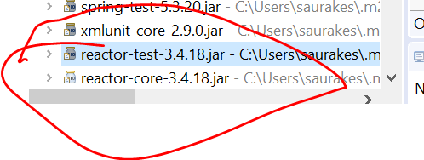

All those classes in reactor core like flux ,mono

**Mono and Flux**

**Note :--**

Mono and Flux are the keys to develop reactive application

Map :--in java 8 -> it will allow to convert data into something else

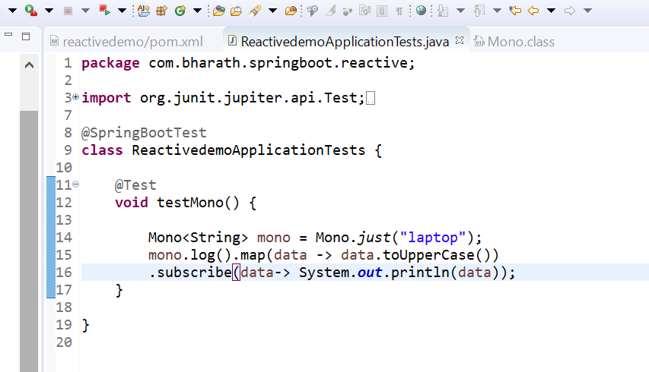

Due to mono.log it will print on console

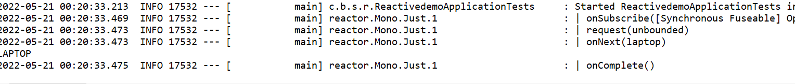

**Note :-**

Multiple data we can pass in flux

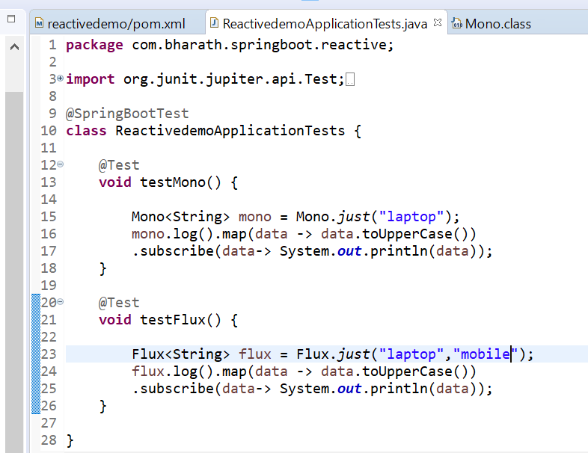

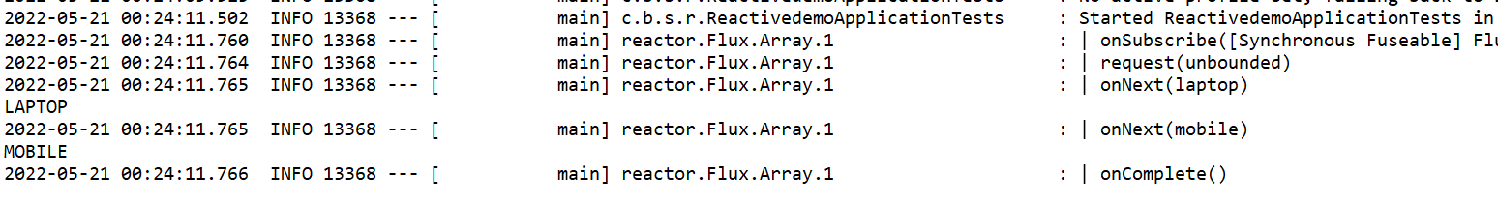

onComplete will invoked only once at end

**Note :**

Without subscribe data will not kicked in but in spring framework subscribe will automatically kicked on

We can also keep in single line

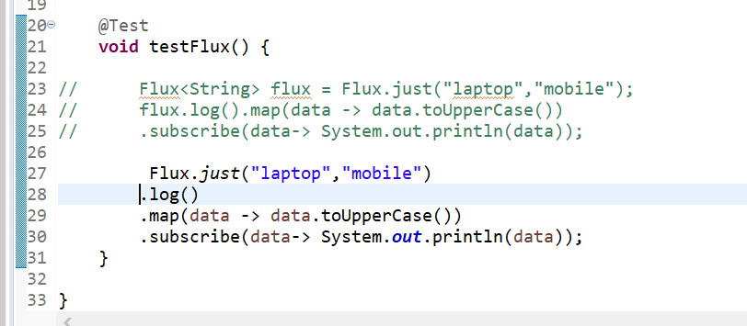

Note subscribe argument is consume interface which is having one method **public void accept(String data)**

**Few more method**

Few more method that can be use with flux and mono

**Expectation :--** want to delay between two data of flux we need to use Thread.sleep since subscriber wont wait

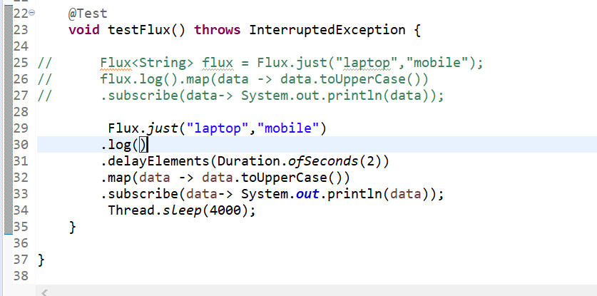

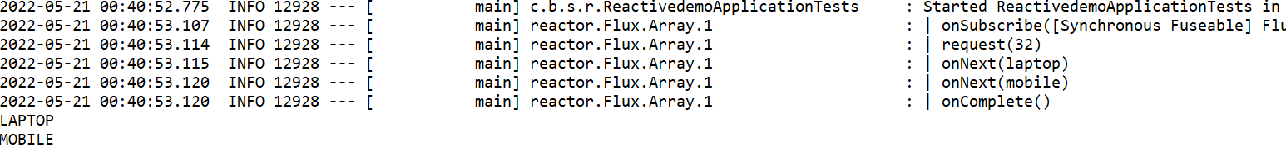

**Use a Subsciber**

Subscribe method is overloaded with different types of consumer

Note :-- due to log signal occur in console ----onSubscribe , onNext ,onComplete

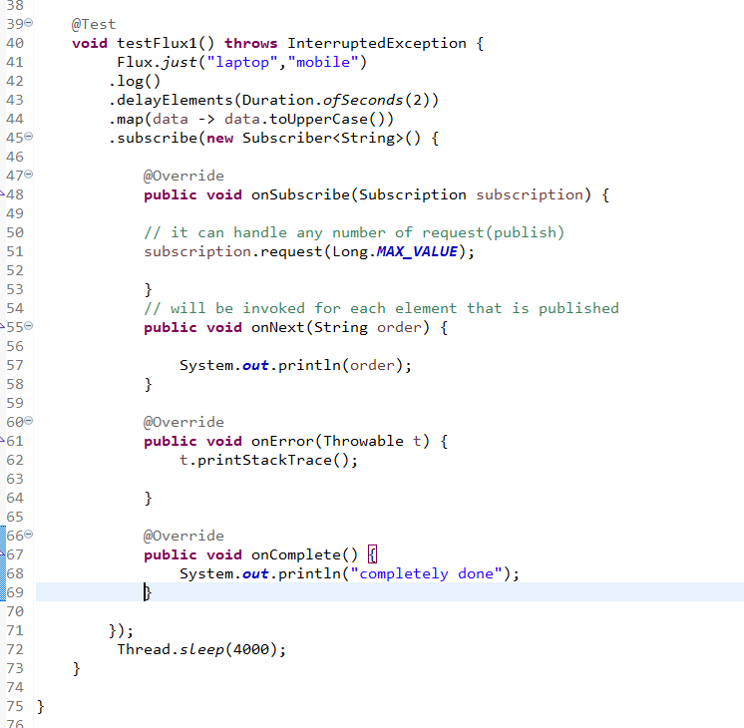

**// output**

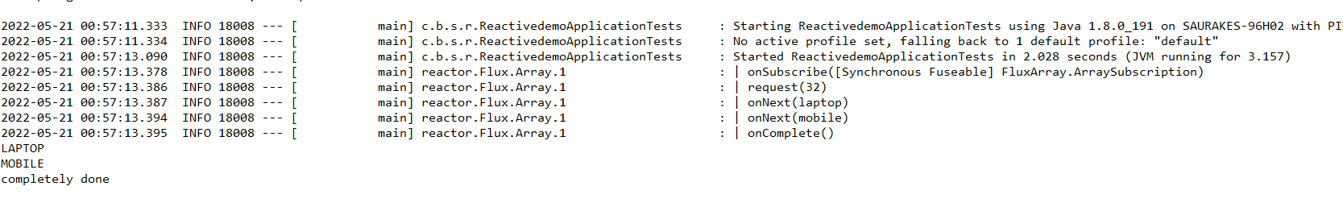

**Imp**

**Request is the method on subscriber which tell publisher how much request it can handled**

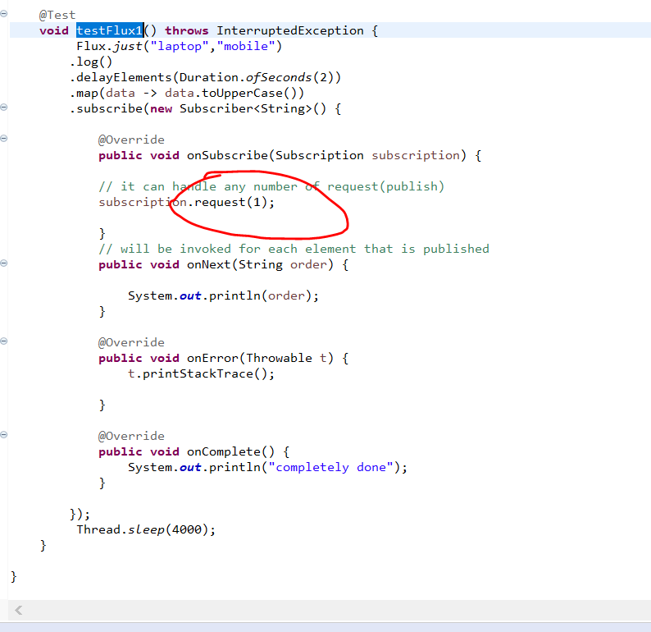

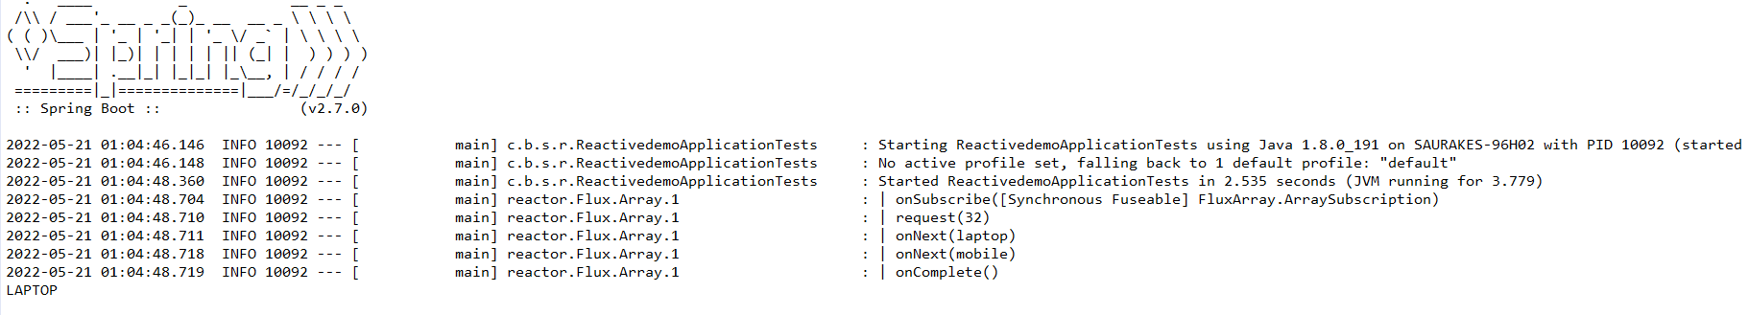

**Although the flux can publish 2 element but there is a capacity of subscriber of 1 element**

**Configure Batching**

**Note :-**

Using this request method we can configure batching

We need to have Subscription inside onNext() so that we can invoke this request method again

Once we handle a certain batch

Note :---- now processing happen in batches first for 2 publish then again 2 like that

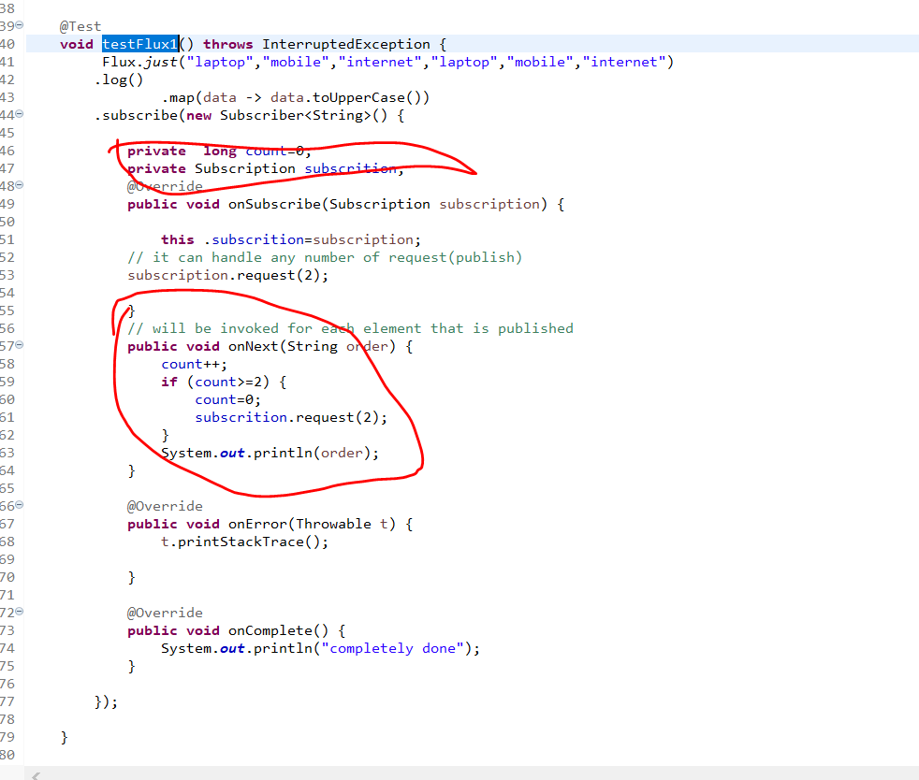

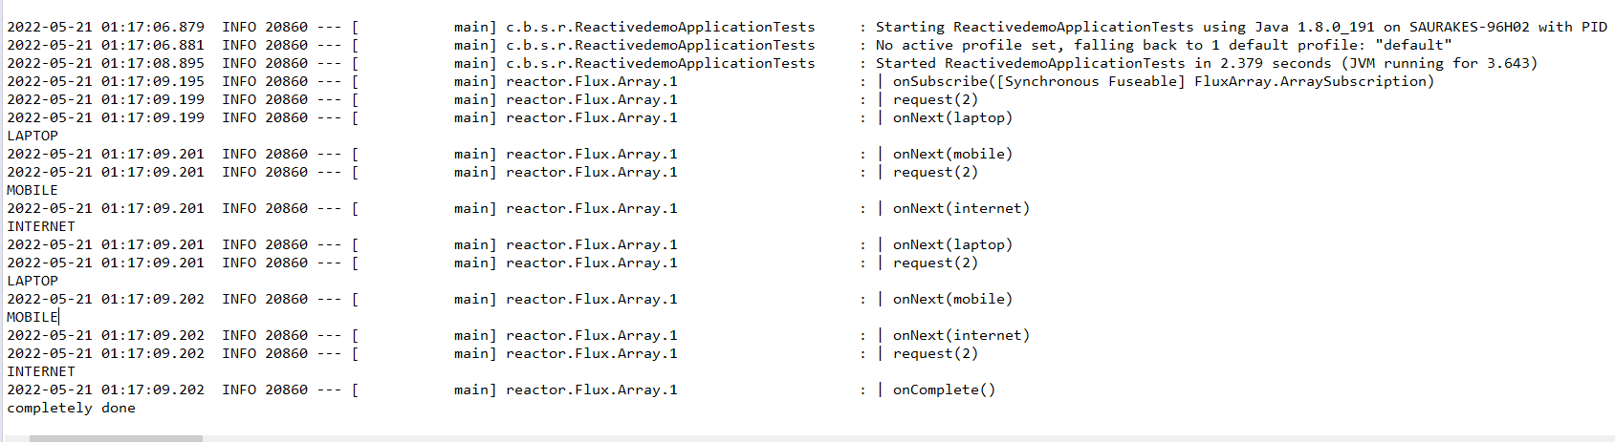

**Implement the usecase**

**Vaccine**

**VaccineService**

**VaccineProvider class :---** responsible for delivering the vaccine

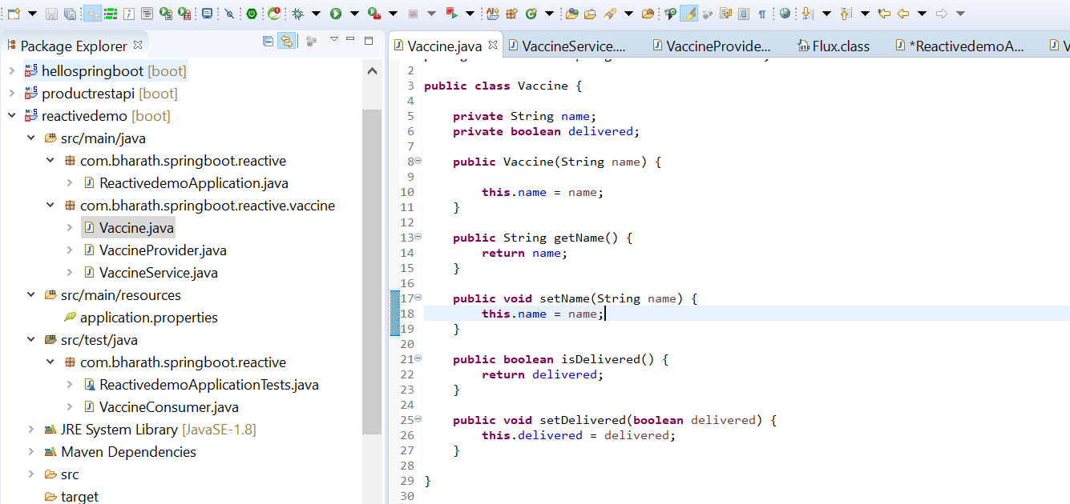

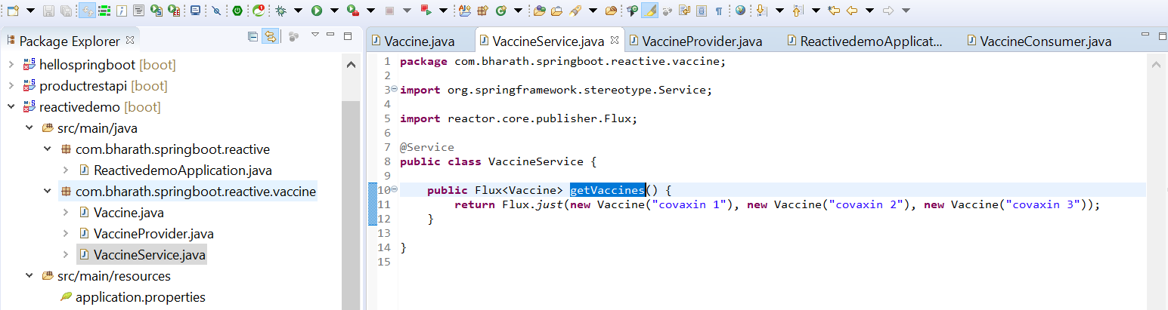

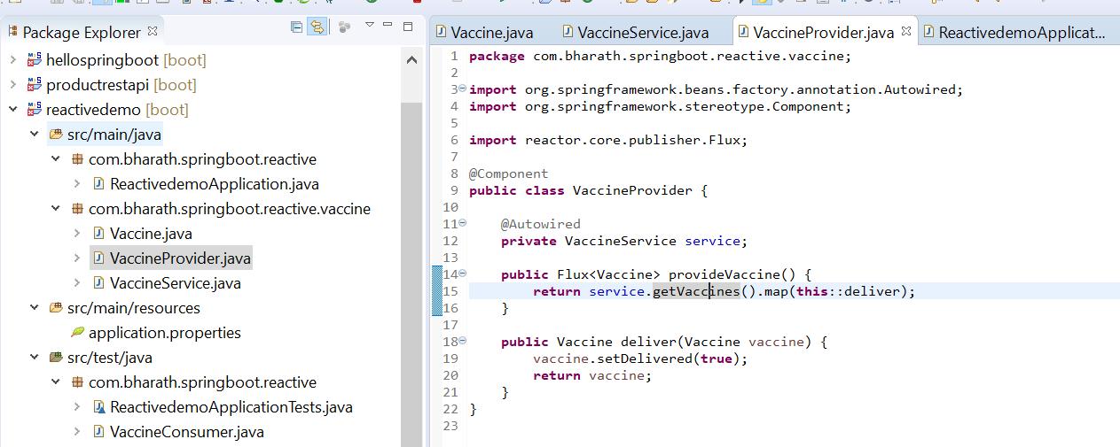

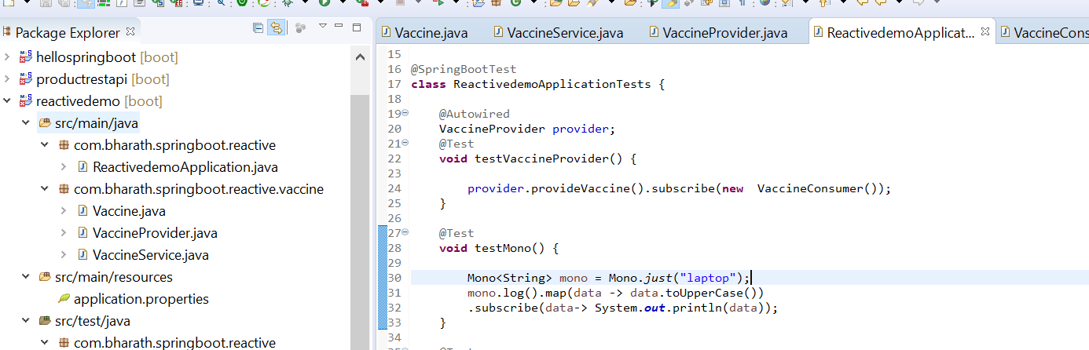

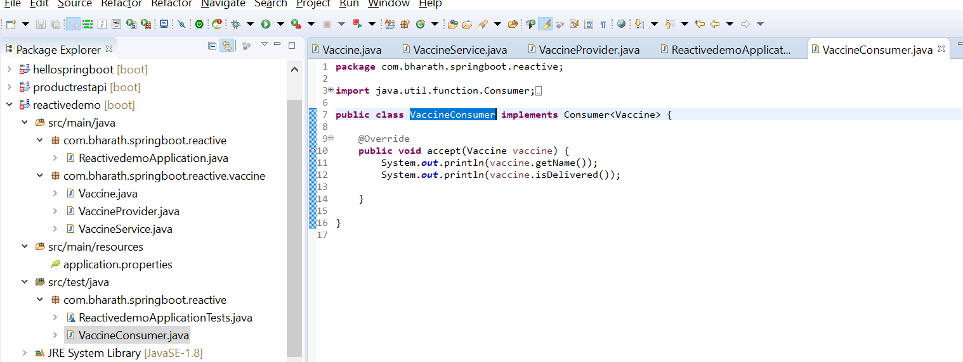

//output

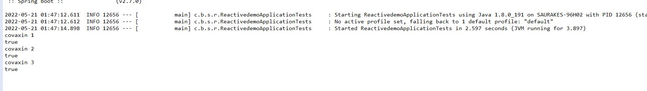

**Spring Webflux**

**Spring-boot-starter-webflux**

Not uses embedded container tomcat, it uses netty container which is a reactive container

Controller and model will still remain the same

Note :--- netty will handle back pressure we don’t have to worry about subscription to flux or mono

**Create a reactive rest api**

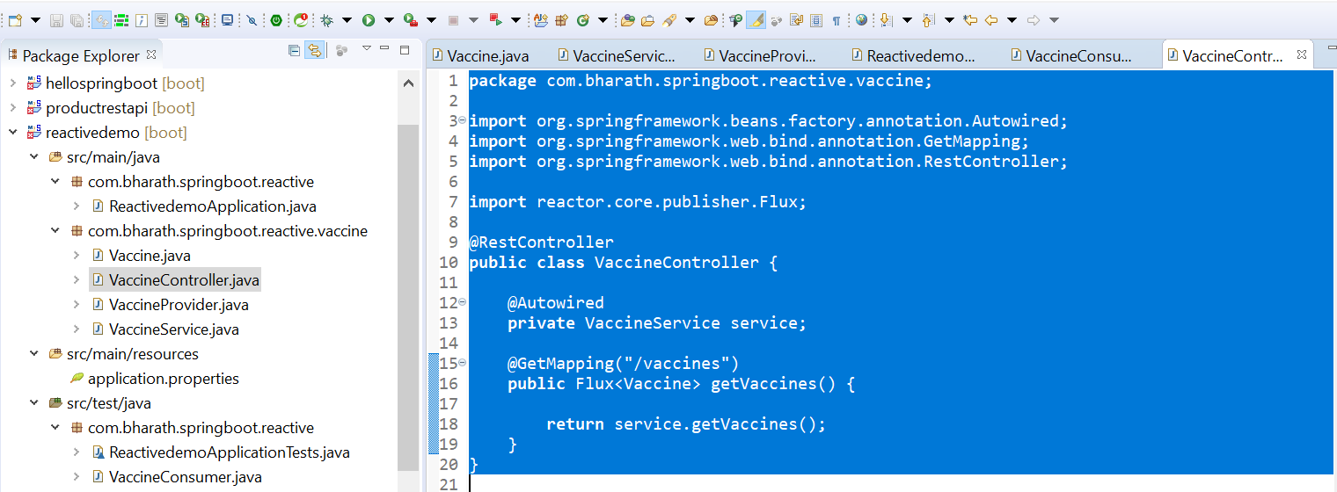

**Note :**

Springboot internally through webflux will subscribe to flux whenever data is ready it will convert it and send it back

It runs on netty server

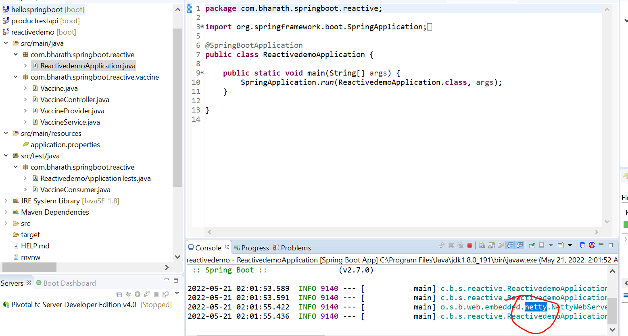

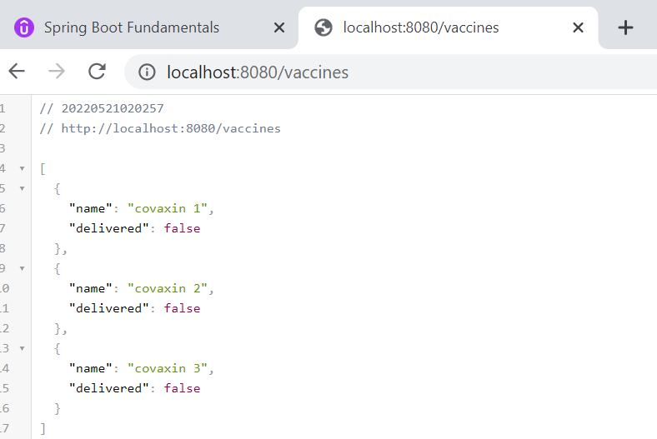

Note :---

flux will publish and no need to subscribe it will happen by netty server.

Whenever data is there automatically it will convert into json

**Create a web layer**

**Using thymeleaf :----** add thymeleaf dependency in pm.xml

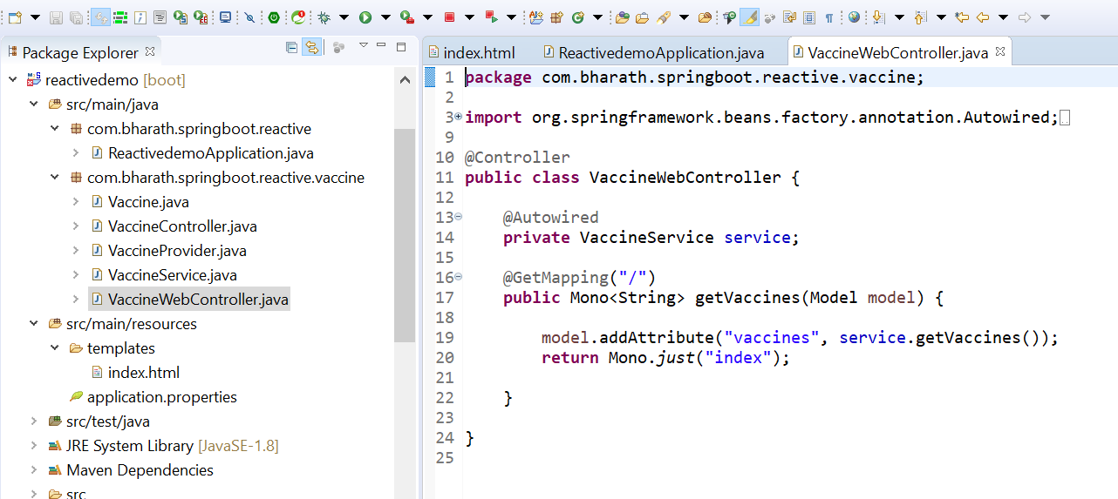

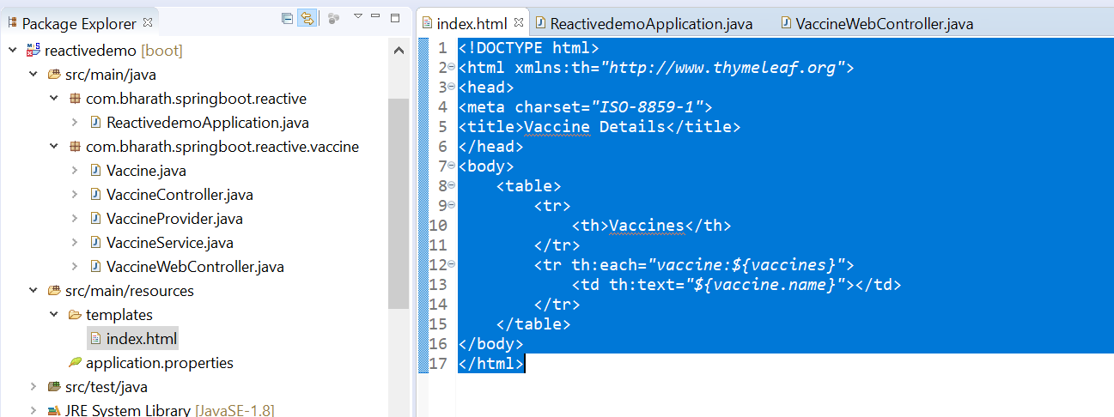

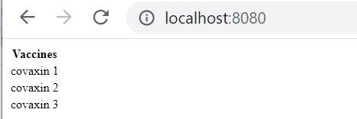

Use Reactive Mongo DB

How to work with reactive d/b

**Note :-**

In reactive architecture every component should be reactive

Database support reactivity

MongoDb

Cassandra

ElasticDb

**MongoDB intoduction**

MongoDB store data in form of collection or json

MongoDB is built on a scale-out architecture that has become popular with developers of all kinds for **developing scalable applications with evolving data schemas**. As a document database, MongoDB makes it easy for developers to store structured or unstructured data. It uses a JSON-like format to store documents.

**Note**

In orm each class is mapped to particular document or one collection

Each object --------one json row in that particular collection

**Reactive Testing**

**Create first test**

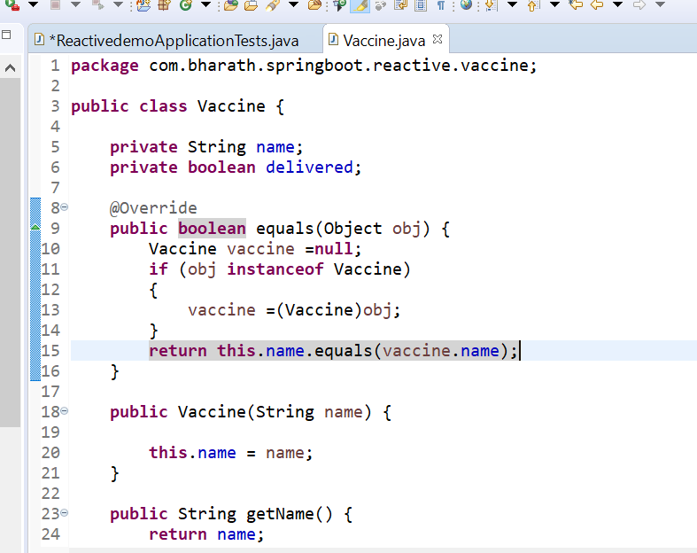

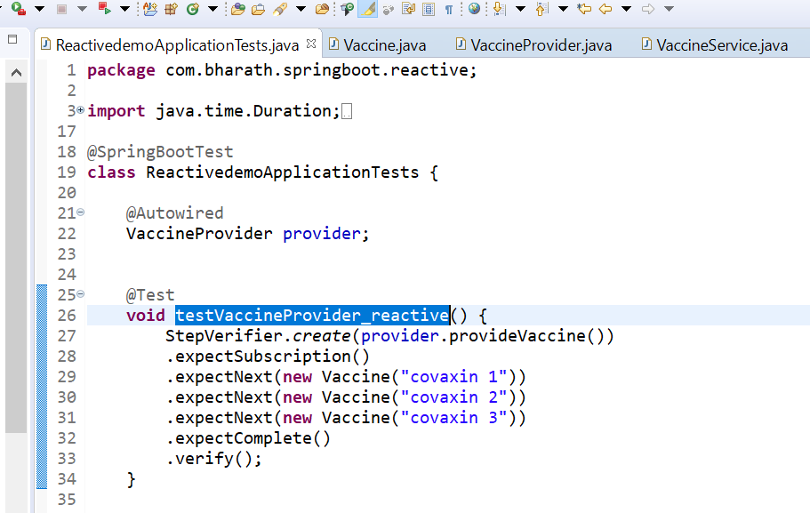

Note :

The entire flow will kicked on only when write verify()

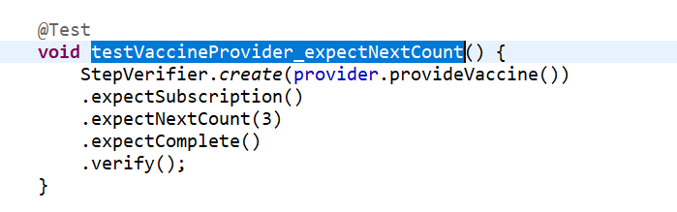

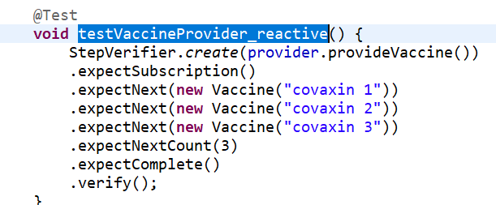

This wont work since it is expecting 3 but after subscription signal is already completed and count is 0

